Table of Contents

1. This Year’s Budget Process 2
2. Signing On PeopleSoft 5
   1. Sign On Screen 5
   2. Changing Your Password 6
3. Getting Started 7
   1. Menu Overview 7
   2. Budget Terminology 11
4. Organizational Overview 12
   1. The Search Dialog Box 12
   2. Organizational Rollup Panel 14
5. Budgeting by Account 17
   1. The Search Dialog Box 17
   2. AF Account Distribution Panel Group 19
   3. CPMP Account Distribution Panel Group 35
   4. IDC Account Distribution Panel Group 48
   5. IFR Account Distribution Panel Group 57
   6. EXT Account Distribution Panel Group 72
   7. SR Account Distribution Panel Group 77
   8. SBF Account Distribution Panel Group 86
6. Targets by Account 102
7. Viewing Employees by Account 106
   1. The Search Dialog Box 106
   2. Account Salary Detail Panel 108
8. Budgeting by Employee 110
   1. The Search Dialog Box 111
   2. Employee Information Panel Group 112
   3. Adding An Employee 132
   4. Deleting An Employee 134
   5. Employees Split Outside Your Organizational Level 134
   6. Cloning an Employee 136
   7. USB Change Form 138
9. Reports 141
   1. Creating a Run Control ID 141
   2. Using Process Monitor to Check Report Status 145
   3. Printing & Exporting From Report Files 148
10. Helpful hints 153
    1. Copying Data into Worksheets 153
    2. Changing the Model 153
    3. Error Messages & Warnings 155
11. Need Help? 157

Appendix 159

1.0 The 2016/2017 Budget Process

# Models

* The budget information in the PeopleSoft Budget Module is grouped by model. This is roughly analogous to fiscal year. For the **2016/2017** budget preparation cycle, there are four associated models:

Initial

Current

Proposed

Outyear

#### Initial

* The Initial model contains the initial budget information for the current fiscal year. It is the final version of the budget that you prepared last year for the current fiscal year. The information in this model is read-only. It is not modifiable.

#### Current

* The Current model is the one you would use to project your fiscal condition for the *current* fiscal year.

#### Proposed

* The Proposed model is the one you will use to enter the budget information for the upcoming fiscal year. The final version of your Proposed budget will be used to populate next year’s Initial model.

#### Outyear

* To project your budget for the budget cycle two years from now, you would use the Outyear model. The Outyear model will *not* be carried forward to next year’s associated models.
* For each budget preparation cycle, there will always be four associated models. What will change from year to year is the model ID. For the **2016/2017** budget preparation cycle, the model IDs for each of the four associated models are:

###### Model Model ID Description

Initial 2015 Initial 7/1/15 to 6/30/16 budget

Current C2015 Current projection of 7/1/15 to 6/30/16 budget

Proposed 2016 Proposed budget for 7/1/16 to 6/30/17 fiscal year

Outyear O2017 Projected budget for 7/1/17 to 6/30/18 fiscal year

* For all of the panels in the PeopleSoft Campus Budget Module, the system will initially default to the Proposed model.

# Data Load

* For the **2016/2017** budget preparation cycle the following data was loaded into the system:

|  |  |  |  |  |
| --- | --- | --- | --- | --- |
| Model | Employee Information | Account OSE | OTPS | Revenue |
| 2016 | Final budget data from prior year | | | |
| C2016 | Current payroll data from HR systems * | Copy of model 2016 | Copy of model 2016 | Copy of model 2016 |
| 2017 |
| O2018 |
| * RF distribution data is from OASIS. | | | |  |

* Model 2017 contains the final budget information that you prepared during last year’s budget preparation cycle. This information is read-only.
* For the three write-able models (C2016, 2017 and O2018) the employee information was loaded from a current snapshot of the following Human Resources payroll systems.
* The employee information snapshot for appropriated funds was loaded from 12/1/2015 data from the PeopleSoft HR modules.
* The employee payroll distribution for Research Foundation was loaded from 11/27/2015 data from the PeopleSoft HR modules.
* The employee information snapshot for ADP CPMP employees was loaded from 12/4/2015 data from CPMP office.
* The employee information snapshot for SBF employees was loaded from 11/30/2015 data from SBF office.
* All of the employee information snapshots were loaded into the three new models: 2017, C2016 and O2018.

#### Research Foundation OASIS Crosswalk

Please note that if you have IDC or CPMP accounts, you will now see one account used consistently for all models.  As per your requests, the technical team has crosswalked the ever-changing RF IDC and CPMP projects into the more familiar ‘431’ and '436' account numbers.  These generic ‘431’ and '436' numbers will be used each year so that we can do historical comparisons.  When you look at the IDC and CPMP Account Distribution panel groups, the initial column *will be* populated with your final budgeted figures from last year.

2.0 Signing On to PeopleSoft

# Sign On Screen

* To sign on to the PeopleSoft Campus Budget Module (CBM), go to the following address via Internet Explorer:

[**http://www.stonybrook.edu/hcmprod**](http://www.stonybrook.edu/hcmprod)

* You will then see the signon screen below.

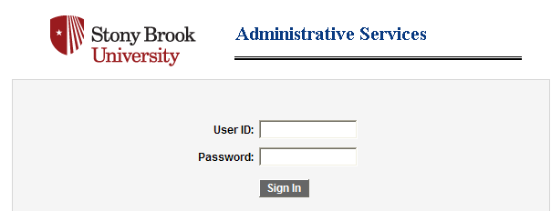

* Type in your User ID and Password in the indicated boxes. Both User ID and Password should be entered in all capitals.

# Changing Your Password

* If you are still using your default password, please change it to a personalized one by clicking on Change My Password from the Main Menu at the top of your screen.

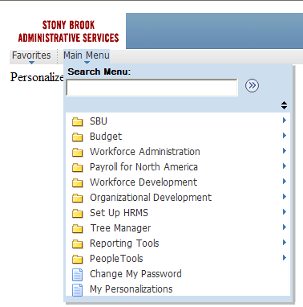

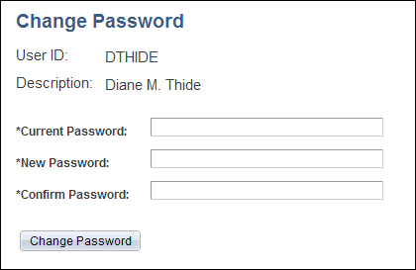

* In the Change Password window, type in your current password, new password, and confirm password in the spaces provided.
* Click on Change Password.

3.0 Getting Started

# Menu Overview

* After signing on to the system, you will see a PeopleSoft Home page. [If you also have HR access, this is the same page you use to access the Human Resources modules.]

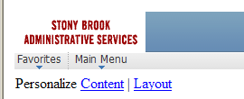

* Click the arrow under Main Menu to open up the cascading menu choices.

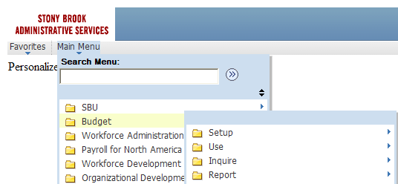

* Under **Budget**, you should see these menu choices: **Setup**, **Use**, **Inquire**, and **Report**.
* The Budget pages that you need are **Use**, **Inquire**, **Report** and sometimes **Setup**. The remaining items contain other functions that relate to the PeopleSoft environment.
* The **Setup** page is available in display-only mode for informational purposes. It contains setup information (such as IFR rate and account fund & function) that you can safely ignore for the duration of the budget process.

#### The USE Menu

* The **Use** menu is the one you will *use* most often. You will input and modify all of your data on the panel groups in this menu.

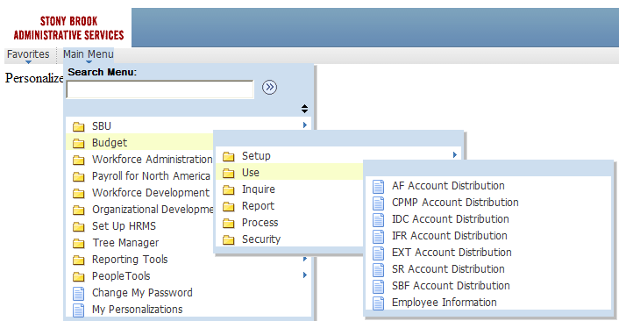

* There are eight panel groups in this menu:

1. **AF Account Distribution** panel group

* This panel group is used to budget expenditures on accounts that are in appropriated funds (AF).
* AF accounts include State Purpose (fund 10), Dormitory (fund 30), Hospital (fund 40) and Veterans Home (fund 60).

1. **CPMP Account Distribution** panel group

* This panel group is used to budget revenue and expenditures on accounts that are in the Clinical Practice fund (fund 90).

1. **IDC Account Distribution** panel group

* This panel group is used to budget expenditures on accounts that are in the Research Foundation Indirect Cost of Practice fund (fund 73).

1. **IFR Account Distribution** panel group

* This panel group is used to budget revenue and expenditures on accounts that are in Income Fund Reimbursable (IFR) funds.
* Although IFR accounts are appropriated fund accounts, they are budgeted in a separate panel group because they have revenue component that is budgeted by account.
* IFR accounts include General IFR (fund 20), SUTRA (fund 35), Dormitory IFR (fund 35) and Hospital IFR (fund 45).

1. **EXT Account Distribution** panel group

* This panel group is used to budget revenue to offset the salary supplements from external sources. External sources include the Northport VA (fund 93), Brookhaven National Labs (fund 95) and other external sources (fund 97).

1. **SR Account Distribution** panel group

* This panel group is used to budget revenue and expenditures on accounts that are in the Research Foundation Sponsored Research and Service & Agreements funds.

1. **SBF Account Distribution** panel group

* This panel group is used to budget revenue and expenditures on accounts that are in the SBF Restricted, Unrestricted, Agency, and Grant funds.

1. **Employee Information** panel group

* The six Account Distribution panel groups are for budgeting information by account. The Employee Information panel group is for budgeting information by employee. You add and modify employee records from this panel group.
* For detailed information on each Account Distribution panel group, see Unit 5, Budgeting by Account. For detailed information on budgeting by employee see Unit 7.
* Please refer to the Appendix for a summary of the fund type, account code and fund code conventions used in CBM. The chart also directs you to which panel group to go to for certain funds. The information contained in this summary is also included in Unit 5, Budgeting by Account.

**The INQUIRE Menu**

* The **Inquire** menu contains display-only information.

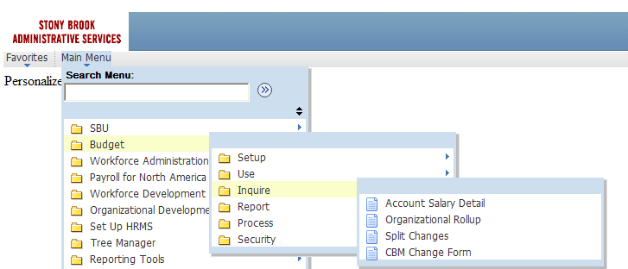

* There are four panels in this menu:

1. **Account Salary Detail** panel

* This panel lists all of the employee records that are charged to the selected account.

1. **Organizational Rollup** panel

* This panel is a summary of the allocation targets/revenue and budgeted expenditures within an organizational area.

1. **Split Changes** panel

* This panel lists all employee records that are split outside your area *and* that have been modified.

1. **CBM Change Form** panel

* This panel gives you access to the USB Change Form. For information on this form, see Unit 8, Budgeting by Employee.

**The REPORT Menu**

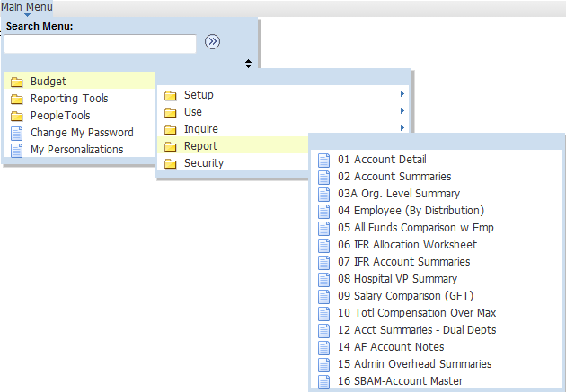

* The **Report** menu contains panels for each of the reports in the system.
* You will run the reports from their corresponding panels.
* For detailed instructions on running reports and descriptions of each report see Unit 9, Reports.

# Budget Terminology

* The table below lists PeopleSoft fields used for budgeting and their descriptions.

|  |  |
| --- | --- |
| **PeopleSoft Field** | **Description** |
| GL Class (General Ledger Class) | GL class is the name of the budget categories. Each fund has its own set of valid revenue and expense GL classes. |
| Comp Frequency | Compensation frequency describes an employee’s rate of pay. |
| Account | An account is the segment of an organization dealing with a particular activity in which costs can be segregated; it is analogous to a cost center. |
| Department ID | Despite its name, Department ID does not necessarily mean department. Department ID is really analogous to organizational level. This can be anything from the VP level to a parent account. |
| Model ID | The data in the system is grouped by model. This is roughly analogous to fiscal year. See Unit 1 for more details. |
| AF Comp Rate | The AF Comp Rate is the full time value of an employee’s salary. |
| Account OSE (Other Salary Expenses) | These are personnel expenses that are budgeted in aggregate by account, not by individual employee. |
| OTPS (Other Than Personal Services) | These are expenses that are not related to personnel. Examples are Supplies, Equipment, Telephone, Travel. |
| Employee OSE (Other Salary Expenses) | These are personnel expenses not included in an employee’s base salary. |

4.0 Organizational Overview

# The Search Dialog Box

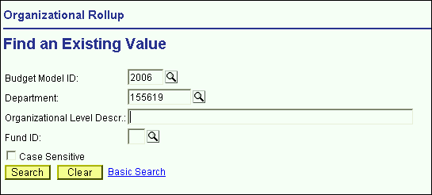

* In PeopleSoft, you will spend a great deal of time looking at windows like the one shown above. They are search dialog boxes. They are PeopleSoft’s way of asking you for the information that you would like to select.
* Each panel group has its own search dialog box. Depending on where you are in the system, the search dialog box will default certain information for you.
* From the **Inquire** menu, select **Organizational Rollup**. You will see the search dialog box above.
* The fields at the top of the box (Budget Model ID, Department, Organizational Level Descr, and Fund ID) are search keys.

Budget Model ID

* The system will automatically default the model ID of the Proposed year. For more information on the model, see Unit 1.
* To change the model, you can enter the desired value in the edit box or you can click on the magnifying glass to the right of the edit box to view a list of options to choose from.

Department

* For this panel, the system is also defaulting to the highest level organizational area to which you have access. In this example the default is 155619, which is Central Services in VP for Administration.

**Organizational Level Descr**

* The Organizational Level Descr field is the literal description of the Department field.
* When narrowing a search based using a description field, you can use the % symbol as a placeholder for one or more characters. For example, if you are looking for an organizational level that contains the word “Central” in the description, you may type %Central% in the Organizational Level Descr field and click the **Search** button.
* Please remember that PeopleSoft character fields are case sensitive. %Central% is different from %central%.

Fund

* To select the fund, you can enter the desired value in the edit box or you can click on the magnifying glass to the right of the edit box to view a list of options to choose from.
* For this panel, if you do not select a fund you will get all of the funds.
* Once you have inputted the desired search criteria, click **Search**. You will then see a list at the bottom half of all of the data that PeopleSoft found as a match to your criteria. You can then select the desired data and click **OK**.
* To summarize, in a search dialog box, you may directly enter the information you need, or you can view the list of valid values for a field by clicking on the magnifying glass to the right of the field.

# The Organizational Rollup Panel

Panel name

Excel Export button

Sort Order dropdown

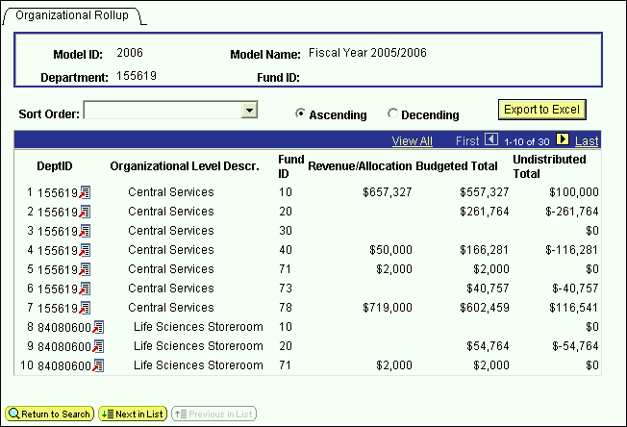

Panel name

Command buttons

* If you click **OK** from the previous search dialog box, you will see the Organizational Rollup panel above.
* Please note that all of the PeopleSoft panels have the following panel layout in common:

Title bar – the title bar is located at the top of the screen and contains the name of the module that you are in, the panel group you have selected and the menu it is located in. In the example above, you are in the Budget module, and you have selected the Organizational Rollup panel group, which is located in the Inquire menu.

Panel name – the panel name can be found in two places, under the command buttons at the top of the panel and at the bottom of the panel.

Selected action – there are two actions that are used in the Budget module, Update/Display and Add.

Database name – the database name that you are logged into will always be at the bottom of the PeopleSoft window.

* The Organizational Rollup panel is a summary of the allocation targets/revenue and budgeted expenditures within an organizational area
* Since you did not specify a fund, all of the valid funds for your organizational level were included in the grid.
* Under the panel name at the top of the screen, is the model and department you selected.
* The grid on the panel is a summary of your budgeted information by organizational level and fund. The grid contains the following columns:

**Dept ID** – This is all of the organizational nodes under the “Department” you selected in the search dialog box.

**Organizational Level Descr** – This column contains the corresponding literal descriptions of the Dept ID column. The descriptions of the organizational levels are indented to visually represent a lower level.

**Fund ID** – This column displays the fund code of each grouping of accounts in your area.

**Revenue/Allocation**

For appropriated funds (including IFR), this column displays the allocation that you have been authorized to budget against.

For the IDC fund, this column displays the amount of spending authority you have to budget against.

For Sponsored Research (SR) and Clinical Practice (CPMP), this column is a rollup of the revenue that is budgeted on each account within those funds.

**Proposed Total** – This is the total of all expenditures that were budgeted in the model you have selected.

For appropriated funds (including IFR), this total *does not* include fringe benefits or overhead.

For IDC, SR and CPMP, this total *does* include fringe benefits and overhead.

**Undistributed Total** – This column is the difference between the Revenue/Allocation column and the Proposed Total column.

* The grid is initially displayed in the tree node order of the organizational levels. You can change the sort order by using the sort order drop down box at the upper left hand corner of the panel.



Link

* Since 71 is the fund code for SR, row 5 tells you that you have budgeted $2,000 in revenue in all of your SR accounts in Central Services.
* Since 10 is the fund code for State Purpose, row 1 tells you that you have $657,327 available to budget in all of the State Purpose accounts in Central Services. You have budgeted $557,327 leaving $100,000.
* The grid is display only (gray fields). To change the numbers, you have to change the values that are budgeted by account.
* To go to the panel group where you budget by account, click on the link on the first row of the grid and select **Account** and then **Search**. You will then see the search dialog box on the next page.

5.0 Budgeting by Account

# The Search Dialog Box

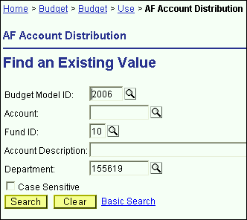

* In the Search dialog box, the Proposed model is defaulted. If you would like to work in a different model, you can type in the desired model number, or you can click on the magnifying glass and select from the valid values in the secondary screen.
* If you know the account that you would like to budget for, you can type in the 8 to 10-digit account number.
* If you don’t know the account number, type the fund code of the account and click the **Search** button.
* The system will then list all of the accounts in your organizational area within the selected fund.
* You should *not* use the Account magnifying glass to look for the account number you need because the valid value list on the secondary panel is not just for the accounts in your area, it is for all 6,000+ accounts in CBM.
* You will notice that the department ID defaulted to the one in the previous Organizational Rollup panel. That is the advantage of starting your PeopleSoft budgeting session from the Organizational Rollup panel.
* Also, since you right-clicked on a State Purpose row the system knows to bring you to the AF Account Distribution search dialog box.
* The AF Account Distribution panel group is used to budget accounts in the following funds:

1. Fund 10 – State Purpose
2. Fund 30 – Dormitory
3. Fund 40 – Hospital
4. Fund 60 – Veterans Home

* After you select the fund and click the **Search** button, you will see a listing similar to the one below. This is all of the fund 10 accounts in 155619 (Central Services).

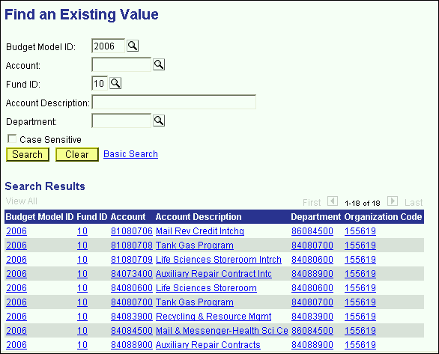

* Select the account that you would like to budget and click **OK**.

# AF Account Distribution Panel Group

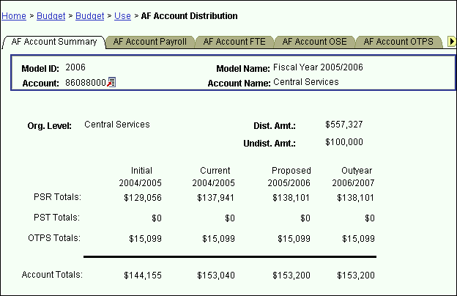

* You are now in the AF Account Distribution panel group.
* There are seven panels in this panel group. The panel tabs are displayed at the top of the panel.
* AF Account Summary panel
* AF Account Payroll panel
* AF Account FTE panel
* AF Account OSE (in Aggregate) panel
* AF Account OTPS panel
* Hospital OT/CL FTE panel
* Performance Indicators panel
* You can click on the panel name to activate the panel or you can navigate using the **Next Tab** button or the **Previous Tab** button.
* You will see the model ID and the account number that you selected at the top of each of the panels in this group.
* You will notice that although you are in the Proposed model, you will see the corresponding budget information for the associated models.

#### AF Account Summary Panel

This first panel is a display only summary of the GL classes that have been budgeted on the account.

Under the account number and the account name, there is a distributed amount for the organizational level (department) that you selected in the Organizational Rollup panel.

The distributed amount is the same number that you saw in the Organizational Rollup panel.

The system is telling you that from your targeted allocation, you have distributed (or budgeted) $557,327 and that you have $100,000 left to distribute.

The distributed amount is for ALL of the accounts within the organizational level and fund that you selected.

You will only see the distributed and undistributed information if you start off in the Organizational Rollup panel.

As you can see from the title bar, this AF Account Distribution Panel group is under the **Use** menu. We accessed it from the Organizational Rollup panel on the **Inquire** menu, but you can also access it from **Use**. The advantage of going through the Organizational Rollup is the following:

The system will “remember” your department ID on the search dialog box.

The system will “remember” your distributed and undistributed amounts on the AF, IDC & IFR Account Distribution Summary panels. The distributed and undistributed amounts are not applicable for the SR and CPMP Account Distribution Summary panels.

Under the distributed and undistributed figures, you see PSR (Personal Services Regular), PST (Personal Services Temporary), OTPS (Other Than Personal Services) and account totals for all four associated models.

**Initial** – The numbers in this column are your final figures from last year’s Proposed model.

**Current** – Use the information in this column to project your budgetary needs for the current fiscal year. This model was pre-loaded with a current payroll snapshot and the OTPS data from last year’s Proposed model.

**Proposed** – Use the information in this column to project your budgetary needs for the upcoming fiscal year. The final version of this model will be used to load various financial systems. For example, the Proposed data in appropriated funds (including IFRs) will be used to load the initial allocation from SUNY.

**Outyear** – This column contains your anticipated budget for the budget period two years from now. Please note that the data in the Outyear model will *not* be carried forward to next year’s associated models.

During next year’s budget cycle, the information that you budget for this year’s Proposed will become next year’s Initial.

#### AF Account Payroll Panel

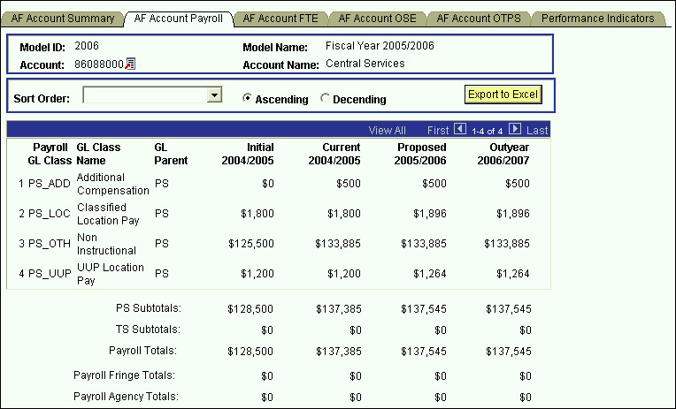

* This panel is a display only sub-total of the employee records by GL class. To modify the numbers on this panel, you will need to modify the employee records associated with this account. (Unit 5 provides instructions on viewing the employees that are charged to a particular account.)
* Since you are in the Proposed model, you are viewing all of the payroll GL class sub-totals in that model. You are also viewing the *corresponding* budget numbers for the associated models.
* This means that you will only see budget values for the three associated models if there is budgeted information for that expense in the Proposed model.
* To view all of the budgeted GL classes in an associated model, you must select that model in the Search dialog box.
* The first two columns in the grid contain the GL classes and their descriptions.
* The third column contains the GL Parent field. This column indicates whether the GL class is under the PS (personal services regular) node or the TS (personal services temporary) node. There are also PS and TS sub-totals by model under the grid.
* The Payroll Fringe Totals are only calculated for applicable funds (i.e., IFRs, SR, IDC, SBF, and CPMP).
* The Payroll Agency Totals are only calculated for CPMP and SBF staff.

#### AF Account FTE Panel

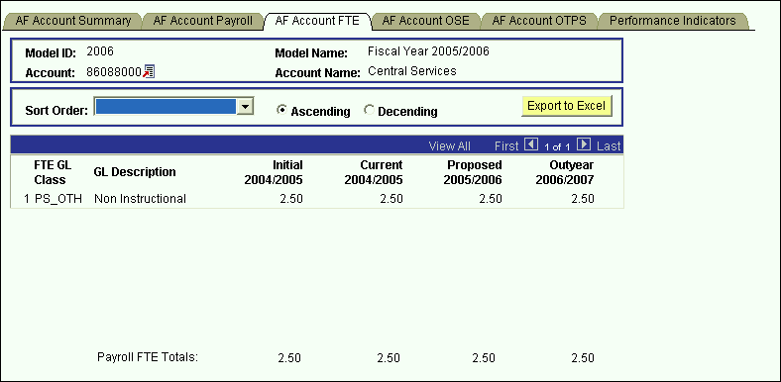

* This panel is similar to the AF Account Payroll panel except that instead of summarizing salaries, the system is summarizing FTE numbers.
* FTEs are summarized for base salary *regular* GL classes only.

**AF Account OSE (in Aggregate) Panel**

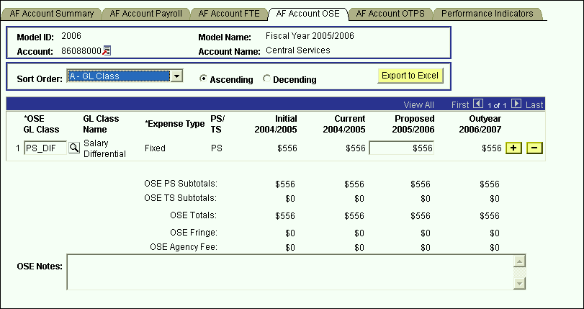

* This is the panel you will use to budget other salary expenses (OSE) in aggregate by account. The OSE in aggregate expenditures are salary expenses that you want to budget in a lump sum for the account, rather than by employee. For example, you may not know which employee will be working holidays, but you do know that you need to budget for that expense. So, rather than budgeting it for each employee, you can budget it here in total for the account.
* Student assistant expenditures should be budgeted in aggregate on this panel. Their employee records were not loaded on the system.
* The white fields are directly modifiable.
* Since you are in the Proposed model, only the Proposed column is modifiable. If you would like to enter data in another model, you have to first change the model you are in.
* **To change the model:**
* Click on the link next to Account.
* You will be directed to the next panel where you may choose the desired Model to transfer to.

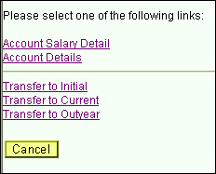

* **To budget for a OSE GL class that is not on the grid:**
* Click on the plus sign to the right of an existing row.
* On the new row, click the magnifying glass in the OSE GL Class column. Click the Lookup button in the next panel. You will then see the list of valid values shown below.

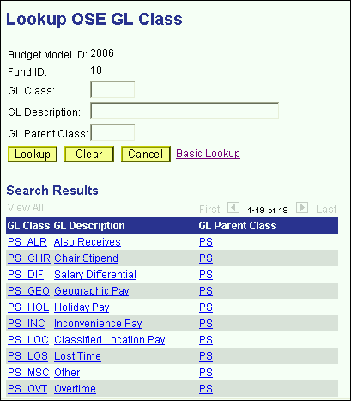

* The list of values contains a column for GL Parent Class. This determines whether a category is personal services regular (PS) or personal services temporary (TS). Since GL Parent Class is also a search key, you can use **Search** for OSE GL classes in specific GL Parent Classes.
* Please note that the set of GL classes you can use depends on the fund or fund type that your account belongs to.
* The list above is valid for OSE in aggregate expenditures in all appropriated funds (including IFRs).
* Select the OSE GL class that you would like to budget.
* Once you tab off of the GL class field on the grid, you will see that the description of the GL class will be displayed.
* Tab to the writable white field and enter the amount that you would like to budget for the selected GL class. When you tab off of the field, you will notice the sub-totals at the bottom of the panel are updated.
* As with the AF Account Payroll panel, there is a sub-total for PS, TS, fringe and agency fee.
* A note field has been provided so that you can enter clarifying notes.

**AF Account OTPS Panel**

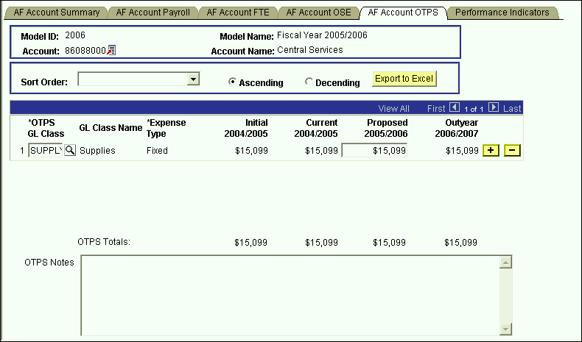

* This is the panel you will use to budget Other Than Personal Services (OTPS) expenditures.
* The white fields are directly modifiable.
* Since you are in the Proposed model, only the Proposed column is modifiable. If you would like to enter data in another model, you have to first change the model you are in.
* **To change the model:**
* Click on the link next to Account.
* You will be directed to the next panel where you may choose the desired Model to transfer to.



* **To budget for a OTPS GL class that is not on the grid:**
* Click on the plus sign to the right of an existing row.
* On the new row, click the magnifying glass in the OTPS GL Class column. Click the Lookup button in the next panel. You will then see the list of valid values shown below.

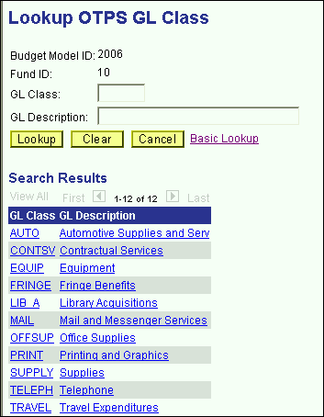

* This list is valid for OTPS GL classes in all appropriated funds (including IFRs) except fund 40. For fund 40 (Hospital), the expenditure categories from the Lawson financial system will be displayed.
* The following is a list of the OTPS expenditures for the Hospital fund:

500400 Advertising

800725 Anesthetic Materials

823251 Books, Subcrip, Memberships

802701 Cleaning

814671 Collection Agency Fees

803701 Consulting

804335 Data Processing Fees

817135 Empl Benefits Non Payroll

817150 Employee Wearing Apparel

805401 Equip Repair/Maint

805601 Equip<$ 500

806301 Expenses Other

806725 Food - Meat, Fish, Poultry

806701 Food Other

809401 Insurance

809851 IV Solutions

810305 Lease / Rental Other

810255 Lease/Rental Bldg Fixed Equip

810260 Lease/Rental Moving Equipment

810725 Licenses and Taxes

810790 Linen & Bedding

805125 Major Movable Equipment >500

812601 Office Supplies

806535 Other Fees

823340 Other Med Care Supplies

823345 Other Non Med & Non Surg Suppl

813001 Other Purch Serv (incl rental)

822410 Outside Training Registr Fees

813255 Oxygen & Other Med Gases

813425 Pharmaceuticals

813801 Postage & Shipping

813901 Printing & Reproduction

814501 Professional Services Audit

814601 Professional Services Legal

813430 Prosthesis

813061 Purch Serv - Manpower

813051 Purch Serv Laundry & Linen

806502 Radioactive Materials

823350 Radiology Film

814405 Services - Medical

822301 Spec Contractual Serv.

823355 Surgical Supplies - General

823690 Tableware & Kitchen Utensils

823801 Telephone

824551 Transcription Fees

826802 Travel & Lodging

827401 Utilities - Electricity

827721 Utilities - Fuel Oil

827725 Utilities - Other

827601 Utilities - Sewage

010158 Utilities - Steam

827701 Utilities - Water

* Select the OTPS GL class that you would like to budget.
* Once you tab off of the GL class field on the grid, you will see the description of the GL class will be displayed.
* Tab to the writable white field and enter the amount that you would like to budget for the selected GL class. When you tab off of the field, you will notice the sub-totals at the bottom of the panel are updated.
* A note field has been provided so that you can enter clarifying notes.

**Hospital OT/CL FTE Panel**

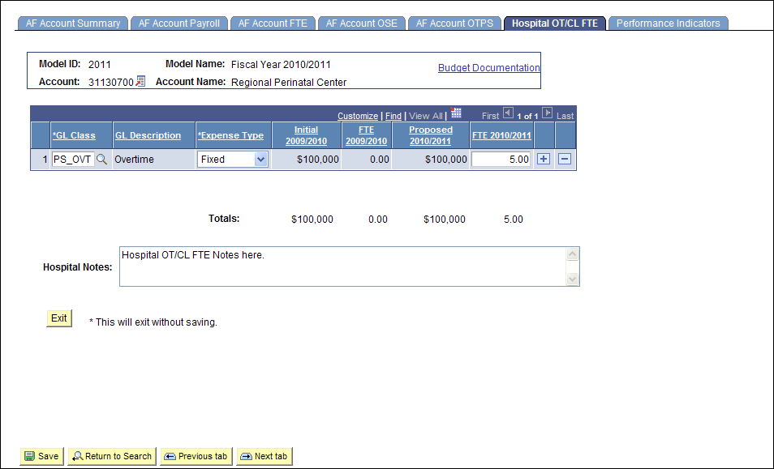

* This is the panel you will use to budget FTE for Overtime, Contract Labor, and Per Diem in aggregate for Fund 40 (Hospital) accounts.
* The white fields are directly modifiable.
* Since you are in the Proposed model, only the Proposed column is modifiable.
* **To budget for a GL class that is not on the grid:**
* Click on the plus sign to the right of an existing row.
* On the new row, click the magnifying glass in the GL Class column. Click the Lookup button in the next panel. You will then see the list of valid values shown below.

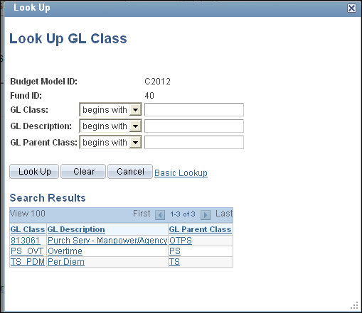

* Select the GL class that you would like to budget.
* Once you tab off of the GL class field on the grid, you will see the description of the GL class will be displayed.
* Click on the dropdown arrow next to Expense Type and choose Fixed or Variable.
* Tab to the writable white field and enter the amount that you would like to budget for the selected GL class. When you tab off of the field, you will notice the sub-totals at the bottom of the panel are updated.
* A note field has been provided so that you can enter clarifying notes.
* You will not be able to enter FTE if there is no corresponding entry budgeted for the GL Class and Expense on the AF Account OSE or AF Account OTPS page. A warning message will be displayed.
* You will have to delete or zero out the FTE before deleting or zeroing out the corresponding entry on the OSE or OTPS page. A warning message will be displayed.

**Performance Indicators Panel**

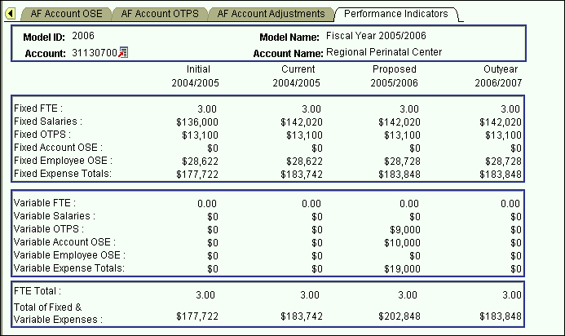

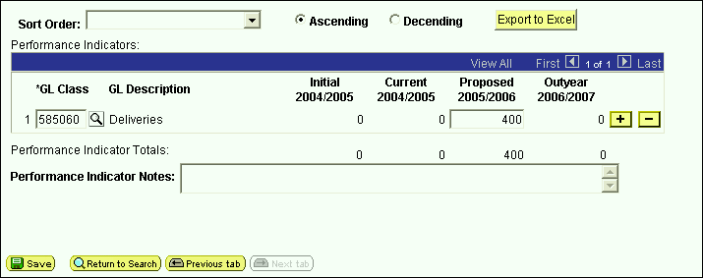

* This is the panel which will be used by the Hospital to budget units of measure (Performance Indicators) for each cost center.
* The top portion of this panel contains read-only information related to Fixed and Variable expenses.
* The bottom portion of this panel contains the Performance Indicators grid with units of measure data for the cost center.
* The white fields are directly modifiable.
* Since you are in the Proposed model, only the Proposed column is modifiable. If you would like to enter data in another model, you have to first change the model you are in.
* **To change the model:**
* Click on the link next to Account.
* You will be directed to the next panel where you may choose the desired Model to transfer to.



* **To budget for a Performance Indicator GL class that is not on the grid:**
* Click on the plus sign to the right of an existing row.
* On the new row, click the magnifying glass in the Performance Indicator GL Class column. Click the Lookup button in the next panel. You will then see the list of valid values shown below.

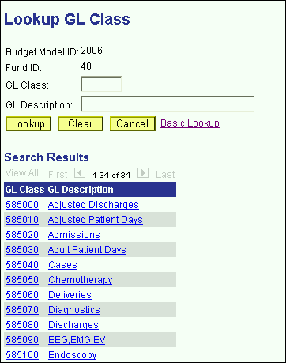

* Select the Performance Indicator GL class that you would like to budget.
* Once you tab off of the GL class field on the grid, you will see the description of the GL class displayed.
* Tab to the writable white field and enter the amount that you would like to budget for the selected GL class. When you tab off of the field, you will notice the sub-totals at the bottom of the panel are updated.
* A note field has been provided so that you can enter clarifying notes.

# CPMP Account Distribution Panel Group

* Since the budgets for the CPMP accounts are not driven by allocation, it is not necessary to access these accounts through the Organizational Rollup panel.
* From the **Use** menu, select CPMP Account Distribution. You will then see the following search dialog box.

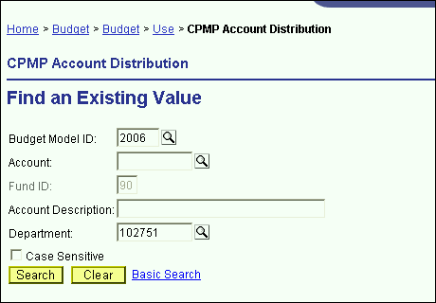

* Since the CPMP Account Distribution panel group is valid only for fund 90, the fund code is automatically entered for you. Enter your department ID and click the **Search** button.
* From the list of accounts, select the account that you wish to budget.

**CPMP Account Summary Panel**

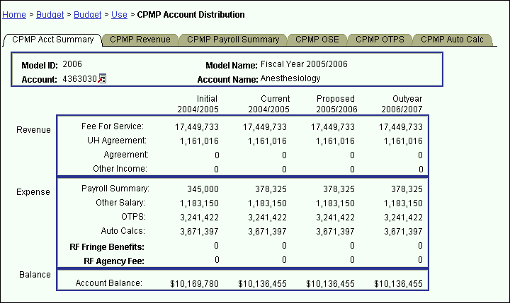

* You are now in the CPMP Account Distribution panel group.
* There are six panels in this panel group. The panel tabs are displayed at the top of the panel.
* CPMP Account Summary panel
* CPMP Revenue panel
* CPMP Payroll panel
* CPMP OSE (in Aggregate) panel
* CPMP OTPS panel
* CPMP Auto Calc panel
* You can click on the panel name to activate the panel or you can navigate using the **Next Tab** button or the **Previous Tab** button.
* You will see the model ID and the account number that you selected at the top of each of the panels in this group.
* You will notice that although you are in one model, you will see the corresponding budget information for the related models.
* The CPMP Account Summary panel is a display only summary of the GL classes that have been budgeted on the account.

The panel is separated into three sections: Revenue, Expense and Balance. These sections are sub-totaled for all four associated models.

**Initial** – The numbers in this column are your final figures from last year’s Proposed model.

**Current** – Use the information in this column to project your budgetary needs for the current fiscal year. This model was pre-loaded with a current payroll snapshot and the OTPS data from last year’s Proposed model.

**Proposed** – Use the information in this column to project your budgetary needs for the upcoming fiscal year. The final version of this model will be used to load various financial systems.

**Outyear** – This column contains your anticipated budget for the budget period two years from now. Please note that the data in the Outyear model will *not* be carried forward to next year’s associated models.

During next year’s budget cycle, the information that you budget for this year’s Proposed will become next year’s Initial.

**CPMP Revenue Panel**

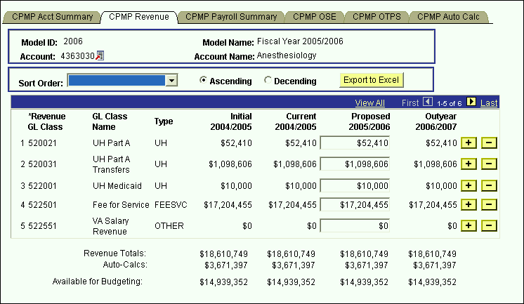

* This panel contains the revenue details that are sub-totaled on the CPMP Account Summary panel.
* The white fields are directly modifiable.
* Since you are in the Proposed model, only the Proposed column is modifiable. If you would like to enter data in another model, you have to first change the model you are in.
* **To change the model:**
* Click on the link next to Account.
* You will be directed to the next panel where you may choose the desired Model to transfer to.



* **To budget for a revenue category that is not on the grid:**
* Click on the plus sign to the right of an existing row.
* On the new row, click the magnifying glass in the Revenue category GL Class column. Click the Lookup button in the next panel. You will then see the list of valid values shown below.

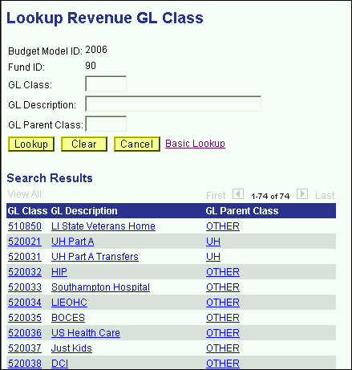

* The list of values contains a column for GL Parent Class. This determines the grouping of the revenue on the CPMP Account Summary panel. Since GL Parent Class is also a search key, you can use **Search** for revenue GL classes in specific GL Parent Classes.
* Select the revenue GL class that you would like to budget.
* Once you tab off of the GL class field on the grid, you will see the description of the GL class will be displayed.
* Tab to the write-able white field and enter the amount that you would like to budget for the selected GL class. When you tab off of the field, you will notice the sub-totals at the bottom of the panel are updated.
* The list below contains a **sample** list of valid values for CPMP revenue grouped by the GL parent class.

FEESVC - Fee for Service

522501 Fee for Service

UH - UH Agreements

521002 Coram Health Center Agreement

522001 UH Medicaid

520021 UH Part A

520031 UH Part A Transfers

522041 UH Part B

522011 UH Back Program

AGREE - Agreements

521001 Brookhaven National Lab Agreement

521003 Developmental Disability Agree

521004 Eastern Hospital Agreement

521005 Epilepsy Foundation Agreement

521006 Family Service League Agreement

521007 St Johnland Nursing Ctr

521008 Lab Animal Resources Agreement

521009 Maryhaven Center Hope Agreement

521010 Planned Parenthood Agreement

521011 School of Dental Med Agreement

521012 St Charles Neo-Natal Agreement

521013 St John's Hospital Agreement

521014 UCP PSY Agreement

521015 UCP PSY Greater NY Agreement

521016 Winthrop UH Agreement

521017 National Inst Peo/Disbl Agreement

OTHER - Other Income

510850 LI State Veterans Home

520032 HIP

520033 Southampton Hospital

520034 LIEOHC

522551 VA Salary Revenue

520035 BOCES

520036 US Health Care

520037 Just Kids

520415 Contractual

520416 Board Fund

520417 Deans Fund

520418 Billing Cost

520419 Administrative Costs

* To budget for UH Part A (GL Class 520021) and UH Part B (GL Class 522041), use the CPMP UH Revenue panel. The data for these GL Classes should be entered in detail for each Revenue Provider in the inner scroll.

**CPMP UH Revenue Panel**

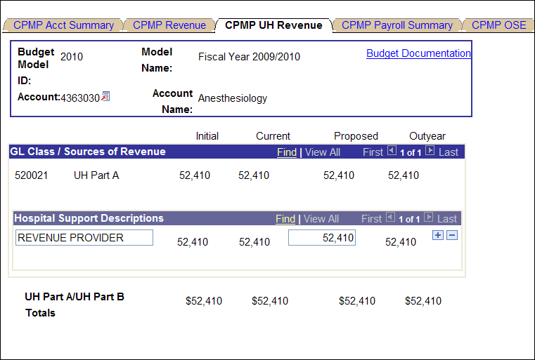

**CPMP Payroll Summary Panel**

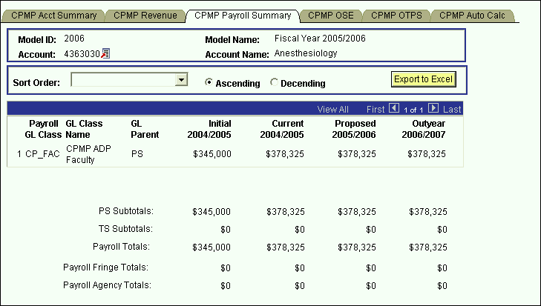

* This panel is a display only sub-total of the employee records by GL class. To modify the numbers on this panel, you will need to modify the employee records associated with this account. (Unit 5 provides instructions on viewing employees by account.)
* Since you are in the Proposed model, you are viewing all of the payroll GL class sub-totals in that model. You are also viewing the *corresponding* budget numbers for the associated models.
* This means that you will only see budget values for the three associated models if there is budgeted information for that expense in the Proposed model.
* To view all of the budgeted GL classes in an associated model, you must select that model in the Search dialog box.
* The first two columns in the grid contain the GL classes and their descriptions.
* The third column contains the GL Parent field. This column indicates whether the GL class is under the PS (personal services regular) node or the TS (personal services temporary) node. There are also PS and TS sub-totals by model under the grid.
* The Payroll Fringe Totals are only calculated for applicable funds (i.e., IFRs, SR, IDC, SBF, and CPMP).
* The Payroll Agency Totals are only calculated for CPMP and SBF staff.

**CPMP OSE (in Aggregate) Panel**

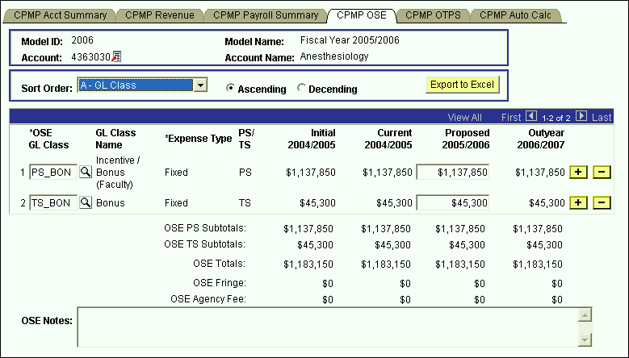

* This is the panel you will use to budget other salary expenses (OSE) in aggregate by account. The OSE in aggregate expenditures are salary expenses that you want to budget in a lump sum for the account, rather than by employee. For example, you may not know which employee will be receiving incentive payments, but you do know that you need to budget for that expense. So, rather than budgeting it for each employee, you can budget it here in total for the account.
* Student assistant expenditures should be budgeted in aggregate on this panel. Their employee records were not loaded on the system.
* The white fields are directly modifiable.
* Since you are in the Proposed model, only the Proposed column is modifiable. If you would like to enter data in another model, you have to first change the model you are in.
* **To change the model:**
* Click on the link next to Account.
* You will be directed to the next panel where you may choose the desired Model to transfer to.



* **To budget for a OSE GL class that is not on the grid:**
* Click on the plus sign to the right of an existing row.
* On the new row, click the magnifying glass in the OSE GL Class column. Click the Lookup button in the next panel. You will then see the list of valid values shown below.

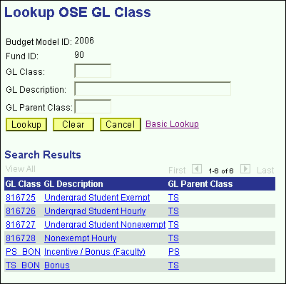

* The list of values contains a column for GL Parent Class. This determines whether a category is personal services regular (PS) or personal services temporary (TS). Since GL Parent Class is also a search key, you can use **Search** for OSE GL classes in specific GL Parent Classes.
* Please note that the set of GL classes you can use depends on the fund or fund type that your account belongs to.
* Select the OSE GL class that you would like to budget.
* Once you tab off of the GL class field on the grid, you will see the description of the GL class will be displayed.
* Tab to the write-able white field and enter the amount that you would like to budget for the selected GL class. When you tab off of the field, you will notice the sub-totals at the bottom of the panel are updated.
* As with the CPMP Payroll Summary panel, there is a sub-total for PS, TS, fringe and agency fee.
* A note field has been provided so that you can enter clarifying notes.

**CPMP OTPS Panel**

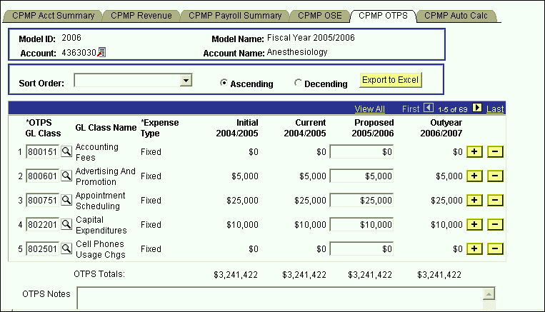

* This is the panel you will use to budget Other Than Personal Services (OTPS) expenditures.
* The white fields are directly modifiable.
* Since you are in the Proposed model, only the Proposed column is modifiable. If you would like to enter data in another model, you have to first change the model you are in.
* **To change the model:**
* Click on the link next to Account.
* You will be directed to the next panel where you may choose the desired Model to transfer to.



* **To budget for an OTPS GL class that is not on the grid:**
* Click on the plus sign to the right of an existing row.
* On the new row, click the magnifying glass in the OTPS GL Class column. Click the Lookup button in the next panel. You will then see the list of valid values shown below.

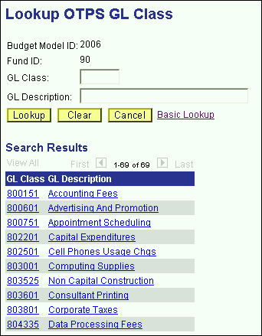

* Select the OTPS GL class that you would like to budget.
* Once you tab off of the GL class field on the grid, you will see the description of the GL class will be displayed.
* Tab to the write-able white field and enter the amount that you would like to budget for the selected GL class. When you tab off of the field, you will notice the sub-totals at the bottom of the panel are updated.
* A note field has been provided so that you can enter clarifying notes.

**CPMP Auto Calc Panel**

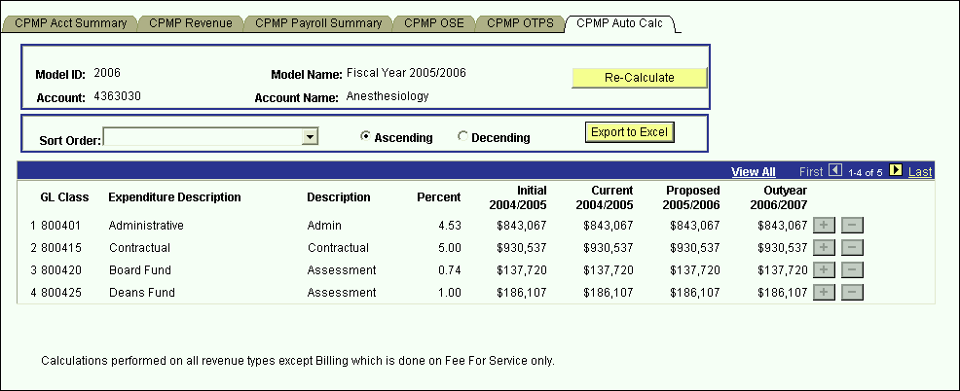

* This panel contains a grid with display-only information for revenue assessments.
* These assessments are automatically calculated on the revenue in the CPMP Revenue panel.
* The first three columns on the grid contain the GL class and the description of these automatic calculations.
* The fourth column contains the rate of each auto calc.
* The next four columns contain the calculated amounts by model ID.
* All of the auto calcs are assessed on all the revenue types except for Billing which is assessed on Fee-For-Service only.

# IDC Account Distribution Panel Group

* Similar to the AF Account Distribution panel group, it is recommended that you access your IDC accounts through the Organizational Rollup panel. When you click on the link on the IDC row (fund 73) on the Organizational Rollup panel, you will get the search dialog box below.

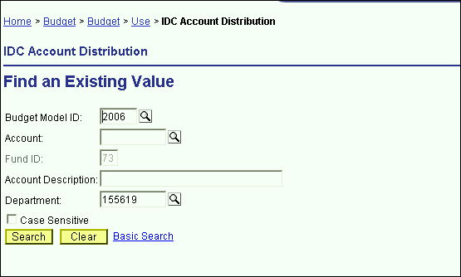

* Since the IDC Account Distribution panel group is valid only for fund 73, the fund code is automatically entered for you.
* Since you started with the Organizational Rollup panel, the system “remembers” your Department ID.
* For the search dialog box, click the **Search** button and select the IDC account you wish to budget.
* You are now in the IDC Account Distribution panel group
* There are four panels in this panel group. The panel tabs are displayed under the command buttons.
* IDC Account Summary panel
* IDC Account Payroll panel
* IDC Account OSE (in Aggregate) panel
* IDC Account OTPS panel
* You can click on the panel name to activate the panel or you can navigate using the **Next Tab** button or the **Previous Tab** button.
* You will see the model ID and the account number that you selected at the top of each of the panels in this group.
* You will notice that although you are in one model, you will see the corresponding budget information for the related models.

**IDC Account Summary Panel**

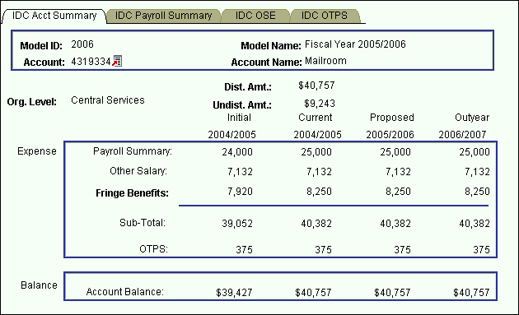

* This first panel is a display only summary of the GL classes that have been budgeted on the account.
* Under the account number and the account name, there is a distributed amount for the organizational level (department) that you selected in the Organizational Rollup panel.
* The distributed amount is the same number that you saw in the Organizational Rollup panel.
* The system is telling you that from your targeted allocation, you have distributed (or budgeted) $40,757 and that you have $9,243 left to distribute.
* The distributed amount is for ALL of the accounts within the organizational level and fund that you selected. The reason the distributed amount of $40,757 matches the account total is because account 4319334 is the only one with budgeted information. If there were other IDC accounts that were budgeted, the distributed amount would be larger.
* You will only see the distributed and undistributed information if you start off in the Organizational Rollup panel.
* As you can see from the title bar, this IDC Account Distribution Panel group is under the **Use** menu. We accessed it from the Organizational Rollup panel on the **Inquire** menu, but you can also access it from **Use**. The advantage of going through the Organizational Rollup is the following:
* The system will “remember” your department ID on the search dialog box.
* The system will “remember” your distributed and undistributed amounts on the AF, IDC & IFR Account Distribution Summary panels. The distributed and undistributed amounts are not applicable for the SR and CPMP Account Distribution Summary panels.
* Under the distributed and undistributed figures, you see Payroll Summary, Other Salary, Fringe Benefits, OTPS and the Account Balance for all four associated models.

**Initial** – The numbers in this column are your final figures from last year’s Proposed model.

**Current** – Use the information in this column to project your budgetary needs for the current fiscal year. This model was pre-loaded with a current payroll snapshot and the OTPS data from last year’s Proposed model.

**Proposed** – Use the information in this column to project your budgetary needs for the upcoming fiscal year. The final version of this model will be used to load various financial systems.

**Outyear** – This column contains your anticipated budget for the budget period two years from now. Please note that the data in the Outyear model will *not* be carried forward to next year’s associated models.

During next year’s budget cycle, the information that you budget for this year’s Proposed will become next year’s Initial.

**IDC Payroll Summary Panel**

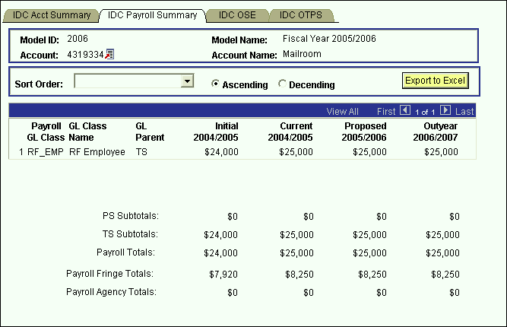

* This panel is a display only sub-total of the employee records by GL class. To modify the numbers on this panel, you will need to modify the employee records associated with this account. (Unit 5 provides instructions on viewing employees by account.)
* Since you are in the Proposed model, you are viewing all of the payroll GL class sub-totals in that model. You are also viewing the *corresponding* budget numbers for the associated models.
* This means that you will only see budget values for the three associated models if there is budgeted information for that expense in the Proposed model.
* To view all of the budgeted GL classes in an associated model, you must select that model in the Search dialog box.
* The first two columns in the grid contain the GL classes and their descriptions.
* The third column contains the GL Parent field. This column indicates whether the GL class is under the PS (personal services regular) node or the TS (personal services temporary) node. There are also PS and TS sub-totals by model under the grid.
* The Payroll Fringe Totals are only calculated for applicable funds (i.e., IFRs, SR, IDC, SBF, and CPMP).
* The Payroll Agency Totals are only calculated for CPMP and SBF staff.

#### IDC OSE (in Aggregate) Panel

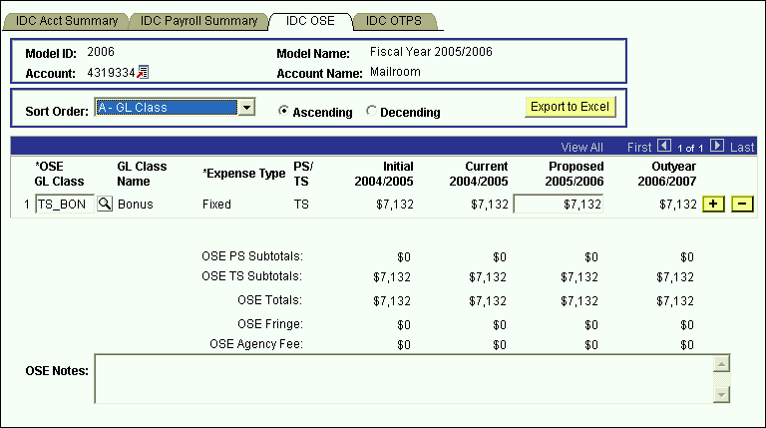

* This is the panel you will use to budget other salary expenses (OSE) in aggregate by account. The OSE in aggregate expenditures are salary expenses that you want to budget in a lump sum for the account, rather than by employee. For example, you may not know which employee will be getting a bonus, but you do know that you need to budget for that expense. So, rather than budgeting it for each employee, you can budget it here in total for the account.
* Student assistant expenditures should be budgeted in aggregate on this panel. Their employee records were not loaded on the system.
* The white fields are directly modifiable.
* Since you are in the Proposed model, only the Proposed column is modifiable. If you would like to enter data in another model, you have to first change the model you are in.
* **To change the model:**
* Click on the link next to Account.
* You will be directed to the next panel where you may choose the desired Model to transfer to.



* **To budget for a OSE GL class that is not on the grid:**
* Click on the plus sign to the right of an existing row.
* On the new row, click the magnifying glass in the OSE GL Class column. Click the Lookup button in the next panel. You will then see the list of valid values shown below.

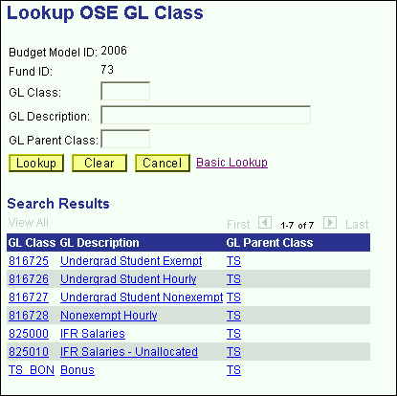

* The list of values contains a column for GL Parent Class. Since GL Parent Class is also a search key, you can use **Search** for OSE GL classes in specific GL Parent Classes.
* Select the OSE GL class that you would like to budget.
* Once you tab off of the GL class field on the grid, you will see the description of the GL class will be displayed.
* Tab to the write-able white field and enter the amount that you would like to budget for the selected GL class. When you tab off of the field, you will notice the sub-totals at the bottom of the panel are updated.
* As with the Account Payroll panel, there is a sub-total for PS, TS, fringe and agency fee.
* A note field has been provided so that you can enter clarifying notes.
* Please note that the set of GL classes you can use depends on the fund or fund type that your account belongs to.
* The list above is valid for the OSE panel in the IDC Account Distribution panel group and the SR Account Distribution panel group.

**IDC OTPS Panel**

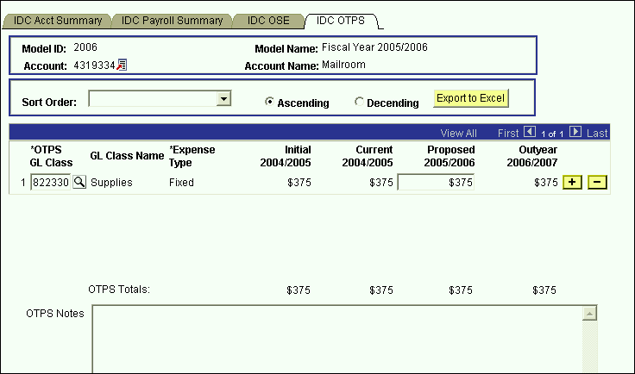

* This is the panel you will use to budget Other Than Personal Services (OTPS) expenditures.
* The white fields are directly modifiable.
* Since you are in the Proposed model, only the Proposed column is modifiable. If you would like to enter data in another model, you have to first change the model you are in.
* **To change the model:**
* Click on the link next to Account.
* You will be directed to the next panel where you may choose the desired Model to transfer to.



* **To budget for a OTPS GL class that is not on the grid:**
* Click on the plus sign to the right of an existing row.
* On the new row, click the magnifying glass in the OTPS GL Class column. Click the Lookup button in the next panel. You will then see the list of valid values shown below.

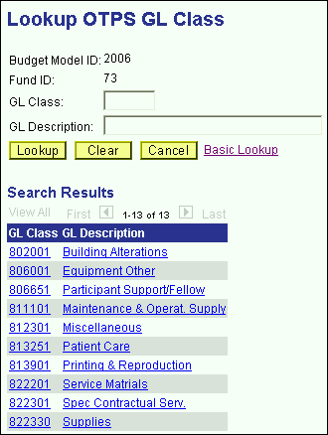

* Select the OTPS GL class that you would like to budget and click **OK**.
* Once you tab off of the GL class field on the grid, you will see the description of the GL class will be displayed.
* Tab to the write-able white field and enter the amount that you would like to budget for the selected GL class. When you tab off of the field, you will notice the sub-totals at the bottom of the panel are updated.
* A note field has been provided so that you can enter clarifying notes.
* The list above is valid for the OTPS panel in the IDC Account Distribution panel group and the SR Account Distribution panel group.

# IFR Account Distribution Panel Group

* IFR accounts are accounts in the following funds:

## Fund 20 – General IFR

Fund 25 – SUTRA

Fund 35 – Dormitory IFR

Fund 45 – Hospital IFR

* Since targets are not set for IFR accounts by VP area, you need not start in the Organizational Rollup panel. From the **Use** menu, select IFR Account Distribution. You will then see the following search dialog box
* Enter the IFR fund that you wish to select an account from and enter your department ID. Then click the **Search** button.

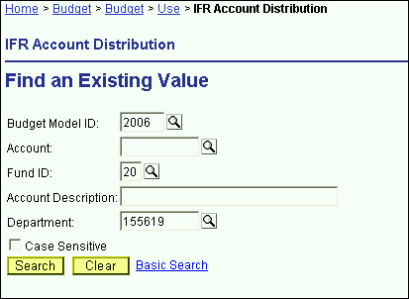

* You will then see a list of all of the accounts that match your search criteria.
* In the screen print below, the system displays all of the General IFR accounts within Central Services.

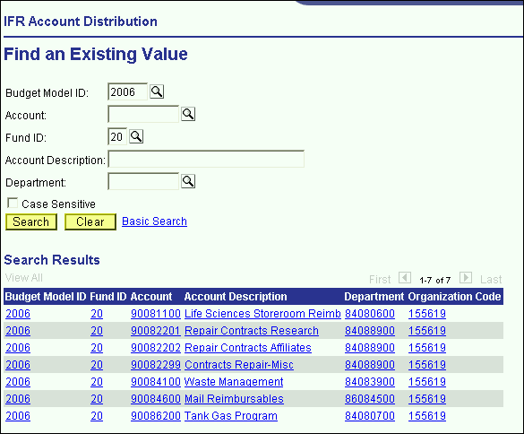

* From the list of accounts, select the account that you wish to budget.

**IFR Summary Panel**

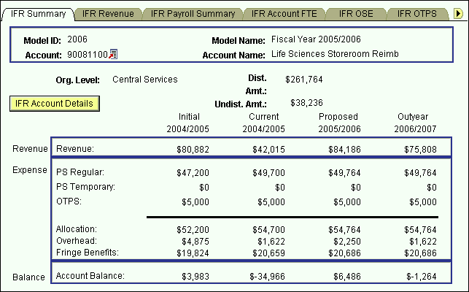

* You are now in the IFR Account Distribution panel group.
* There are six panels in this panel group. The panel tabs are displayed under the command buttons.
* IFR Summary panel
* IFR Revenue panel
* IFR Payroll Summary panel
* IFR OSE (in Aggregate) panel
* IFR OTPS panel
* IFR Overhead panel
* You can click on the panel name to activate the panel or you can navigate using the **Next Tab** button or the **Previous Tab** button.
* You will see the model ID and the account number that you selected at the top of each of the panels in this group.
* You will notice that although you are in one model, you will see the corresponding budget information for the related models.

### The IFR Summary panel is a display only summary of the GL classes that have been budgeted on the account.

* If you selected this panel group from the Organizational Rollup panel you will see a distributed amount for the organizational level (department) that you selected. This is located under the account number and the account name.
* The distributed amount is the same number that you saw in the Organizational Rollup panel.
* The system is telling you that from your targeted allocation, you have distributed (or budgeted) $261,764 and that you have $38,236 left to distribute.
* The distributed amount is for ALL of the accounts within the organizational level and fund that you selected. You have $261,764 budgeted in allocation, which equals the distributed amount. This is because you have only budgeted on some accounts.
* As you can see from the title bar, this IFR Account Distribution Panel group is under the **Use** menu. We accessed it from the Organizational Rollup panel on the **Inquire** menu, but you can also access it from **Use**. The advantage of going through the Organizational Rollup is the following:
* The system will “remember” your department ID on the search dialog box.
* The system will “remember” your distributed and undistributed amounts on the AF, IDC & IFR Account Distribution Summary panels.
* Under the distributed and undistributed figures, you see a Revenue section and an Expense section.
* The Revenue section is a sub-total of the information in the IFR Revenue panel.
* The expense section contains sub-totals for PS Regular, PS Temporary, OTPS as well as an Allocation sub-total for all three.
* The expense section also contains the Overhead total and the Fringe Benefit total.
* The Balance section is the difference between the Revenue section and the Expense section.
* This information is displayed for all four associated models.

**Initial** – The numbers in this column are your final figures from last year’s Proposed model.

**Current** – Use the information in this column to project your budgetary needs for the current fiscal year. This model was pre-loaded with a current payroll snapshot and the OTPS data from last year’s Proposed model.

**Proposed** – Use the information in this column to project your budgetary needs for the upcoming fiscal year. The final version of this model will be used to load various financial systems. For example, the Proposed data in appropriated funds (including IFRs) will be used to load the initial allocation from SUNY.

**Outyear** – This column contains your anticipated budget for the budget period two years from now. Please note that the data in the Outyear model will *not* be carried forward to next year’s associated models.

During next year’s budget cycle, the information that you budget for this year’s Proposed will become next year’s Initial.

#### IFR Account Details Panel

* When you click on the IFR Account Details button on the IFR Summary panel, you will see the panel below. This panel contains information about the fringe benefit rate and overhead rate assessed on the account.

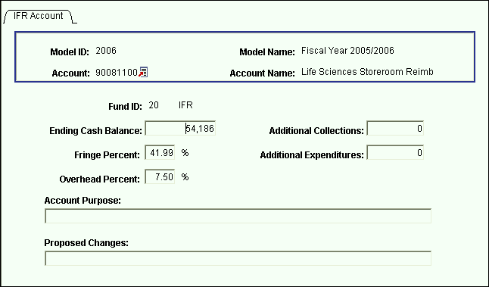

* To get back to the IFR Account Distribution panel group, click on the Back button.

### **IFR Revenue Panel**

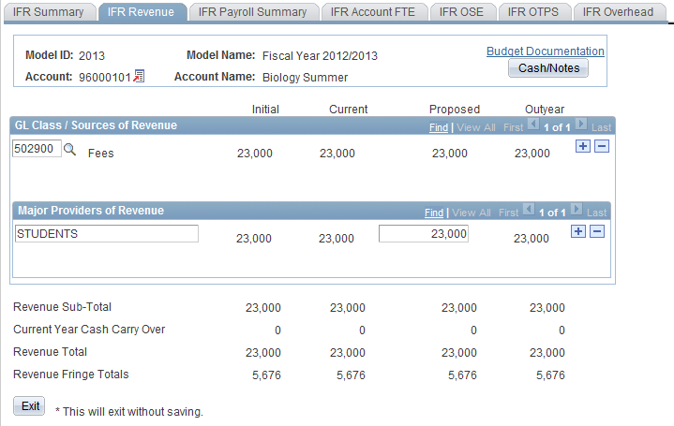

* This panel contains the revenue details that are sub-totaled on the IFR Summary panel.
* Note: For SUTRA Summer and Winter accounts, Fringe is calculated on Revenue, not Expenses.
* As in prior years, you must detail the Sources of Revenue and Major Providers of Revenue. However, now there is a parent-child relationship between Sources of Revenue and Major Providers of Revenue. That is, for each Source of Revenue, you must list the corresponding Major Providers of Revenue.
* Use the outer scroll bar to scroll between Sources of Revenue. Use the inner scroll bar to scroll between the Major Providers of Revenue of a particular Source of Revenue.
* To insert a Source of Revenue,
* Click on the plus sign to the right of an existing row.
* On the new row, click the magnifying glass in the Source of Revenue GL Class column. Click the Lookup button in the next panel. You will then see the list of valid values shown below.

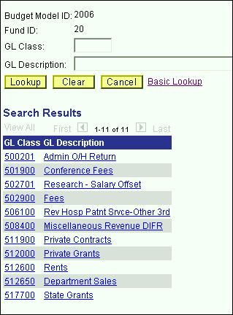

* Select the desired Source of Revenue. Once you tab off the field, you will see the description of the Source of Revenue you selected.
* The numeric field to the right of the Source of Revenue field is display only. It is a sub-total of Major Providers of Revenue entries.
* Click on the editable box under Major Providers of Revenue. Enter the description of the Major Provider of Revenue and tab to the right to enter the corresponding amount.
* Typically each IFR account has one Source of Revenue. To enter additional Sources of Revenue, click the Insert Row button while in the Sources of Revenue section.
* To enter additional Major Providers of Revenue, click the plus sign while in the Major Providers of Revenue section.
* Once you have entered the Sources of Revenue and Major Providers of Revenue that you are anticipating for the Proposed fiscal year, click on the Cash/Notes button located at the top right-hand corner of the IFR Revenue panel.
* You will then see the secondary panel displayed on the next page.

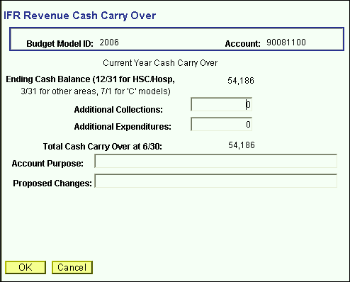

* Use this panel to project your cash balance at the end of this Current year.
* The Ending Cash Balance is as of 12/31 for SOM/HSC/Hospital users, and 3/31 for West Campus users.
* In the Additional Collections field, enter collections you expect for the remainder of the current year. The collection figure should be net of applicable overhead charges.
* In the Additional Expenditures field, enter the expenses you anticipate for the current year.
* The Total Cash Carry Over at 6/30 is the amount you anticipate carrying over from the Current year to the Proposed year. It is the sum of the Ending Cash Balance at 12/31 or 3/31 plus Additional Collections, less Additional Expenditures.
* In the example above, you anticipate carrying over $54,186 to the Proposed year.
* Once you have completed the IFR Revenue Cash Carry Over secondary panel, click **OK** to go back to the IFR Revenue panel.
* You are now done budgeting your revenue. From the Revenue panel previously displayed, you are projecting $30,000 in revenue for the Proposed year, and you are

anticipating to carry over $54,186 from the Current year. The total revenue you can budget against is $84,186.

**IFR Payroll Summary Panel**

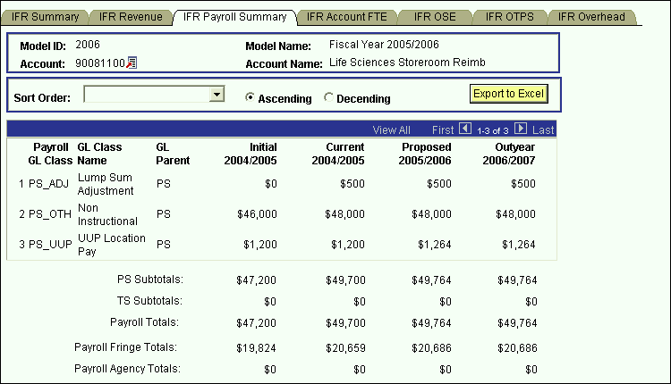

* This panel is a display only sub-total of the employee records by GL class. To modify the numbers on this panel, you will need to modify the employee records associated with this account. (Unit 6 provides instructions on viewing employees by account.)
* Since you are in the Proposed model, you are viewing all of the payroll GL class sub-totals in that model. You are also viewing the *corresponding* budget numbers for the associated models.
* This means that you will only see budget values for the three associated models if there is budgeted information for that expense in the Proposed model.
* To view all of the budgeted GL classes in an associated model, you must select that model in the Search dialog box.
* The first two columns in the grid contain the GL classes and their descriptions.
* The third column contains the GL Parent field. This column indicates whether the GL class is under the PS (personal services regular) node or the TS (personal services
* temporary) node. There are also PS and TS sub-totals by model under the grid.
* The Payroll Fringe Totals are only calculated for applicable funds (i.e., IFRs, SR, IDC, SBF, and CPMP).
* The Payroll Agency Totals are only calculated for CPMP and SBF staff.

**IFR OSE (in Aggregate) Panel**

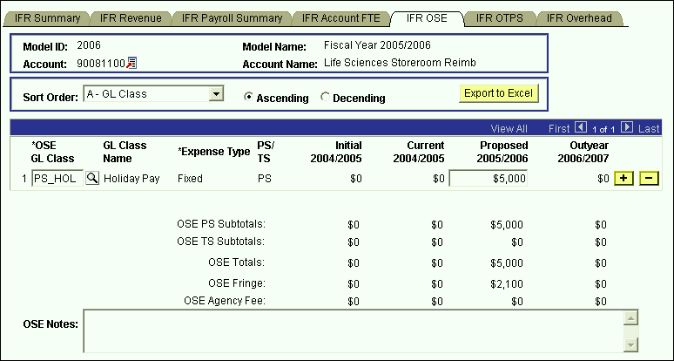

* This is the panel you will use to budget other salary expenses (OSE) in aggregate by account. The OSE in aggregate expenditures are salary expenses that you want to budget in a lump sum for the account, rather than by employee. For example, you may not know which employee will be working holidays, but you do know that you need to budget for that expense. So, rather than budgeting it for each employee, you can budget it here in total for the account.
* Student assistant expenditures should be budgeted in aggregate on this panel. Their employee records were not loaded on the system.
* The white fields are directly modifiable.
* Since you are in the Proposed model, only the Proposed column is modifiable. If you would like to enter data in another model, you have to first change the model you are in.
* **To change the model:**
* Click on the link next to Account.
* You will be directed to the next panel where you may choose the desired Model to transfer to.



* **To budget for a OSE GL class that is not on the grid:**
* Click on the plus sign to the right of an existing row.
* On the new row, click the magnifying glass in the OSE GL Class column. Click the Lookup button in the next panel. You will then see the list of valid values shown below.

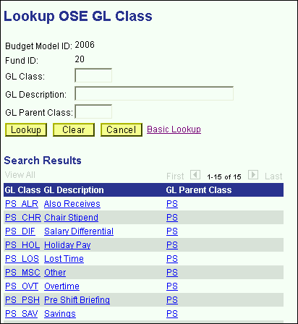

* The list of values contains a column for GL Parent Class. This determines whether a category is personal services regular (PS) or personal services temporary (TS). Since GL Parent Class is also a search key, you can use **Search** for OSE GL classes in specific GL Parent Classes.
* Please note that the set of GL classes you can use depends on the fund or fund type that your account belongs to.
* The list above is valid for OSE in aggregate expenditures in all appropriated funds (including IFRs).
* Select the OSE GL class that you would like to budget.
* Once you tab off of the GL class field on the grid, you will see the description of the GL class will be displayed.
* Tab to the write-able white field and enter the amount that you would like to budget for the selected GL class. When you tab off of the field, you will notice the sub-totals at the bottom of the panel are updated.
* As with the Account Payroll panel, there is a sub-total for PS, TS, fringe and agency fee.
* A note field has been provided so that you can enter clarifying notes.
* The list of valid GL class values for this panel is the same as the list for the AF Account OSE panel in the AF Account Distribution panel group.

#### 

#### IFR OTPS Panel

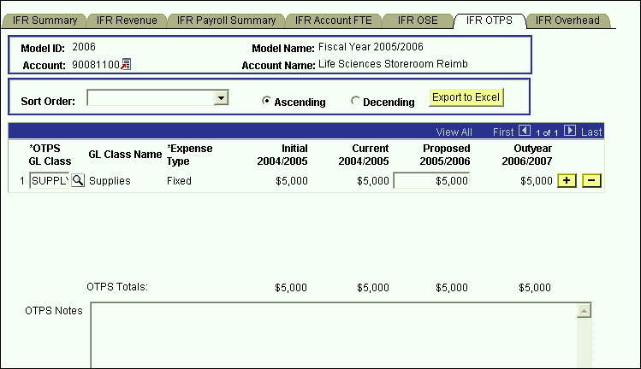

* This is the panel you will use to budget Other Than Personal Services (OTPS) expenditures.
* The white fields are directly modifiable.
* Since you are in the Proposed model, only the Proposed column is modifiable. If you would like to enter data in another model, you have to first change the model you are in.
* **To change the model:**
* Click on the link next to Account.
* You will be directed to the next panel where you may choose the desired Model to transfer to.



* **To budget for a OTPS GL class that is not on the grid:**
* Click on the plus sign to the right of an existing row.
* On the new row, click the magnifying glass in the OTPS GL Class column. Click the Lookup button in the next panel. You will then see the list of valid values shown below.

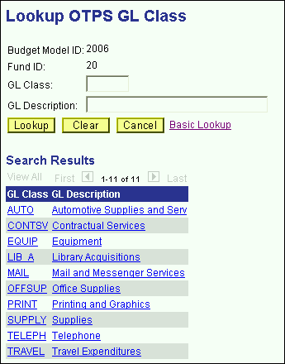

* This list is valid for OTPS GL classes in all appropriated funds (including IFRs)
* Select the OTPS GL class that you would like to budget and click **OK**.
* Once you tab off of the GL class field on the grid, you will see the description of the GL class will be displayed.
* Tab to the write-able white field and enter the amount that you would like to budget for the selected GL class. When you tab off of the field, you will notice the sub-totals at the bottom of the panel are updated.
* A note field has been provided so that you can enter clarifying notes.

**IFR Overhead Panel**

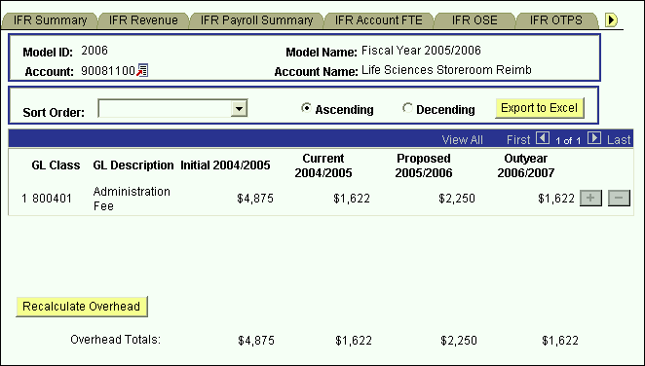

This panel contains a display-only grid, which automatically calculates the Overhead on the account based on the rate that the account is assessed.

* The overhead calculation is performed on Revenue Sub-Total on the IFR Revenue panel, not on the Current Year Carry Over figure.

Please note that in order to save the IFR Account Distribution panel group, the account balance on the summary page must be zero or greater for the majority of accounts. If you attempt to save the panel with a deficit, you will get the following error message:

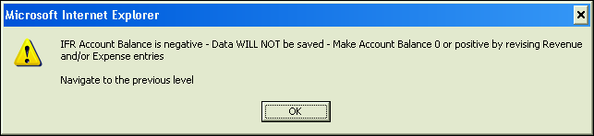

# EXT Account Distribution Panel Group

* This panel group is only used to budget revenue. It is used to budget the revenue used to offset the salary supplements from external sources that are budgeted on employee records in the Employee Information panel group.
* There are three types of External funds:

## Fund 93 – Northport VA

Fund 95 – Brookhaven National Labs

Fund 97 – Other

* Since the budget for the External accounts are not driven by allocation, it is not necessary to access these accounts through the Organizational Rollup panel.
* From the **Use** menu, select EXT Account Distribution. You will then see the following search dialog box.

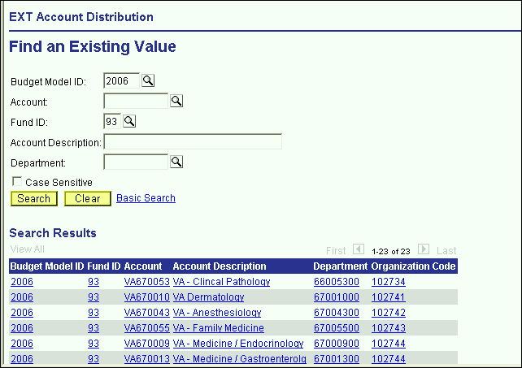

* Enter the desired fund in the Fund ID field. Then enter your department ID and click the **Search** button
* From the list of accounts, select the account that you wish to budget.

**EXT Account Summary Panel**

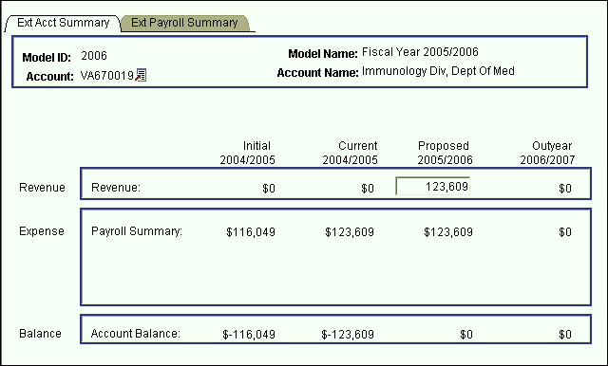

* You are now in the EXT Account Distribution panel group.
* OTPS and account OSE cannot be budgeted on these accounts. There are only two panels in this panel group.
* EXT Account Summary panel
* EXT Payroll Summary panel
* You can click on the panel name to activate the panel or you can navigate using the **Next Tab** button or the **Previous Tab** button.
* You will see the model ID and the account number that you selected at the top of each of the panels in this group.
* You will notice that although you are in one model, you will see the corresponding budget information for the related models.
* The EXT Account Summary panel is a display only summary of the GL classes that have been budgeted on the account.

The GL classes are separated into three sections, Revenue, Expenses (Payroll Summary) and the Balance.

These sections are sub-totaled for all four associated models.

**Initial** – The numbers in this column are your final figures from last year’s Proposed model.

**Current** – Use the information in this column to project your budgetary needs for the current fiscal year. This model was pre-loaded with a current payroll snapshot and the OTPS data from last year’s Proposed model.

**Proposed** – Use the information in this column to project your budgetary needs for the upcoming fiscal year. The final version of this model will be used to load various financial systems.

**Outyear** – This column contains your anticipated budget for the budget period two years from now. Please note that the data in the Outyear model will *not* be carried forward to next year’s associated models.

During next year’s budget cycle, the information that you budget for this year’s Proposed will become next year’s Initial.

In the Revenue edit box enter a revenue figure equal to the payroll expenditures on the account.

**EXT Payroll Summary Panel**

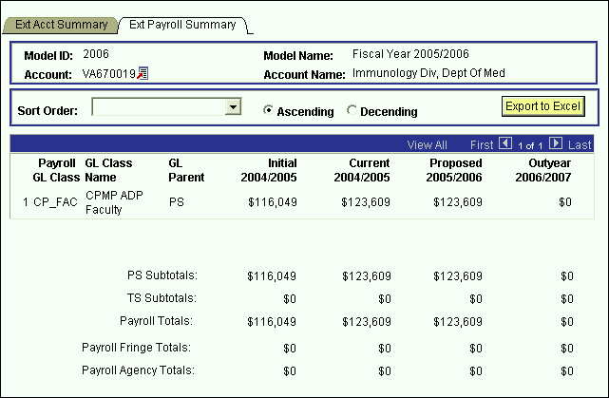

* This panel is a display only sub-total of the employee records by GL class. To modify the numbers on this panel, you will need to modify the employee records associated with this account. (Unit 5 provides instructions on viewing employees by account.)
* Since you are in the Proposed model, you are viewing all of the payroll GL class sub-totals in that model. You are also viewing the *corresponding* budget numbers for the associated models.
* This means that you will only see budget values for the three associated models if there is budgeted information for that expense in the Proposed model.
* To view all of the budgeted GL classes in an associated model, you must select that model in the Search dialog box.
* The first two columns in the grid contain the GL classes and their descriptions.
* The third column contains the GL Parent field. This column indicates whether the GL class is under the PS (personal services regular) node or the TS (personal services temporary) node. There are also PS and TS sub-totals by model under the grid.
* The Payroll Fringe Totals are only calculated for applicable funds (i.e., IFRs, SR, IDC, SBF, and CPMP).
* The Payroll Agency Totals are only calculated for CPMP and SBF staff.

# SR Account Distribution Panel Group

* In the Sponsored Research Account Distribution panel group, the revenue and expenditures are grouped by parent accounts rather than grants. That is, instead of seeing your individual grant numbers, they are rolled up into their parent account number. The parent account will have a SR prefix followed by the six digit parent account number.
* Since the budgets for the Sponsored Research accounts are not driven by allocation, it is not necessary to access these accounts through the Organizational Rollup panel.
* From the **Use** menu, select SR Account Distribution. You will then see the following search dialog box.

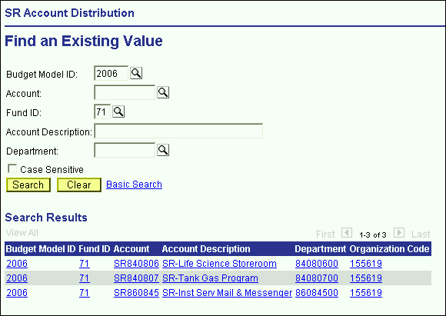

* The SR Account Distribution panel group is valid for fund 71 (Sponsored Research), fund 78 (Service & Facilities), and fund 80 (Service Agreements). You will need to specify one of theses fund codes. Then, enter your department ID and click the **Search** button.
* From the list of accounts, select the account that you wish to budget.

#### SR Account Summary Panel

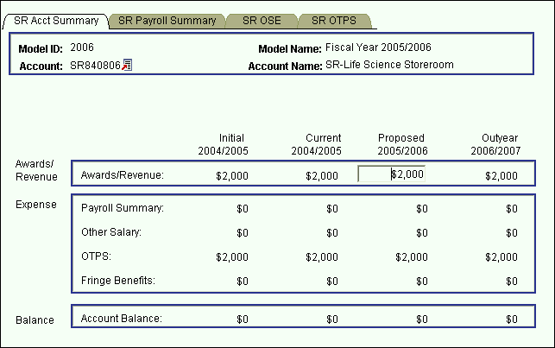

* You are now in the SR Account Distribution panel group.
* On this account you will budget for all the Sponsored Research grants that rollup to parent account 840806. The payroll for all the grants under 840806 will rollup to this account.
* There are four panels in this panel group. The panel tabs are displayed under the command buttons.
* SR Account Summary panel
* SR Account Payroll panel
* SR Account OSE (in Aggregate) panel
* SR Account OTPS panel
* You can click on the panel name to activate the panel or you can navigate using the **Next Tab** button or the **Previous Tab** button.
* You will see the model ID and the account number that you selected at the top of each of the panels in this group.
* You will notice that although you are in one model, you will see the corresponding budget information for the related models.
* The SR Account Summary panel is a display only summary of the GL classes that have been budgeted on the account.

The GL classes are separated into three sections, Awards/Revenue, Expenses (Payroll Summary, Other Salary, OTPS and Fringe Benefits) and the Balance.

These sections are sub-totaled for all four associated models.

**Initial** – The numbers in this column are your final figures from last year’s Proposed model.

**Current** – Use the information in this column to project your budgetary needs for the current fiscal year. This model was pre-loaded with a current payroll snapshot and the OTPS data from last year’s Proposed model.

**Proposed** – Use the information in this column to project your budgetary needs for the upcoming fiscal year. The final version of this model will be used to load various financial systems.

**Outyear** – This column contains your anticipated budget for the budget period two years from now. Please note that the data in the Outyear model will *not* be carried forward to next year’s associated models.

During next year’s budget cycle, the information that you budget for this year’s Proposed will become next year’s Initial.

In the Awards/Revenue edit box enter the net direct revenue for the account. The expenditure figures are sub-totals from the remaining panels.

**SR Payroll Summary Panel**

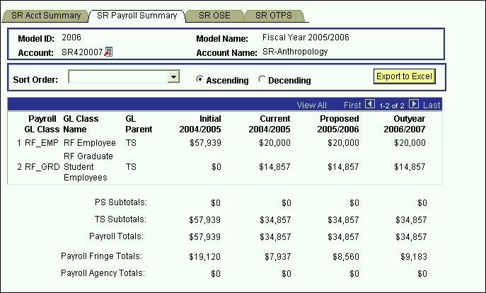

* This panel is a display only sub-total of the employee records by GL class. To modify the numbers on this panel, you will need to modify the employee records associated with this account. (Unit 5 provides instructions on viewing employees by account.)
* Since you are in the Proposed model, you are viewing all of the payroll GL class sub-totals in that model. You are also viewing the *corresponding* budget numbers for the associated models.
* This means that you will only see budget values for the three associated models if there is budgeted information for that expense in the Proposed model.
* To view all of the budgeted GL classes in an associated model, you must select that model in the Search dialog box.
* The first two columns in the grid contain the GL classes and their descriptions.
* The third column contains the GL Parent field. This column indicates whether the GL class is under the PS (personal services regular) node or the TS (personal services temporary) node. There are also PS and TS sub-totals by model under the grid.
* The Payroll Fringe Totals are only calculated for applicable funds (i.e., IFRs, SR, IDC, SBF, and CPMP).
* The Payroll Agency Totals are only calculated for CPMP and SBF staff.

#### SR OSE (in Aggregate) Panel

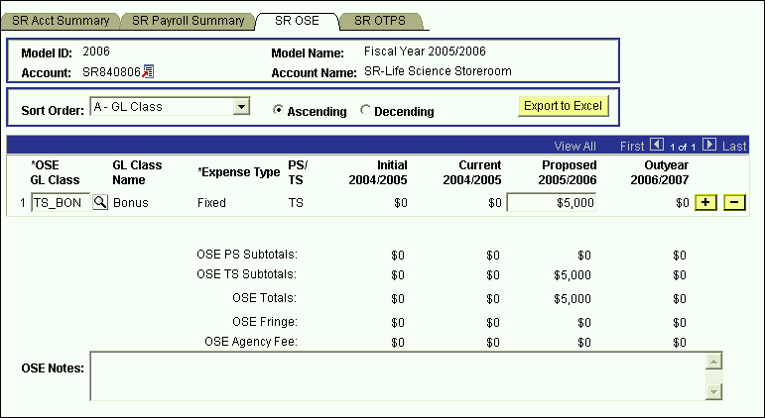

* This is the panel you will use to budget other salary expenses (OSE) in aggregate by account. The OSE in aggregate expenditures are salary expenses that you want to budget in a lump sum for the account, rather than by employee. For example, you may not know which employee will be getting a bonus, but you do know that you need to budget for that expense. So, rather than budgeting it for each employee, you can budget it here in total for the account.
* Student assistant expenditures should be budgeted in aggregate on this panel. Their employee records were not loaded on the system.
* The white fields are directly modifiable.
* Since you are in the Proposed model, only the Proposed column is modifiable. If you would like to enter data in another model, you have to first change the model you are in.
* **To change the model:**
* Click on the link next to Account.
* You will be directed to the next panel where you may choose the desired Model to transfer to.



* **To budget for a OSE GL class that is not on the grid:**
* Click on the plus sign to the right of an existing row.
* On the new row, click the magnifying glass in the OSE GL Class column. Click the Lookup button in the next panel. You will then see the list of valid values shown below.

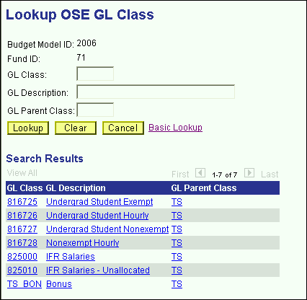

* The list of values contains a column for GL Parent Class. Since GL Parent Class is also a search key, you can use **Search** for OSE GL classes in specific GL Parent Classes.
* Select the OSE GL class that you would like to budget.
* Once you tab off of the GL class field on the grid, you will see the description of the GL class will be displayed.
* Tab to the write-able white field and enter the amount that you would like to budget for the selected GL class. When you tab off of the field, you will notice the sub-totals at the bottom of the panel are updated.
* As with the Account Payroll panel, there is a sub-total for PS, TS, fringe and agency fee.
* A note field has been provided so that you can enter clarifying notes.
* The list of valid GL class values for Sponsored Research is the same as the ones for Service & Facility and Service Agreements accounts.

**SR OTPS Panel**

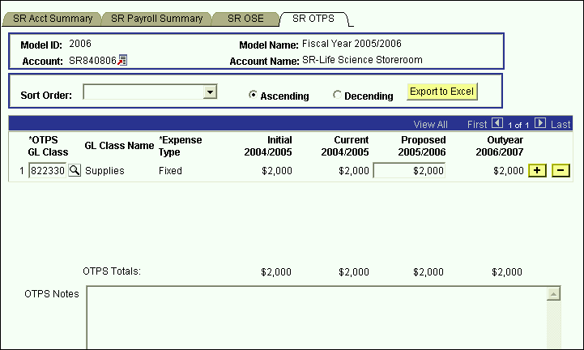

* This is the panel you will use to budget Other Than Personal Services (OTPS) expenditures.
* The white fields are directly modifiable.
* Since you are in the Proposed model, only the Proposed column is modifiable. If you would like to enter data in another model, you have to first change the model you are in.
* **To change the model:**
* Click on the link next to Account.
* You will be directed to the next panel where you may choose the desired Model to transfer to.



* **To budget for a OTPS GL class that is not on the grid:**
* Click on the plus sign to the right of an existing row.
* On the new row, click the magnifying glass in the OTPS GL Class column. Click the Lookup button in the next panel. You will then see the list of valid values shown below.

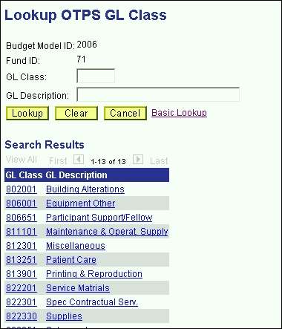

* Select the OTPS GL class that you would like to budget.
* Once you tab off of the GL class field on the grid, you will see the description of the GL class will be displayed.
* Tab to the write-able white field and enter the amount that you would like to budget for the selected GL class. When you tab off of the field, you will notice the sub-totals at the bottom of the panel are updated.
* A note field has been provided so that you can enter clarifying notes.
* The list of valid GL class values for Sponsored Research is the same as the ones for Service & Facility and Service Agreements accounts.

# SBF Account Distribution Panel Group

* SBF accounts are accounts in the following funds:

## Fund 63 – Restricted

Fund 64 – Unrestricted

Fund 65 – Agency

Fund 69 – Grant

* Since targets are not set for SBF accounts by VP area, you need not start in the Organizational Rollup panel. From the **Use** menu, select SBF Account Distribution. You will then see the following search dialog box
* Enter the SBF fund that you wish to select an account from and enter your department ID. Then click the **Search** button.

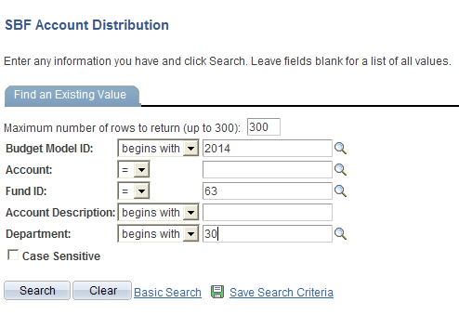

* You will then see a list of all of the accounts that match your search criteria.
* In the screen print below, the system displays all of the Restricted SBF accounts within Advancement.

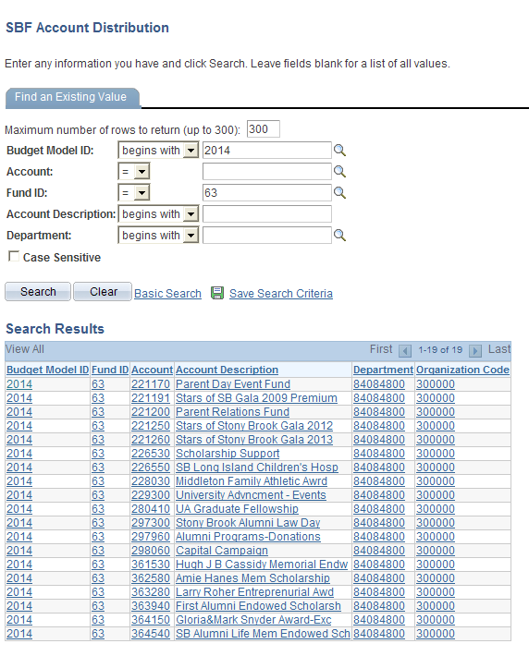

* From the list of accounts, select the account that you wish to budget.

**SBF Summary Panel**

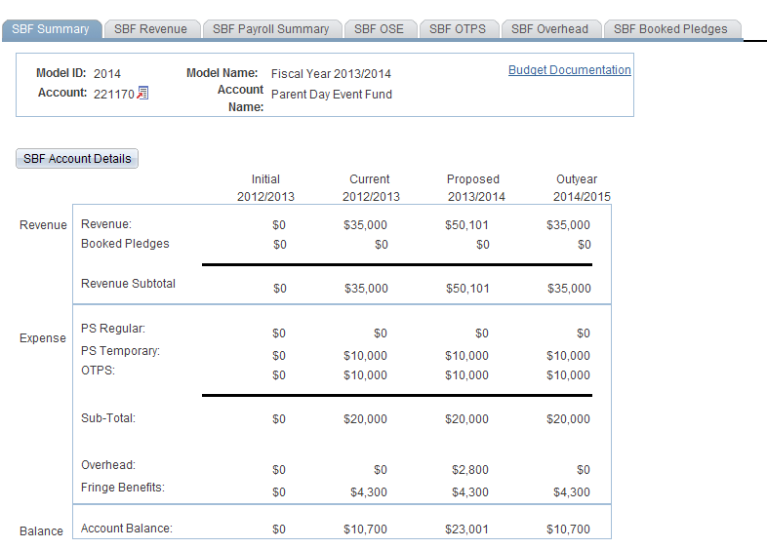

* You are now in the SBF Account Distribution panel group.
* There are seven panels in this panel group. The panel tabs are displayed under the command buttons.
* SBF Summary panel
* SBF Revenue panel
* SBF Payroll Summary panel
* SBF OSE (in Aggregate) panel
* SBF OTPS panel
* SBF Overhead panel
* SBF Booked Pledges panel
* You can click on the panel name to activate the panel or you can navigate using the **Next Tab** button or the **Previous Tab** button.
* You will see the model ID and the account number that you selected at the top of each of the panels in this group.
* You will notice that although you are in one model, you will see the corresponding budget information for the related models.

### The SBF Summary panel is a display only summary of the GL classes that have been budgeted on the account.

* You see a Revenue section and an Expense section.
* The Revenue section is a sub-total of the information in the SBF Revenue panel.
* The Expense section contains sub-totals for PS Regular, PS Temporary, OTPS as well as a Sub-total for all three.
* The Expense section also contains the Overhead total and the Fringe Benefit total.
* The Balance section is the difference between the Revenue section and the Expense section.
* This information is displayed for all four associated models.

**Initial** – The numbers in this column are your final figures from last year’s Proposed model.

**Current** – Use the information in this column to project your budgetary needs for the current fiscal year. This model was pre-loaded with a current payroll snapshot and the OTPS data from last year’s Proposed model.

**Proposed** – Use the information in this column to project your budgetary needs for the upcoming fiscal year. The final version of this model will be used to load various financial systems. For example, the Proposed data in appropriated funds (including IFRs) will be used to load the initial allocation from SUNY.

**Outyear** – This column contains your anticipated budget for the budget period two years from now. Please note that the data in the Outyear model will *not* be carried forward to next year’s associated models.

During next year’s budget cycle, the information that you budget for this year’s Proposed will become next year’s Initial.

#### SBF Account Details Panel

* When you click on the SBF Account Details button on the SBF Summary panel, you will see the panel below. This panel contains information about the fringe benefit rate and overhead rate assessed on the account.

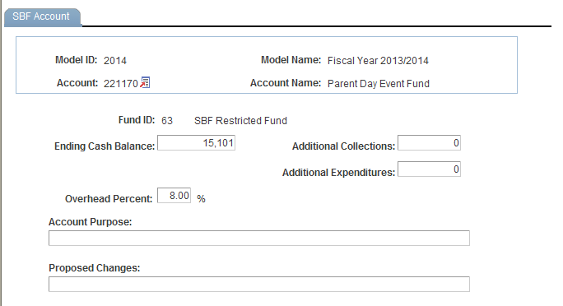

* To get back to the SBF Account Distribution panel group, click on the Back button or close the new window or tab.

### **SBF Revenue Panel**

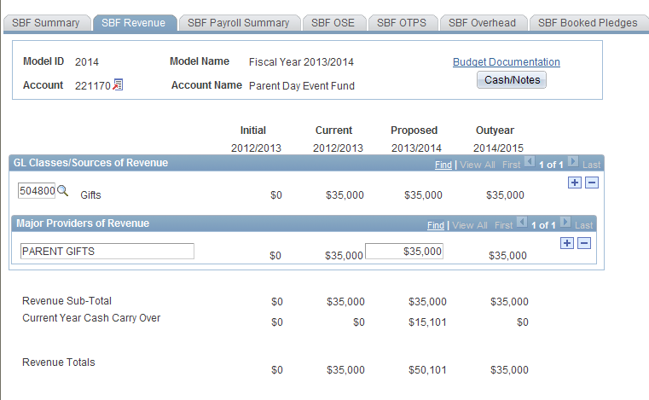

* This panel contains the revenue details that are sub-totaled on the SBF Summary panel.
* You must detail the Sources of Revenue and Major Providers of Revenue. There is a parent-child relationship between Sources of Revenue and Major Providers of Revenue. That is, for each Source of Revenue, you must list the corresponding Major Providers of Revenue.
* Use the outer scroll bar to scroll between Sources of Revenue. Use the inner scroll bar to scroll between the Major Providers of Revenue of a particular Source of Revenue.
* To insert a Source of Revenue,
* Click on the plus sign to the right of an existing row.
* On the new row, click the magnifying glass in the Source of Revenue GL Class column. Click the Lookup button in the next panel. You will then see the list of valid values shown below.

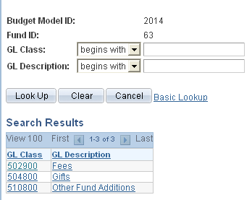

* Select the desired Source of Revenue. Once you tab off the field, you will see the description of the Source of Revenue you selected.
* The numeric field to the right of the Source of Revenue field is display only. It is a sub-total of Major Providers of Revenue entries.
* Click on the editable box under Major Providers of Revenue. Enter the description of the Major Provider of Revenue and tab to the right to enter the corresponding amount.
* To enter additional Sources of Revenue, click the Insert Row button while in the Sources of Revenue section.
* To enter additional Major Providers of Revenue, click the plus sign while in the Major Providers of Revenue section.
* Once you have entered the Sources of Revenue and Major Providers of Revenue that you are anticipating for the Proposed fiscal year, click on the Cash/Notes button located at the top right-hand corner of the SBF Revenue panel.
* You will then see the secondary panel displayed on the next page.

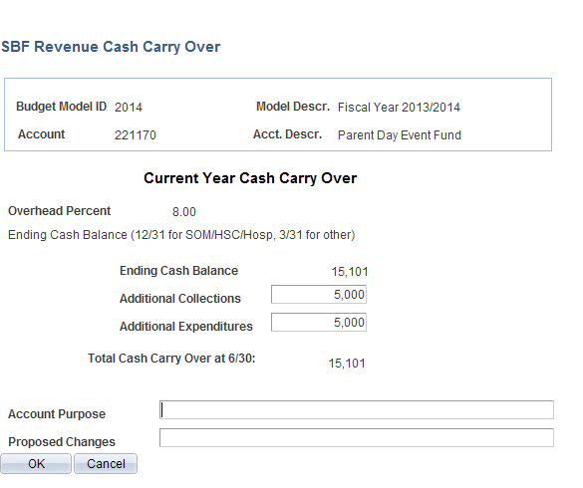

* Use this panel to project your cash balance at the end of this Current year.
* The Ending Cash Balance is as of 12/31 for SOM/HSC/Hospital users, and 3/31 for West Campus users.
* In the Additional Collections field, enter collections you expect for the remainder of the current year. The collection figure should be net of applicable overhead charges.
* In the Additional Expenditures field, enter the expenses you anticipate for the current year.
* The Total Cash Carry Over at 6/30 is the amount you anticipate carrying over from the Current year to the Proposed year. It is the sum of the Ending Cash Balance at 12/31 or 3/31 plus Additional Collections, less Additional Expenditures.
* In the example above, you anticipate carrying over $15,101 to the Proposed year.
* Once you have completed the SBF Revenue Cash Carry Over secondary panel, click **OK** to go back to the SBF Revenue panel.
* You are now done budgeting your revenue. From the Revenue panel previously displayed, you are projecting $35,000 in revenue for the Proposed year, and you are anticipating to carry over $15,101 from the Current year. The total revenue you can budget against is $50,101.

**SBF Payroll Summary Panel**

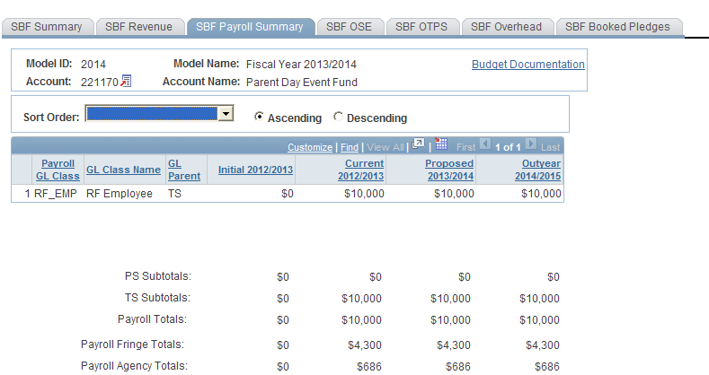

* This panel is a display only sub-total of the employee records by GL class. To modify the numbers on this panel, you will need to modify the employee records associated with this account. (Unit 7 provides instructions on viewing employees by account.)
* Since you are in the Proposed model, you are viewing all of the payroll GL class sub-totals in that model. You are also viewing the *corresponding* budget numbers for the associated models.
* This means that you will only see budget values for the three associated models if there is budgeted information for that expense in the Proposed model.
* To view all of the budgeted GL classes in an associated model, you must select that model in the Search dialog box.
* The first two columns in the grid contain the GL classes and their descriptions.
* The third column contains the GL Parent field. This column indicates whether the GL class is under the PS (personal services regular) node or the TS (personal services

temporary) node. There are also PS and TS sub-totals by model under the grid.

* The Payroll Fringe Totals are only calculated for applicable funds (i.e., IFRs, SR, IDC, SBF, and CPMP).
* The Payroll Agency Totals are only calculated for CPMP and SBF staff.

**SBF OSE (in Aggregate) Panel**

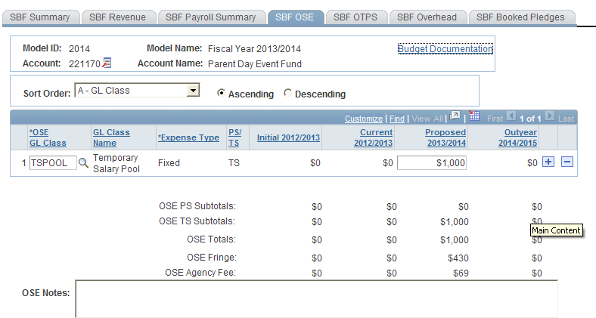

* This is the panel you will use to budget other salary expenses (OSE) in aggregate by account. The OSE in aggregate expenditures are salary expenses that you want to budget in a lump sum for the account, rather than by employee. For example, you may not know which employee will be working holidays, but you do know that you need to budget for that expense. So, rather than budgeting it for each employee, you can budget it here in total for the account.
* Student assistant expenditures should be budgeted in aggregate on this panel. Their employee records were not loaded on the system.
* The white fields are directly modifiable.
* Since you are in the Proposed model, only the Proposed column is modifiable. If you would like to enter data in another model, you have to first change the model you are in.
* **To change the model:**
* Click on the link next to Account.
* You will be directed to the next panel where you may choose the desired Model to transfer to.



* **To budget for a OSE GL class that is not on the grid:**
* Click on the plus sign to the right of an existing row.
* On the new row, click the magnifying glass in the OSE GL Class column. Click the Lookup button in the next panel. You will then see the list of valid values shown below.

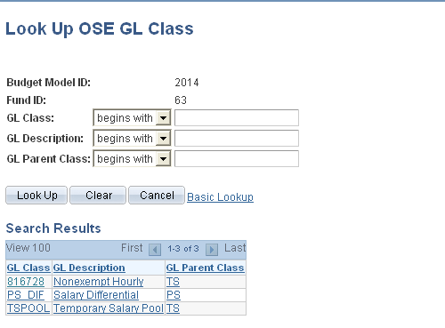

* The list of values contains a column for GL Parent Class. This determines whether a category is personal services regular (PS) or personal services temporary (TS). Since GL Parent Class is also a search key, you can use **Search** for OSE GL classes in specific GL Parent Classes.
* Please note that the set of GL classes you can use depends on the fund or fund type that your account belongs to.
* The list above is valid for OSE in aggregate expenditures in SBF funds.
* Select the OSE GL class that you would like to budget.
* Once you tab off of the GL class field on the grid, you will see the description of the GL class will be displayed.
* Tab to the write-able white field and enter the amount that you would like to budget for the selected GL class. When you tab off of the field, you will notice the sub-totals at the bottom of the panel are updated.
* As with the Account Payroll panel, there is a sub-total for PS, TS, fringe and agency fee.
* A note field has been provided so that you can enter clarifying notes.

#### 

#### SBF OTPS Panel

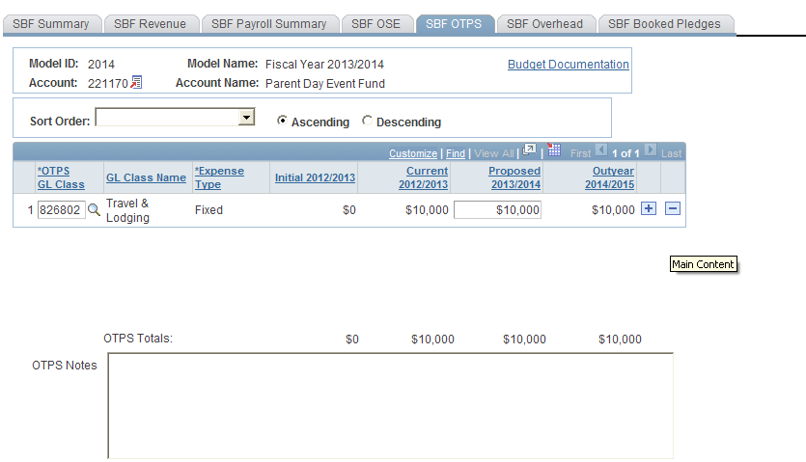

* This is the panel you will use to budget Other Than Personal Services (OTPS) expenditures.
* The white fields are directly modifiable.
* Since you are in the Proposed model, only the Proposed column is modifiable. If you would like to enter data in another model, you have to first change the model you are in.
* **To change the model:**
* Click on the link next to Account.
* You will be directed to the next panel where you may choose the desired Model to transfer to.



* **To budget for a OTPS GL class that is not on the grid:**
* Click on the plus sign to the right of an existing row.
* On the new row, click the magnifying glass in the OTPS GL Class column. Click the Lookup button in the next panel. You will then see the list of valid values shown below.

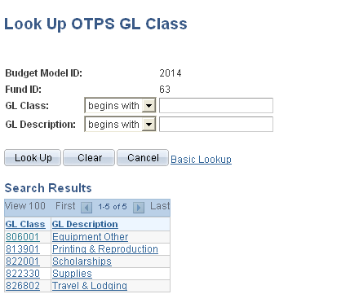

* This list is valid for OTPS GL classes in SBF funds.
* Select the OTPS GL class that you would like to budget and click **OK**.
* Once you tab off of the GL class field on the grid, you will see the description of the GL class will be displayed.
* Tab to the write-able white field and enter the amount that you would like to budget for the selected GL class. When you tab off of the field, you will notice the sub-totals at the bottom of the panel are updated.
* A note field has been provided so that you can enter clarifying notes.

**SBF Overhead Panel**

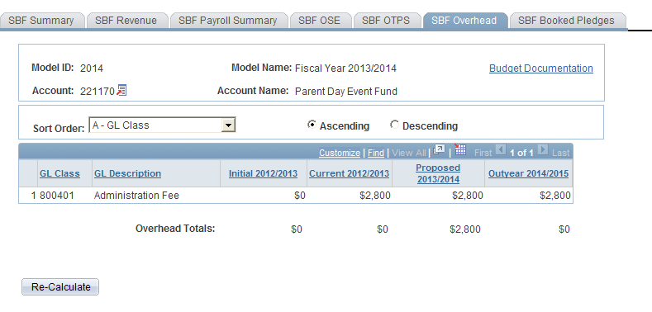

This panel contains a display-only grid, which automatically calculates the Overhead on the account based on the rate that the account is assessed.

* The overhead calculation is performed on Revenue Sub-Total on the SBF Revenue panel, not on the Current Year Carry Over figure.

Please note that in order to save the SBF Account Distribution panel group, the account balance on the summary page must be zero or greater for the majority of accounts. If you attempt to save the panel with a deficit, you will get the following error message:

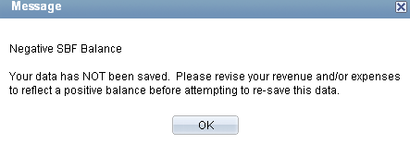

**SBF Booked Pledges Panel**

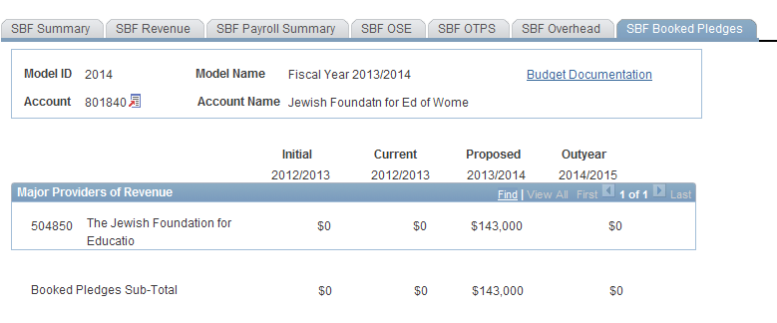

* This panel is a display only list of the Booked Pledges supplied by the Stony Brook Foundation Office. It is for reference only and cannot be modified in CBM.
* On the SBF Summary panel, you will see the Booked Pledges Sub-Total in the Revenue section.
* 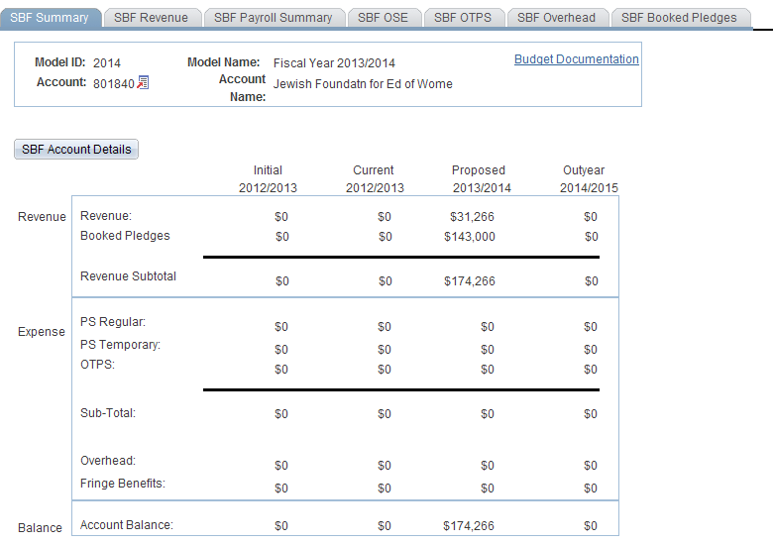6.0 Targets by Account
* The Target by Account panel is used to set targets on the account level for Appropriated funds (fund codes 10 through 70) and IDC fund code 73.
* This feature does not replace the functionality of setting targets by org level and does not change what is displayed in the organizational overview. If an account has a target, the Target by Account amount will be displayed on the Account Distribution panel for AF, IDC, and IFR accounts, not on the Organizational Rollup Panel.
* A total target amount for each account within an organizational level can be set by users with VP level access.
* Users below the VP level can view but not update their account targets.

# Setting Targets By Account

* To access the Target by Account panel, select **Target by Account** from the **Setup** menu.You will see the search dialog box below.

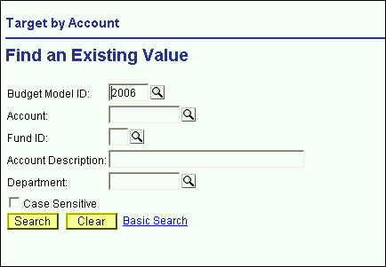

* In the Search dialog box, the Proposed model is defaulted. In order to display accounts that you have access to, type the desired fund code and click the **Search** button. Valid

fund codes for the Target by Account panel are 10 through 70 and 73.

* If you type an invalid fund for Target by Account, you will get the following error message:

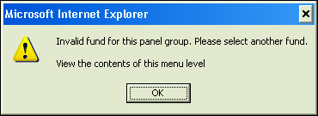

* To make the search more specific, type an organizational area into the Department field in the Search dialog box and click the **Search** button.
* You will see all of the accounts in the selected organizational area for the selected fund as displayed below.

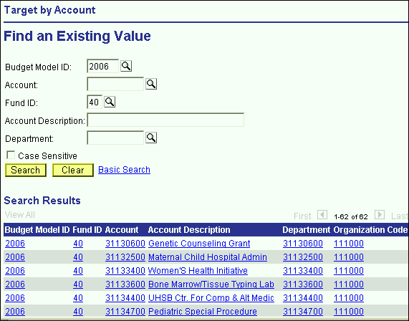

* Select an account from the list in the Search dialog box.
* The Target by Account panel will be displayed.

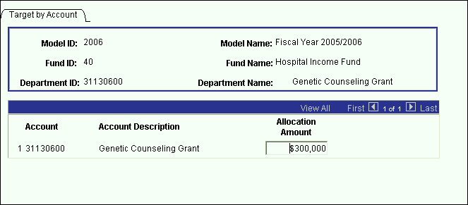

* If your security is below the VP level, the Allocation Amount field will be grayed out. Only users with VP level access may enter the targets for their accounts.
* To input an amount in the Allocation Amount field, tab into the field and enter the desired amount. Then click the **Save** command button.
* Whether you are viewing or updating, click the **Next in List** or the **List** command button to select another account.
* If an account has a Target, it will be displayed on the summary panels of the following panel groups as shown in the next panel:
* AF Account
* IFR Account
* IDC Account

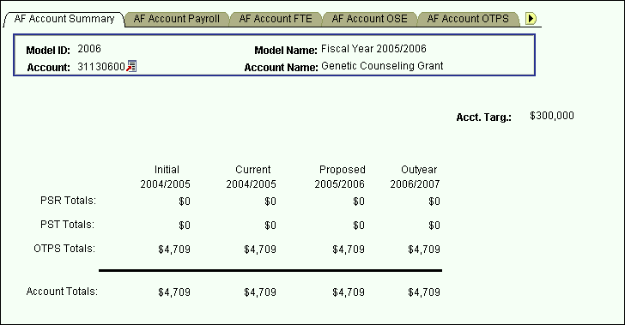

7.0 Viewing Employees by Account

# The Search Dialog Box

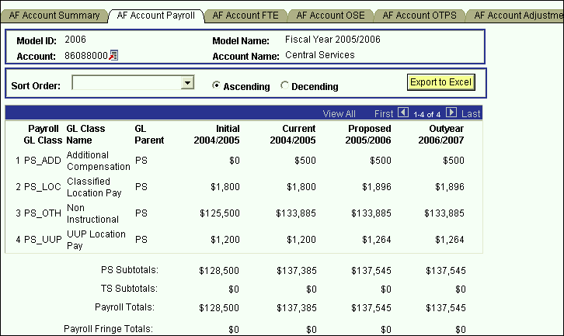

There are two methods to view the employees that are charged to an account.

First Method:

The first method is shown above. From the Account Payroll panel, click on the link next to Account. Choose Account Salary Detail from the page that is displayed. This will bring you to the Account Salary Detail panel.

Second Method:

The second method is to click on **Inquire** and select Account Salary Detail.

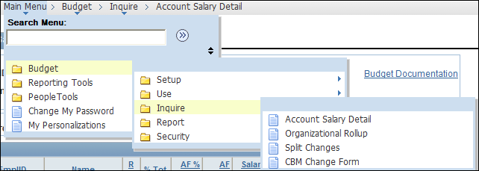

You will then see the search dialog box shown below.

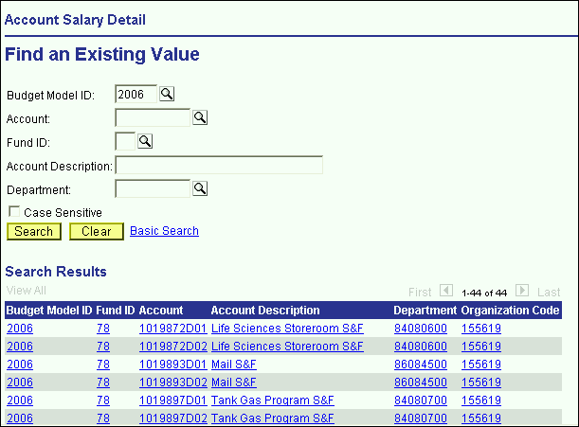

Enter your Department ID and click the **Search** button. The system will list all of the accounts within your organizational level.

Select the desired account.

# Account Salary Detail Panel

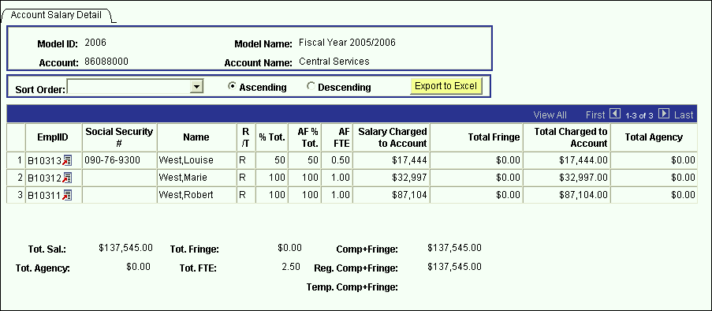

* The Account Salary Details panel is a grid containing all of the distributions charged to the account you’ve selected. That is, the grid contains the pieces of each employee’s salary that is charged to the selected account.
* The grid contains the following columns:

**EmplID** – This key field is used to identify all of the employee records. For employees pre-loaded into the system from the HR modules, the employee ID is the same as the HR employee ID. For employee records from other systems or for employees that were manually created on the system, the employee ID is automatically generated by CBM.

**Social Security #** - Social Security numbers are provided for employees that were pre-loaded into the system.

**Name** – The name field must be in the PeopleSoft default format: *Lastname,Firstname*

**R/T** – This is the regular/temporary indicator. For employees on appropriated funds, everyone is “regular” except for those whose compensation frequency is bi-weekly or hourly. Employees on RF are “temporary.”

**% Total** – The value in this column represents the percent of the employee’s total salary that is charged to the account.

**AF % Total** – The value in this column represents the percent of the employee’s total appropriated funds salary that is charged to the account. The value in the % Total column will only differ from the AF % Total column if the employee is split between appropriated funds and non-appropriated funds.

**AF FTE** – This column is the appropriated funds FTE. This value is also only displayed if the employee is “regular.”

**Salary Charged to Account** – This column is the amount of an employee’s salary that is charged to the selected account.

**Total Fringe** – This column is the fringe on the salary charged to the account.

**Agency Costs** – This is the 4.8% of salaries and fringe that is charged to RF CPMP payroll. This is automatically calculated based on the fund of the account and the GL class of each distribution.

* The numeric fields are totaled under the grid.
* The values on the Account Salary Detail grid are not modifiable.
* To make changes to an individual employee record, click on the link next to the Emplid of the employee you wish to select.

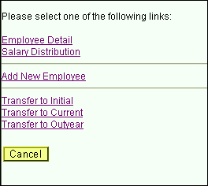

* You will then see the list of links shown in the screen print above.
* Select Employee Detail or Salary Distribution to open the Employee Information panel group.

8.0 Budgeting By Employee

* There are two ways to access existing employee data in the Employee Information panel group.

First Method:

* If you are already in the Account Salary Detail panel, click on the link next to the Emplid of the employee you would like to view/modify. Then, select Employee Detail from the list of links on the previous page. [See the screen print on the previous page.]

When you select Employee Detail from the list of links, the system will bring up the Employee Information panel group for the employee you selected on the grid.

Second Method:

Alternately, you can select the Employee Information panel group from the **Use** menu.

If you access the Employee Information from the **Use** menu, you will have the extra step of having to select an employee from the Employee Information search dialog box.

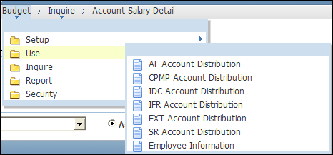

Click on Employee Information which will display the Employee Information search dialog box. Click on Add a New Value to add a new employee or enter the Employee Emplid or Name to view/modify a pre-loaded employee.

# The Search Dialog Box

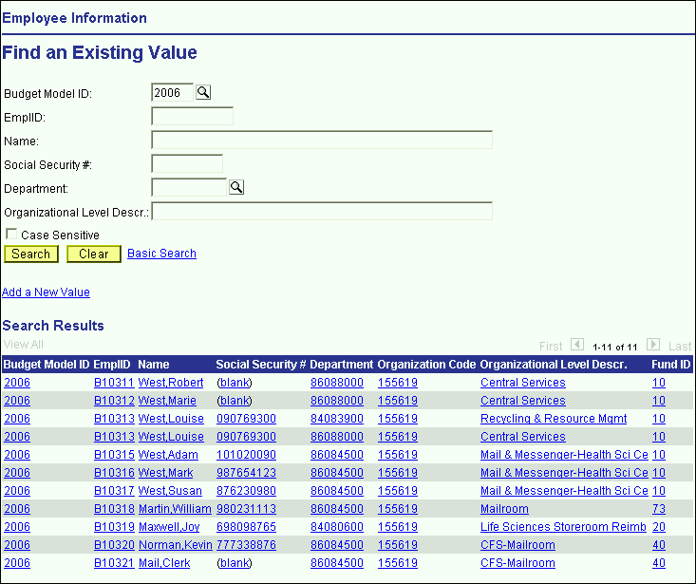

* If you enter the Model ID and the Department ID and click the **Search** button, the system will list all of the employees within the organizational area you selected.
* You can search using any of the search keys in this dialog box. For example, if you enter “West” in the Name field, the system will list all of the employees within your organizational level whose name starts with “West”.
* In the example above, the system listed all of the employees who have a salary distribution in Central Services.
* Please note that if an employee is split, each of their distributions will roll up under its respective organizational area. In the example above, Louise West is listed twice. This is because she is split and two of her distributions are rolling up to 155619.
* To view employee records that are split outside your area and that have been modified, see the Employee Split section at the end of this unit.

# Employee Information Panel Group

* There are four panels in the Employee information panel group:
* Employee Details – This panel contains demographics information for the employee.
* Salary Distribution – This panel contains the base salary amounts and the accounts to which the base salaries are charged.
* OSE – This panel contains non-base other salary amounts (OSE) and the accounts to which they are charged.
* All Salary by Account – This panel contains a summary grid of all of the pieces of an employee’s compensation.

#### Employee Details Panel

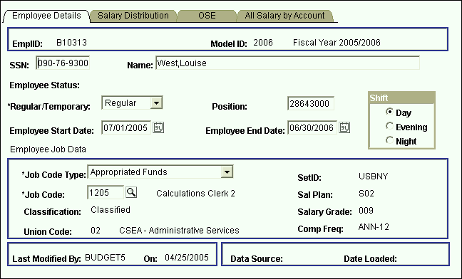

The Employee Details panel contains the following fields:

###### EmplID

* This key field is used to identify all of the employee records.
* For employees pre-loaded into the system from the HR modules, the employee ID is the same as the HR employee ID.
* For employee records from other systems or for employees that were manually created on the system, the employee ID is automatically generated by CBM.
* Employee IDs that have been generated by the CBM will start with the letter B.

###### SSN

* Social Security numbers are provided for employees that were pre-loaded into the system.
* If you are adding a new employee to CBM, leave the Social Security number field empty unless you know it. If not blank, the system performs an edit check for uniqueness. Therefore, you cannot enter dummy placeholders for this field.
* This field is display only for employee records that were pre-loaded into the system.

###### Name

* The name field must be in the PeopleSoft default format: Lastname,Firstname.
* This field is display only for employee records that were pre-loaded into the system.
* When you add an employee to the system, you need not format the name field in proper case. When you tab off of the field the system will automatically change the case of the name field to proper case, this is, initial capitalization. This feature is for this field only. The other character fields in the system are case sensitive.

###### Employee Status

* This display only field is the employee’s status at the time of the data load.
* If the employee status is “Leave” or “Leave With Pay” the system will also display the reason for the leave.

###### Regular/Temporary

* This field indicates whether or not an employee is “Regular” or “Temporary.”
* Employees that meet the following criterion should be coded as “Regular”
* Employees in appropriated funds (including IFRs) whose pay basis is *not* biweekly, hourly or fee.
* Employees that meet the following criterion should be coded as “Temporary”
* Employees in appropriated funds (including IFRs) whose pay basis is biweekly, hourly or fee.
* All Research Foundation employees should be coded as temporary, unless the employee is a GFT faculty member split with appropriated funds.
* It is important to select the correct Regular/Temporary indicator because it will determine the GL classes that are available to you on the Salary Distribution panel.

###### Position

* This field is for employees who have at least one distribution charged to an appropriated fund account.
* Position is an eight-character field, which is the five-digit SUNY line number followed by three zeros.
* This field is updateable for all employee records, including those that were pre-loaded into the system.
* You may leave this field empty for TBA (to be announced) employees that you have added to the system.
* Please note that currently if you only enter the five-digit line number and tab off of the field, three zeros will be added to the beginning of the number instead of at the end. In order to avoid this, you will need to manually add the three zeros at the end of the line number before tabbing off of the field.

**Employee Start Date** & **Employee End Date**

* These date fields do not represent the actual start and end date for the employee. It is the start and end date of the employee during the selected fiscal year.
* For each model, the default is 7/1 and 6/30 of that model’s fiscal year.
* If the employee will be on the payroll for the entire fiscal year, you should leave the default values. Otherwise, if the employee will be terminating mid-year, you should change the Employee End Date field to reflect the end date of the employee. Alternately, if a new employee is starting mid-year, you should change the Employee Start Date field to reflect the start date of the employee.
* These two fields are informational purposes only. They do not at this time alter the salary figures.

###### Shift Code

###### This field indicates whether the employee works Day, Evening, or Night shift.

###### The value of this field will default to Day if it is left blank.

###### For employees meeting certain criteria who are paid from appropriated fund accounts, Evening or Night selection will automatically generate Shift and Inconvenience Pay on the Employee OSE panel.

###### Job Code Type

* This field indicates whether the employee is on appropriated funds or on the Research Foundation. Once you have the selected the correct one, the system will use the information to determine which set of job codes will be available in the Job Code field.
* For employee who has all or part of his/her salary on an appropriated fund account, select the Appropriated Funds job code type. (If an employee is split between appropriated funds and non-appropriated funds, select the Appropriated Funds job code type.)
* For employees who have all of their salary on non-appropriated fund accounts, select the Research Foundation job code type.

###### Set ID

* This is a PeopleSoft required field that is automatically entered based on the Job Code Type of the employee.

###### Job Code

* The job code field is a listing of all of the titles for the selected job code type.
* It is very important that the correct job code is selected because the values for several fields are defaulted based on the job code.
* To select a job code, click on the magnifying glass to the right of the field and click on Lookup from the next panel.
* You will then get a list of valid values.
* Since there are more valid values than can be displayed, you will need to narrow the search by typing in values in the search keys above the list.
* For example, if you need job code descriptions that start with “Staff” you will type “Staff” in the Description field and click on the **Lookup** button on the screen.

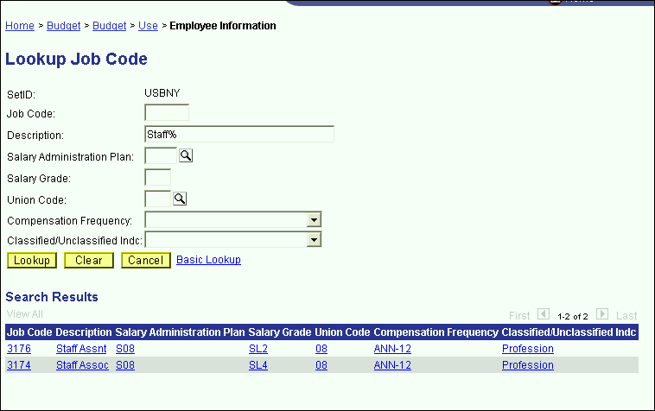

* The system will then display the job codes shown above.
* You can search by any of the search keys shown.
* Remember that the Description field is case sensitive. If you type “staff” instead of “Staff” the system would not have found any matching items.
* Click on the desired job code. You will then see the job code number in the job code field, but the description and other related displays will not be shown until you tab off of the job code field.

**Sal Plan**, **Classification**, **Salary Grade**, **Union Code** & **Comp Frequency**

* The values of these fields are automatically entered based on the job code selected.
* The value in the Classification field is used to group employees in one of the reports in development.
* The Union Code field is used to automatically calculate the classified location payment and the UUP location stipend in the OSE panel on the Employee Information panel group.
* This is a one-to-many relationship between the job code and the Comp Frequency field. It is possible to have more than one valid Comp Frequency for a given job code. Therefore, if the default compensation frequency is not the one you wish to assign to the employee, you can override the compensation frequency on the Salary Distribution panel.
* At the bottom of the Employee Details panel, there is a **Last Modified By** field. This field stores the operator ID of the last user to save changes to the employee record. The date of the change is also displayed.
* Also at the bottom of the Employee Details panel is a field indicating the data source of the employee record as well as the date the record was loaded.

#### Salary Distribution Panel

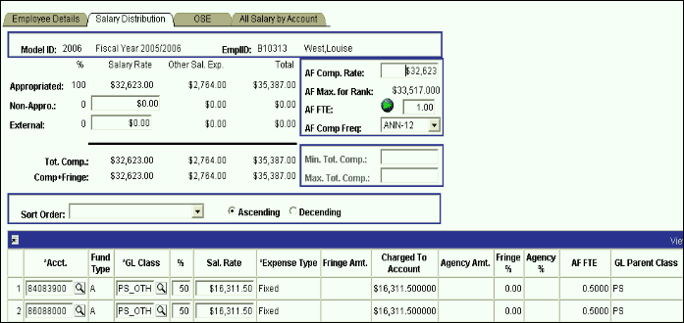

Non-appropriated fund Salary Rate field

Appropriated fund Salary Rate field

External fund Salary Rate field

For AF funds only.

To create and modify account splits

There are two ways to add and modify salary distribution information on this panel. There is one for the appropriated funds salaries, and one for the non-appropriated/external fund salaries.

To budget appropriated fund salaries:

* You must begin in the upper right-hand corner of the panel where the AF fields are displayed.

**AF Comp Rate** – This field is the compensation rate for appropriated funds. This field was formerly known as the annual salary.

**AF Max for Rank** – This field is the maximum for the rank of the employees appropriated funds job code.

**AF FTE** – This field is the appropriated funds full-time equivalent.

To the right of the AF FTE label there is a button for the FTE Calculation Worksheet.

This worksheet will calculate the AF FTE based on the AF Comp Rate you enter.

After you enter the AF Comp Rate, click on the AF FTE button. Then, in the white field labeled Appropriated Base Salary (salary rate) enter the amount that you want the person to receive.

When you **tab** off the field, the system will calculate the closest FTE that will generate the salary rate that you entered. Click **OK** to accept this change and return to the Salary Distribution panel.

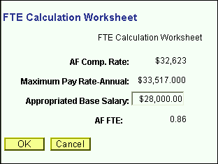

**AF Comp Freq** – This is the rate of pay for the employee.

Comp frequency ending in “SEM,” signify semester employees. The salary rate for employees with compensation frequencies ending in “SEM” is the product of the AF Comp Rate, the AF FTE and 0.5.

For pre-loaded employees, the AF Comp Freq corresponds with the AF Comp Rate.

As you modify the AF fields you will notice that the Appropriated Fund Salary Rate field on the left side of the panel changes. For appropriated Funds, the Salary Rate field is a product of the AF Comp Rate field and the AF FTE field.

The Appropriated Fund Salary Rate field is the amount that you want the employee to receive. This is the amount that you will distribute by account.

Once you have the desired amount in the Appropriated Funds Salary Rate field, you are ready to distribute this amount in the grid at the bottom of the panel.

* The salary distribution grid contains the following fields:
* **Acct** – This column contains the account(s) the employee’s salary is charged to.

**Fund Type** – This display only column is the fund type of the account field in the first column. It is automatically entered when you tab off of the Account field.

**GL Class** – This the expenditure code that the salary will be charged to on the account. The valid values for this field differs depending on the fund of the account and the “Regular/Temporary” indicator on the Employee Details panel.

The valid values for Regular employees on appropriated fund accounts are shown below.

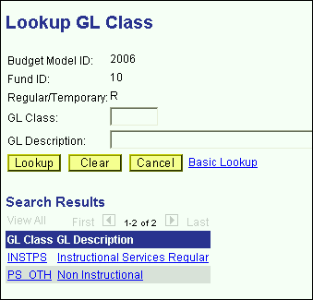

The valid values for Temporary employees on appropriated fund accounts are shown below:

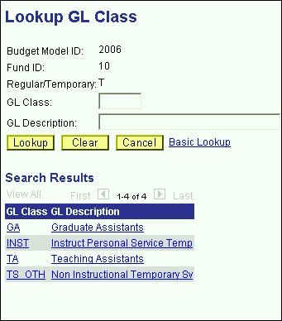

**%** - This column contains the percent field. This is where you will indicate the percent of the Appropriated Fund Salary Rate that you want charged to each account. For appropriated funds only, the salaries distributed to each account must be a whole number percent of the AF Salary Rate.

**Sal Rate** – This column contains the portion of the Salary Rate (Appropriated Funds, Non-Appropriated Funds or External) that is budgeted on the selected account.

**Fringe Amount** – This display only column contains the fringe benefit assessments associated with the account selected. The fringe benefit calculation is based on the fund of the account and the GL class of the distribution.

**Charged to Account** – This display only column is the sum of the Salary Rate column on the grid and the Fringe Amount column.

**Agency Amt** – This display only column is automatically calculated based on the fund of the account and the GL class of the distribution. Agency charges are assessed only for CPMP staff.

**Fringe %** - This column displays the fringe benefit percentage that is being assessed on the distribution.

**Agency %** - This column displays the agency percentage that is being assessed on the distribution.

**AF FTE** – This column displays the AF FTE for the distribution.

**GL Parent Class** – This column displays the parent of the GL class, that is, whether the GL class is PS (Personal Services Regular) or TS (Personal Services Temporary).

**Import ID** – This display only column indicates the import ID of the data load. [This is for use by the technical team. You can safely ignore it.]

**Emp Srce** – This indicates the source of the distribution. An employee may have distributions from several sources if their distributions are split across fund types.

If you are distributing the Appropriated Fund Salary Rate to only one account, type 100 in the % column after entering the account and GL class in the Salary Distribution grid. Once you tab off of the % field, you will notice that the next column will contain the full value of the Appropriated Fund Salary Rate field.

If you are distributing the Appropriated Fund Salary Rate to more than one account, you can do one of the following:

* Enter the percent of the Appropriated Fund Salary Rate that you want in each distribution.
* Alternately, tab past the % column and type in the amount that you want to charge to the account in the Salary Rate column in the grid.
* 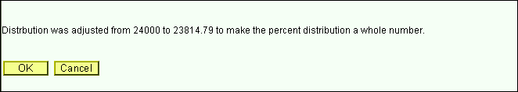Once you tab off of the Salary Rate field on the grid, you will notice that the system changed the amount you entered to the nearest whole percent of the Appropriated Fund Salary Rate field. This is done only for account distributions in appropriated funds. You will get a message similar to the one below.
* You will also notice that the value in the % column is adjusted.

For appropriated funds, the value in the % column is always the Salary Rate amount on the grid divided by the Appropriated Fund Salary Rate field.

In order to save the Employee Information panel, the total appropriated fund percent in the upper left-hand corner of the panel must equal 100. You will need to modify the percentages of each distribution until you have a total of 100%.

If you attempt saving the panel while the Appropriated Fund Salary Rate is not equal to the sum of the distribution Salary Rates, you will get an error message similar to the one below.

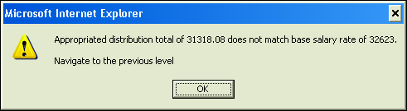

If you change the Appropriated Fund Salary Rate (by changing the AF Comp Rate or AF FTE), the system will hold the % values constant and automatically prorate the Salary Rate amounts in the grid.

To budget salaries on accounts that are in non-appropriated funds and external funds:

For employees with no appropriated fund salary component, you may budget the salaries directly in the grid at the bottom of the panel.

As you insert rows on non-appropriated and external accounts, you can skip the % column and enter the amount you want budgeted in the Sal Rate column on the grid. For non-appropriated funds there is no whole number percent restriction on the distribution salary rate. The amount you enter in the grid is the amount you want. It will not be rounded to the nearest percent of the Non-Appropriated Fund Salary Rate.

As you enter an amount in the Salary Rate column on the grid, the system will *add* that amount to the Non-Appropriated Fund Salary Rate field in the upper left-hand corner of the panel.

Additionally, the percentages will automatically adjust when you tab off of the Sal Rate column on the grid.

For non-appropriated funds (and external funds), the amounts in the % column are not important. It is the values on the distributions that are key. You can save the panel if the Non-Appropriated Fund Salary Rate or the External Fund Salary Rate is not equal to 100%. After you save the panel, the percentage will reset to 100%.

If you change the Non-Appropriated Fund Salary Rate (or the External Fund Salary Rate), the system will hold the Salary Rate values in the grid constant and automatically prorate the figures in the % column. Consequently, you will not be able to save the panel until the amount in the Non-Appropriated Fund Salary Rate (or the External Fund Salary Rate) is equal to the distribution Salary Rates in the grid. You will get an error message similar to the one below.

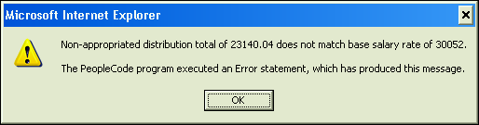

* The valid values for Regular employees on non-appropriated fund or external fund accounts are shown below:

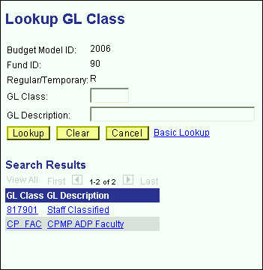

* The valid values for Temporary employees on non-appropriated fund or external fund accounts are shown below:

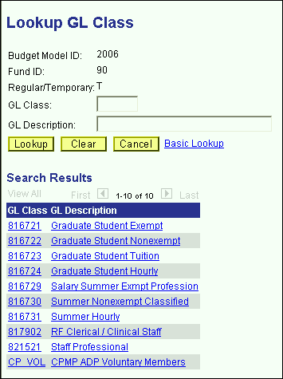

Minimum Total Compensation & Maximum Total Compensation

These fields are located on the right side of the panel, above the grid.

These fields are editable only for employees whose AF Comp Freq is ANN-GFT.

For ANN-GFT employees you will not be able to save the panel group unless you enter a non-zero value for the Maximum Total Compensation field. You will get the error message below if you are attempting to save the panel without a value for this field.

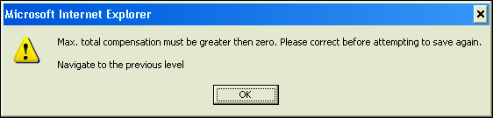

If the Total Compensation amount (located above the grid to the left of the panel) is greater than the Maximum Total Compensation you will get the warning message similar to the one below, but you will be able to save the panel.

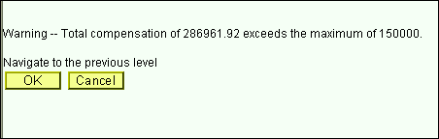

At the top of the panel, to the right of the Salary Rate fields, there are Other Sal Exp fields. The grid at the bottom of the panel is only for distributing the Salary Rate fields. To modify and distribute the Other Sal Exp fields, click on the next panel in the group: OSE.

#### OSE (by Employee) Panel

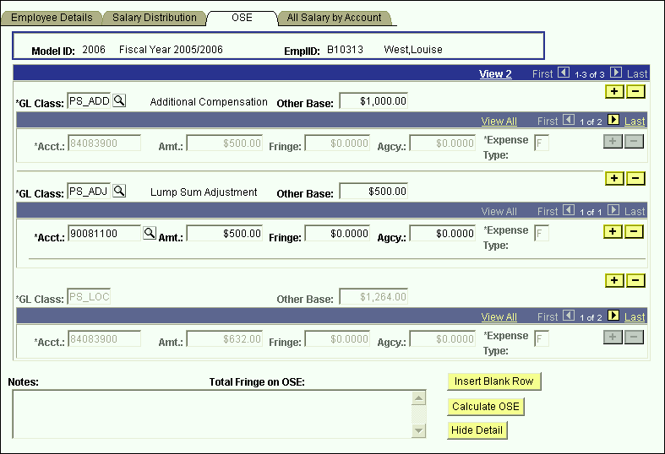

* The OSE panel is used to add and modify Other Salary Expense categories and their distributions.
* There are two components of the OSE GL classes that need to be budgeted: their amounts and their distributions. Different GL classes are calculated and distributed to accounts differently.
* In the panel shown above, you see that each OSE GL class has its own scroll bar for the account distribution.
* There are three types of OSE GL classes.

### Types of OSE by Employee GL Classes: Auto Calc/Auto Distribute

* The first type of OSE GL classes is automatically calculated and automatically distributed.
* Examples of this type are the UUP location stipends, the classified location payments, Shift payments, Inconvenience payments, and Geographic payments.
* These types are valid for appropriated fund distributions only.
* In the screen print on the previous page, the second GL class is PS_LOC. It is grayed out because it is automatically calculated based on the employee’s union code, FTE and compensation frequency.
* Additionally, the $1,264 amount for PS_LOC is automatically distributed among the accounts of the employee’s base salary from the Salary Distribution panel. Since this employee’s base salary is charged 50% on 84083900 and 50% on 86088800, the classified location stipend is prorated 50/50 to those accounts.

Types of OSE by Employee GL Classes: Manual Calc/Auto Distribute

* The second type of OSE GL classes is manually calculated and automatically distributed.
* The only Example of this type is Additional Compensation.
* This type is valid for appropriated fund distributions only.
* To budget for this GL classes on an employee, click the Insert Blank Row button at the bottom of the screen. You will then get an empty row.
* Click the magnifying glass to the right of the GL class field and select Additional Compensation.
* Once you tab off of the GL class field, type an amount in the Other Base field.
* When you tab off of the Other Base field, you will then notice that the account distribution scroll bar underneath is grayed out. The system is automatically distributing the amount that you have manually entered using the salary distribution of the base salary in the Salary Distribution panel.



* In the screen print above, this employee’s base salary is charged 50% on 84083900 and 50% on 86088800, so the system is distributing the $1,000 in additional compensation to 50/50 between these accounts.

Types of OSE by Employee GL Classes: Manual Calc/Manual Distribute

* The third type of OSE GL classes is manually calculated and manually distributed.
* The only GL class is that is manually calculated and manually distributed is Lump Sum Adjustment.
* This GL class is valid for appropriated and non-appropriated fund types.
* The Lump Sum Adjustment GL class allows you the flexibility of designating the account where the amount will be budgeted.
* Once you select PS_ADJ GL class (or TS_ADJ for Temporary employees) and you enter the Other Base amount, you will need to manually enter the account number for each distribution, as well as the portion of the amount that you wish to budget for each distribution.
* In the screen print below, you see that a PS_ADJ amount of $500 is budgeted and all of it is distributed to account 90081100.



* Please note that for the Lump Sum Adjustment GL class, you need to manually enter the fringe amounts for any accounts that are assessed fringe as well as any application agency costs.
* The screen print below displays the valid OSE GL class values for Regular employees.

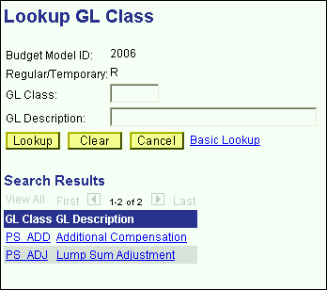

* The screen print below displays the valid OSE GL class values for Temporary employees.

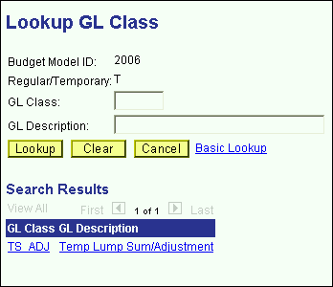

#### All Salary by Account Panel

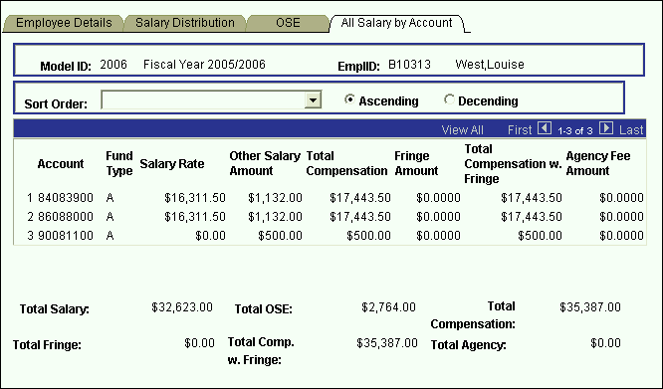

* The last panel in the Employee Information panel group is the All Salary by Account panel. This panel is a display only grid, which summarizes all of the accounts an employee is charged to.
* The Salary Rate column on the grid corresponds with the base distribution amounts in the Salary Distribution panel.
* The Other Salary Amount column corresponds with the amounts in the OSE panel.
* The Total Compensation column is the sum of the Salary Rate column and the Other Salary Amount column.
* The Fringe Amount column is the total fringe charged to the account.
* The Total Compensation with Fringe column is the sum of the Total Compensation column and the Fringe Amount column.
* The Agency Fee Amount column is the total agency assessment charged to the account.
* Totals for the columns in the grid are displayed under the grid.

# Adding an Employee

There are two types of employee “Add”s on the CBM system. You can create an employee record from scratch, or you can copy an employee record from another CBM model or from an HR module.

**Adding an Employee Record From Scratch**:

* From the Use menu, select Employee Information, and click on Add a New Value.

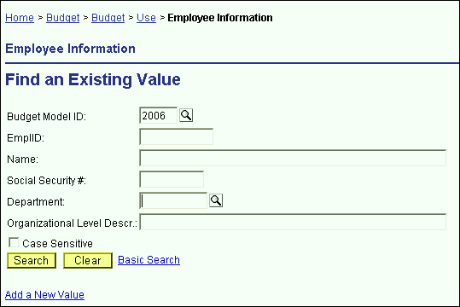

* You will then see the screen below. Enter the model where you would like to create the employee record and click OK. The system will automatically generate temporary “B” employee ID numbers. The “B” employee ID number indicates that the employee record did not originate from the PeopleSoft HR modules.

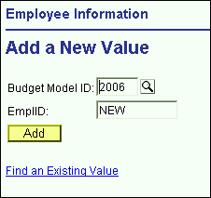

* You will then see an empty Employee Information panel group. You should enter data for the white fields.
* SSN is not a required field. You can leave it empty. If you fill-in the SSN field and it is already in use on another employee record, you will get an error message when you try to save the panel.
* Name is also not required, but we recommend that you enter data for that field since it is used on the Search dialog box.
* Please refer to the Employee Details field descriptions on the preceding pages in this unit for information on using each field in this panel group.

**Copying an Employee Record from the HR Modules or a CBM Model**:

* From the Use menu, select Employee Information, and click on Add a New Value.



* You will then see the screen below. Enter the model where you would like to create the employee record, *and* enter the employee ID of the employee record that you want the system to copy into the indicated model.

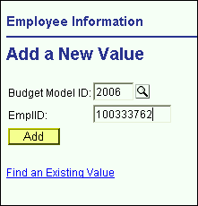

* You will then see the Employee Information panel group for the employee ID you requested. Please note that the system fills in the information on the Employee Details panel *only*. You will need to enter salary distribution information on the Salary Distribution panel and the OSE panel.
* When you enter the employee ID on the previous screen, the system searches the HR modules first to find the most current information on the employee. If the system does not find the requested employee record in the HR modules, it will then search the CBM module for that employee record.
* Please refer to the Employee Details field descriptions on the preceding pages in this unit for information on using each field in this panel group.

# Deleting an Employee

* For each budget preparation cycle, a current snapshot of active employees will be pre-loaded into the write-able models (Current, Proposed & Outyear). Consequently, you will not need to delete an employee record unless he/she terminated after the snapshot was taken.
* Since a new employee snapshot is taken every year, the vice presidential areas did not want records to be delete-able.
* Therefore, you may not delete employee records once they have been added to the CBM system.
* If an employee terminates after the payroll snapshot was loaded, you will want to adjust their salary.
* If no portion of an employee’s salary will be charged during the fiscal year of the model that you are budgeting, then zero the salary fields *and* the FTE field.

# Employees Split Outside Your Organizational Level

* If an employee is split between organizational levels, each area that the employee is split to has access to the employee record.
* You cannot view or modify an employee record unless some portion of the employee’s salary is charged to one of your accounts.
* In order to keep track of whether or not a split employee record has been modified you will use the Split Changes Panel in the Inquire menu.

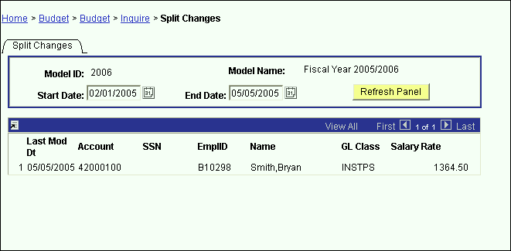

* Use the Start Date field and the End Date field on this panel to specify the date range of the modifications. In the example above, we are searching for all changes to employees split outside our area since February 1st. One employee distribution was modified during that timeframe.

# Cloning an Employee

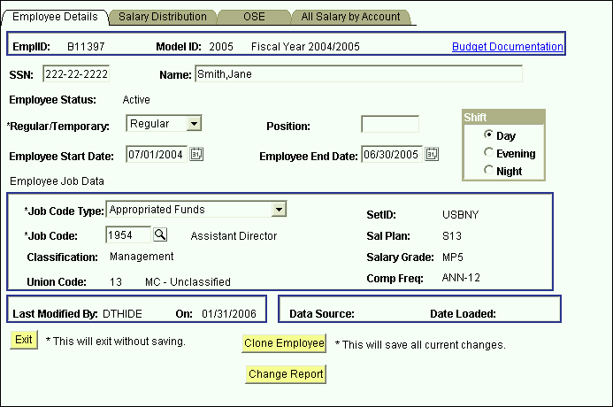

The Clone Employee button on the Employee Details page provides the ability to “clone” a complete CBM Employee record (demographic, salary, and OSE data) into a new CBM employee record **in the same model**. All data from the existing employee, except for Emplid, SSN, Name, and Position, will be copied to the “clone”. A new ‘C’ Emplid will be automatically generated from CBM. The existing employee record is saved when you click the Clone Employee button.

Note: As soon as you click Clone Employee, the data for the cloned employee is input into the employee/salary/OSE tables even though you do not press Save. For that reason, a warning message is generated to make sure you want to create the clone.

To clone an existing CBM employee record:

* Bring up the record you wish to clone;
* Click the Clone Employee button and this warning will be displayed:

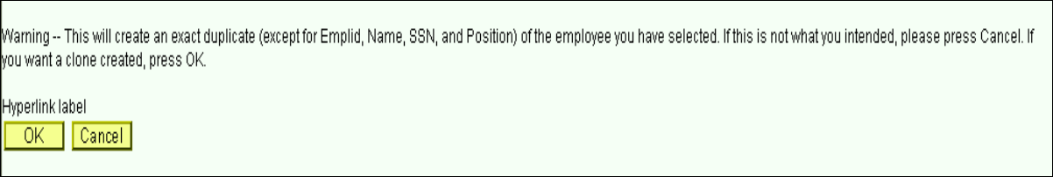

* If you click OK, a copy of the existing record will open in a new window. Notice that a new ‘C’ Emplid has been generated for the cloned employee.
* If you click Cancel, you will be returned to the existing employee record without creating a new employee.

# CBM Change Form

This CBM Change form is now available from CBM for use by non-Hospital administrators. This form will contain FTE, Compensation Rate, Salary Rate, and Job Earnings Distribution accounts and percentages from CBM. Users can complete this form for AF employees and submit it for authorization before sending to HR. Users should follow the usual HR guidelines and timetable for submitting account salary paperwork so HR can process the changes in a timely manner.

The CBM Change form can be accessed from the Inquire menu or from the Change Report button on the Employee Details page.

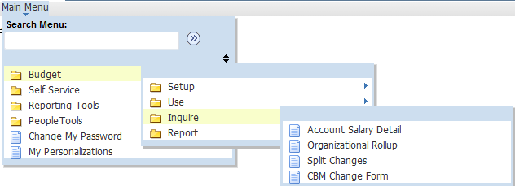



To generate the CBM Change form from the Change Report button on the Employee Details page:

* Click the Change Report button and the Change Information Form will be displayed with the HR data for the employee;

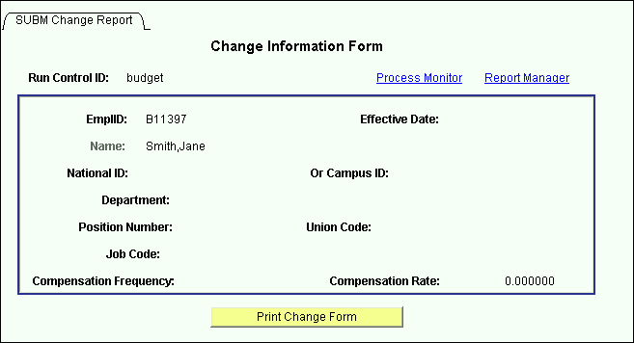

* Click the Print Change Form button;
* Click on Process Monitor and the report will be displayed in the Process List as shown below;

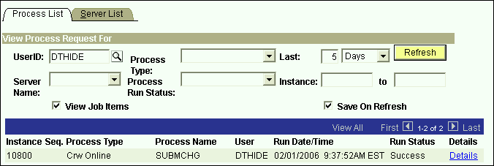

* To print the CBM Change Report, follow the instructions in the Using Process Monitor to Check Report Status section of this manual.

To generate the CBM Change form from the Inquire menu:

* Choose SUBM Change Report from the menu;
* Input the Employee Emplid or Name in the Employee Search page as shown below;

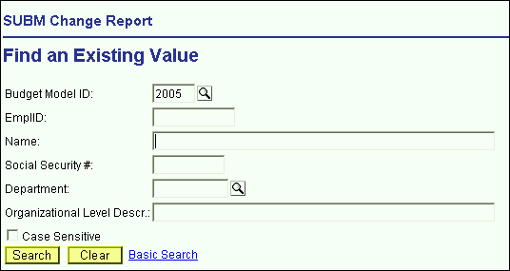

* When the Change Information Form is displayed, click the Print Change Form button;
* Click on Process Monitor and the report will be displayed in the Process List;
* To print the CBM Change Report, follow the instructions in the Using Process Monitor to Check Report Status section of this manual.

9.0 Reports



Click on a report in the list. The Run Control Search page will be displayed.

# Run Control ID

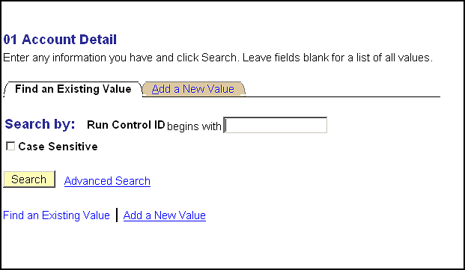

If you are new to CBM, click on **Add a New Value.** Enter a name for your Run Control ID that is no longer than 13 characters with no spaces. Click the Add button and the Report page will be displayed.

If you already have a Run Control ID, click the **Search** button.

If you have multiple Run Control IDs, a list of your Run Control IDs will be displayed.

**Note that if you only have one Run Control ID, the Report page will be displayed next.**

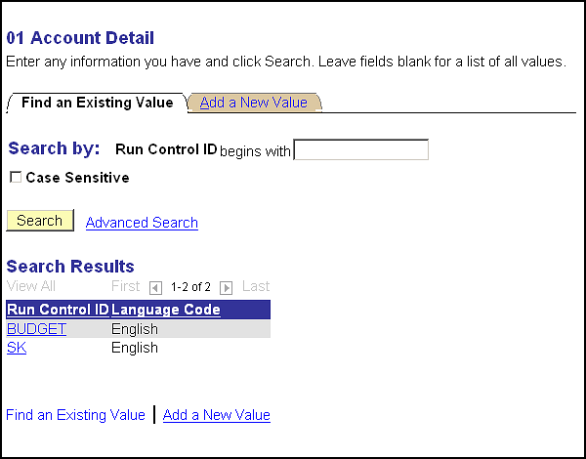

Click a **Run Control ID** from the list. The Report page will be displayed.

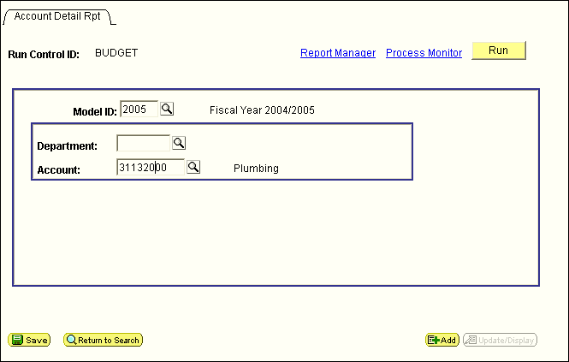

**Input the Model and other Parameters** for the selected report.

Click the **Run** button.

The Process Scheduler Request page will be displayed as shown on the next page.

The Process Scheduler Request page will be displayed. This is where you will choose the specific report you want to run and set up the output parameters.

Click the link to the report version you wish to run; i.e. Account/Detail (FTE/Title)

Note that from this point forward, setting up to print in PeopleSoft 8.9 is different than in previous versions.

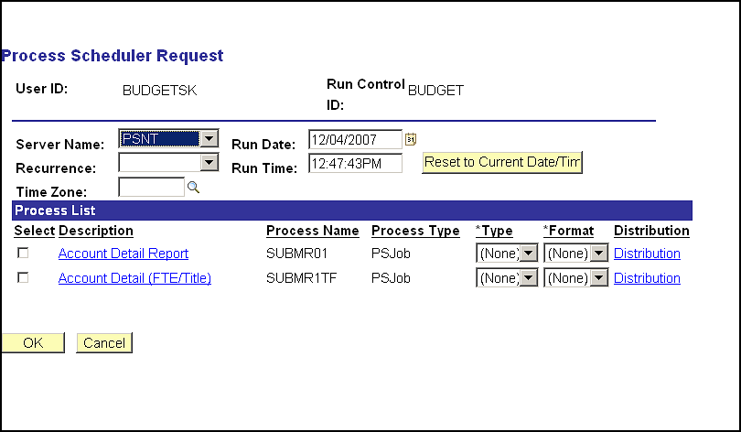

The Job Detail page will be displayed. For Process Type SQR Report and Crystal, make sure that Web is selected for Type and PDF is selected for Format.

Note: If you plan to Export the report to Excel, change the Crystal Format to RPT.

Click the OK button.

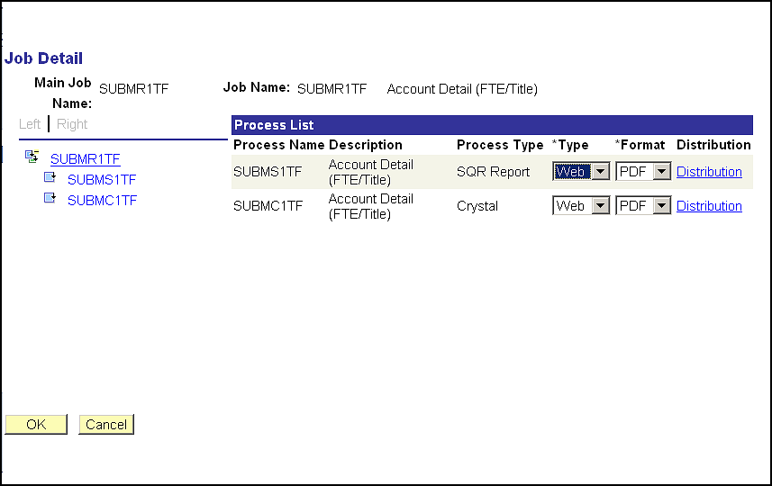

The Process Scheduler Request page will again be displayed.

From the Process List, check off the report you want to print. Click the OK button.

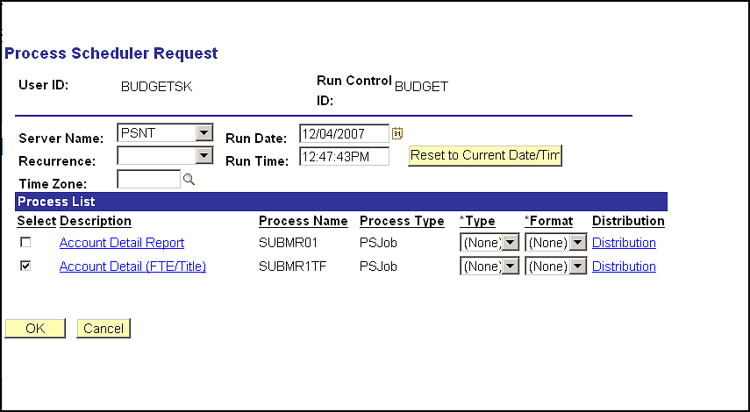

The Report page will again be displayed. Note that it now shows the Process Instance number for your print job under the Run button.

Click on Process Monitor.

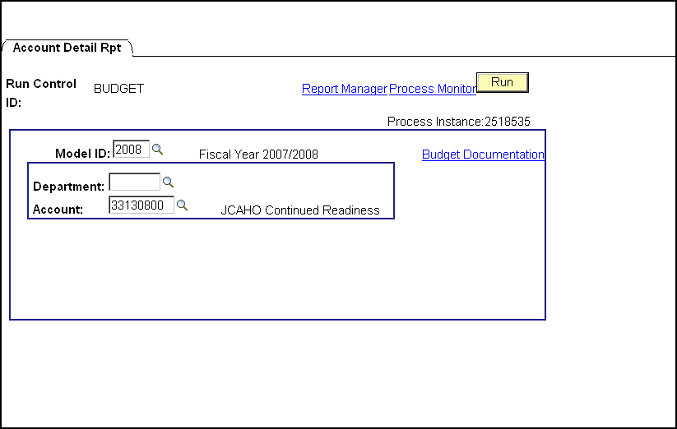

# Using Process Monitor to Check Report Status

The Process List page will be displayed. It shows the reports you have processed with the most recent report listed at the top.

Click the dropdown box to the left of the Refresh button and choose Days.

Make sure that the Type dropdown is blank.

Click the Refresh button to update the Run Status column in the grid.

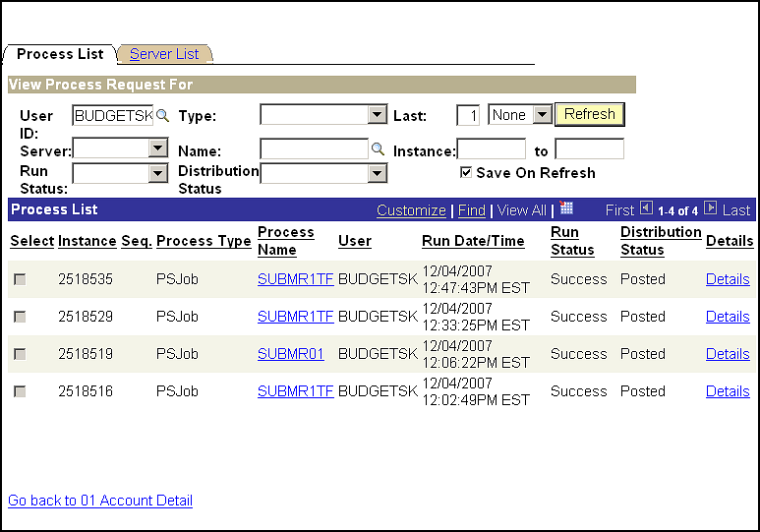

Each print job that you have submitted will show on an individual line that begins with its Process Instance number.

Click the Refresh button until the print job in the grid shows Run Status of Success; this means that your print job has completed processing.

When your report shows Run Status of Success, click the link under the report’s Process Name; i.e. SUBMR1TF.

The Process Detail page will be displayed.

For all reports except Report 05, click the third link that is displayed; i.e. SUBMC1TF.

(Since Report 05 is the only CBM report that does not produce a Crystal report, it will only show two links. Click the second link that is displayed to access this report.)

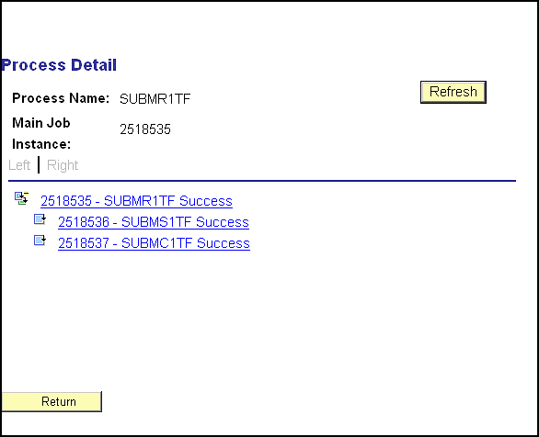

Clicking on the link will open up the next Process Detail page. To view and print your report, click View Log/Trace.

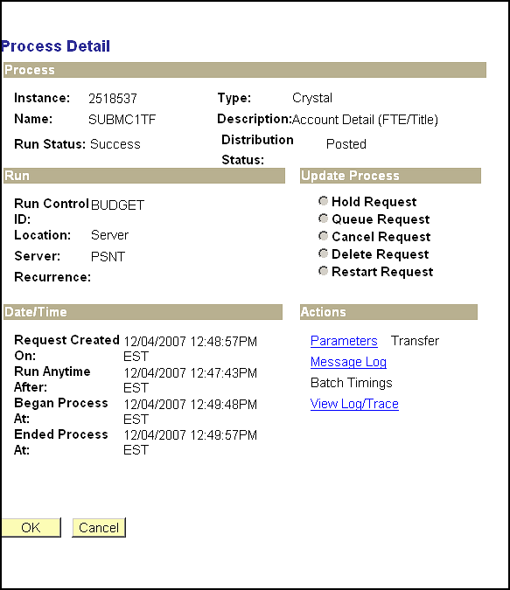

The View Log/Trace page will be displayed. In the Name column in the File List, click on the Report Name which starts with SUBM.

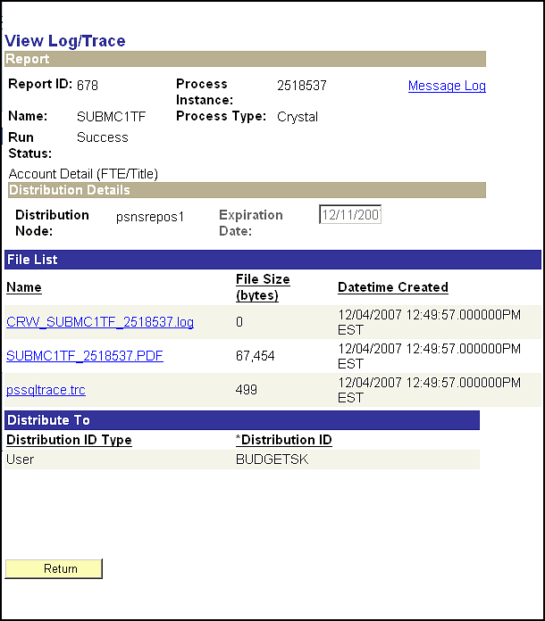

Finally!!! Your report will open in a separate window as an Adobe Acrobat Reader file or a Crystal report, depending on which Format you selected on the Job Detail page.

Click on File – Print to print the report.

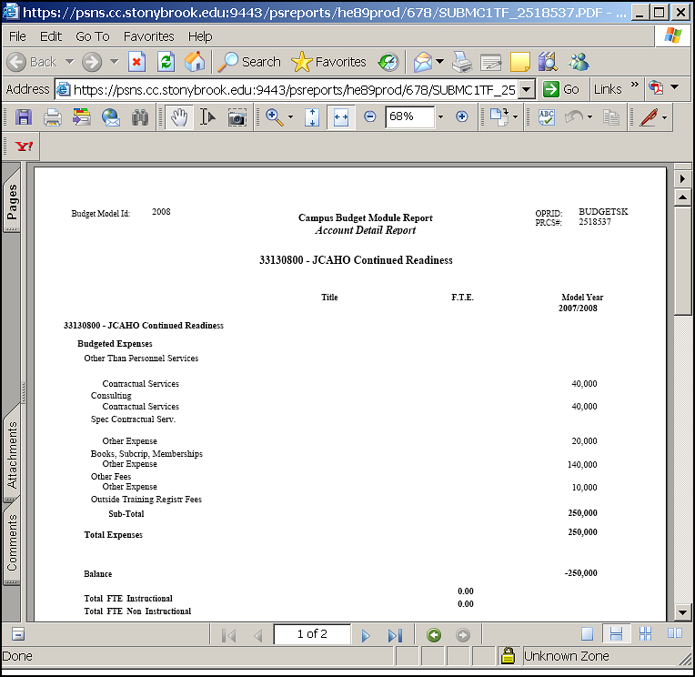

# Printing & Exporting From Report Files

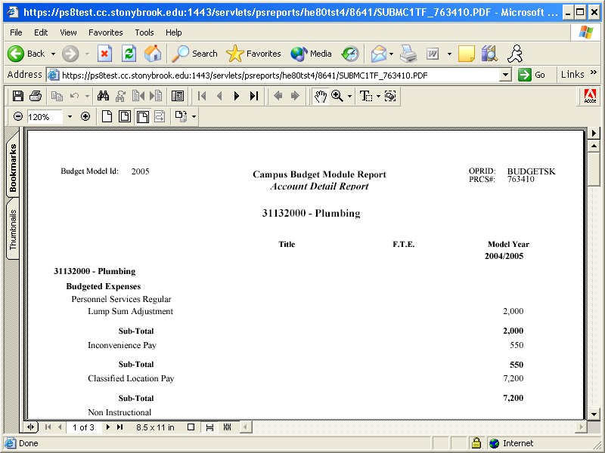

Your report will open in Adobe

Acrobat Reader in a new window.

To the left is a report sample.

You may click on File – Print to print the report from Acrobat Reader.

See below for instructions on printing the report from Crystal Reports.

Close the report window to get back to CBM.

Click Return, then Cancel, then Return buttons to return to Process Monitor.

Printing from Crystal Reports:

If you selected RPT as the format for your report, it will be generated in Crystal Reports format.

To print the report file:

* You can print the file from the **File** menu by selecting **Print**, then **Printer**, then clicking Okay.
* You can change the destination printer from the **File** menu by selecting **Printer Setup**.

### To export the file to Excel:

* You can export the file into Excel from the **File** menu by selecting **Print**, then **Export**.
* From the Export box, select the following then click **Ok**.

## Format: **Excel**

Destination: **Disk File**

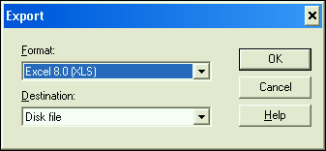

* Type the name that you would like to assign to your file, select the desired directory and click **Save**.
* You can now open your export file through the Excel application.

### **Report Types**

These are the reports that are currently in production:

* **Account Detail** (#01)– This report details the revenue, allocation, and expenditures budgeted within an account by GL class. The base salary GL classes include employee names and amounts. Also, the Notes fields are appended at the end of the report. This report can be printed for individual accounts or departments. When you run the report from the report panel, you will now see three choices at the bottom of the Process Scheduler Request box: "Account Detail Report ", "Hospital Account Detail", and "Account Detail (FTE/Title)" If you select "Account Detail Report", data for the model year selected and the three related model years will be displayed. If you select "Account Detail (FTE/Title)" you will see data for the selected model year only with the employee's FTE and Title listed. If you select "Hospital Account Detail" you will see the data in “FTE/Title” report plus the Hospital Overtime/Contract Labor FTE amounts and totals.
* **Account Summaries** (#02) – This report displays the budgeted targets, revenue, allocation, and expenditures by major categories for each account within an organizational area. The accounts are grouped by organizational level. Since account balances are included on this report, the targeted allocation was included (for appropriated funds and IDC) in order to generate an accurate representation of an area’s resources. This report can be printed for specific funds within a department or for combinations of funds (i.e., State & IDC). When you run the report from the report panel, you will now see two choices at the bottom of the Process Scheduler Request box: "Account Summaries MF by Dept" and "Account Summaries MF by Fund." If you select "Account Summaries MF by Dept" you will see your accounts grouped by organizational level (dept). If you select "Account Summaries MF by Fund" you will see the accounts grouped first by fund and then by organizational level.
* **Organizational Level Summary** (#03) – This report displays revenue and expenditure GL class sub-totals for the organizational level selected. This report can be printed for a specified fund or for all funds.
* **Employee by Distribution** (#04) – This report is a listing of all employee distributions within the selected organizational level. The employee records are grouped by organizational level and account. There are now three choices at the bottom of the Process Scheduler Request box. If you select “Employee (By Distribution)” the report will be printed in alphabetical order by employee name and will include the Emplid. If you select “Empl By Distrib (Title Shown)” you will see the grade and title of the employee displayed. If you select “Empl By Distrib (Title Sub Tot)” the report will be printed grouped by employee title with subtotals for each title group. The employee GL classes are displayed in columns. This report may be printed for any combination of fund and department or for a specific account. This report includes a column named "Flg". This column contains a flag that denotes whether or not an employee record has been modified or manually added into the system. "L" indicates that the employee record was pre-loaded into CBM from PeopleSoft HR or ADP. "M" indicates that the employee record was pre-loaded and then subsequently modified by a user. "N" indicates that the employee record was manually added to CBM.
* **All Funds Comparison With Employees** (#05) – This report has multi-fund parameters. Each selected fund appears on the report as a column. You can select any combination of up to seven funds*. Please note that for this particular report you should use a "****txt****" extension when you name this report on the Process Scheduler Request box.* You can open the report from Microsoft Word or any word processing application. Within Word, please change the setup to landscape for legal size paper. You may also need to make the font smaller in order to fit all seven fund columns across the page. Most reports take a minute or two to run, but this report may take three to eight minutes to run to a file because of its complexity.
* **IFR Allocation Worksheet** (#06) – This two-page report displays the budgeted revenue and expenditures by GL class for a selected IFR account. This report will be reviewed by the Accounting Office for all Income Fund Reimbursable accounts. You can print this report for a department or for a specific account.
* **IFR Account Summaries** (#07) – This report is similar to the second report except it contains fields that are specific to IFR funds. This report displays the budgeted revenue and expenditures by major categories for each account within an organizational area. The accounts are grouped by organizational level.
* **Hospital VP Summaries** (#08) - This report is similar to the second report and is accessible only by users with Hospital VP security. It lists all Fund 40 accounts, even those which fall in VP areas outside the Hospital.
* **Salary Comparison** (#09) – This report lists the salaries of the GFT faculty in your department for the associated models.

### **Total Compensation Over Max** (#10) – This report lists all of the GFT faculty in your area whose total compensation is 250% or 275% over the salary maximum for their rank.

### **Account Summaries – Dual Depts** (#12) –This report displays the budgeted targets, revenue, allocation, and expenditures by major categories for each account within two organizational areas. This report can be printed for specific funds within departments or for combinations of funds (i.e., State & IDC). Its layout is the same as report #2.

### **AF Account Notes** (#14) – This report displays AF accounts with allocation broken out by SUNY object codes and the notes associated with each account. It can be run to display accounts with negative budgeted objects only or for all accounts. This report can be printed for specific AF funds within departments or for combinations of funds.

### **Admin Overhead Summaries** (#15) – This report displays the revenue, allocation, and expenditures by major categories for each administrative overhead account (900760xx) within an organizational area.

### **SBAM Account Master** (#16) – This report displays accounts in the Stony Brook Account Master (SBAM) table based on the parameters input.

### For samples of these reports, please refer to the Appendix.

10.0 Helpful Hints

The CBM online user manual can be accessed from any CBM page by clicking on this link: 

# Copying Grid Data into Worksheets

You can copy the information from this grid and all of the PeopleSoft grids into Excel by clicking on the **Export to Excel** button which is on most panels.

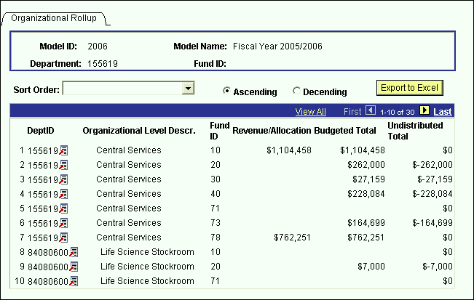

# Changing the Model

The CBM system groups data by model. This is analogous to a fiscal year. In all of the search dialog boxes the model ID field has the default value of the proposed year. There are two ways to change the model on CBM:

Method 1:

* If you are already in a panel group, change the model by clicking on the **Return to Search** button.
* You will then get the search dialog box of the panel group you are in.

Method 2:

* If you are on a panel with a grid (except the Auto Calc panel & Employee Information All Salary by Account), click on the link next to Account.
* You will be directed to the panel shown below where you may choose the desired model to transfer to.

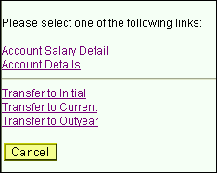

* The links on this panel contains the following model transfer options:
* Transfer to Initial - This option will open your active panel for the Initial model.
* Transfer to Current - This option will open your active panel for the Current model.
* Transfer to Outyear - This option will open your active panel for the Outyear model.
* Please be aware that when you are in an associated model, the position where you are entering data is still the third column. To view all of the associated models you have to be in the Proposed year.
* Since related models open in their own windows, you must close these windows to get back to the Proposed model.

# Error Messages & Warnings

* Keep in mind the Save button saves everything in the panel group, not just the active panel. When you get an error message, it may have to do with a field on a panel that you are not currently on. The error message below states to correct the highlighted fields. The highlighted field may be on another panel in the panel group that you are viewing. Click through all of the panels in the group in order to find the one causing the problem.

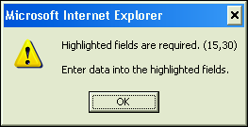

* If you get the error message below, this means that you are attempting to insert a GL class that you already have on the grid that you are working on. Click OK and then click the minus button to delete the duplicate row or click the drop down list to change the selected GL class.

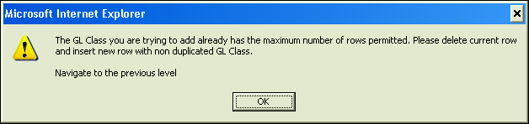

* If you are budgeting an account in one of the six Account Distribution panel groups, and you select another Account Distribution panel group, you will get the error message below. To avoid this message click the Exit button after saving your current panel.

Then you can select the next Account Distribution panel group you wish to work in.

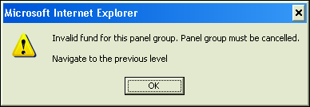

* If you enter a positive amount for Savings (GL Class PS_SAV) on the Account OSE panel, you will get the error message below when you try to save. Click on the OK button and enter a negative amount or zero.

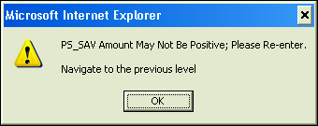

* If you zero the AF Compensation Rate and/or FTE for a split employee, you will receive the warning displayed below. This feature was added so that users are reminded to send email notification to the VP area coordinators who share their split employees.

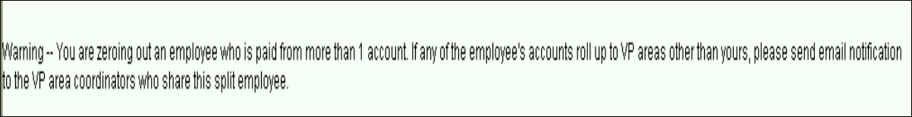

1. Need Help?

# ALL CBM Users

If you have forgotten your PeopleSoft password, you should contact the Computer Accounts office either by calling 2-8011 or by submitting a trouble ticket using this URL:

https://naples.cc.sunysb.edu/SCORE/solarhelp.nsf/trouble+ticket

When you contact Computer Accounts, identify your problem as a "PeopleSoft Admin. Password problem".

# West Campus CBM Users

* For **technical questions** regarding PeopleSoft installations, forgotten network passwords, access to Crystal Reports, etc., call Client Support at 2-9800.
* For **general questions** regarding the CBM module, call Diane Thide in the Budget Office at 2-6090.

# Medical Center CBM Users

* For **technical questions** regarding PeopleSoft installations, forgotten network passwords, etc., call the UHMC Help Desk at 4-4357.
* For **general questions** regarding the CBM module, call Glenn Schmidt in the Budget & Finance Office at 4-2088.

# Health Sciences Center CBM Users

* For **technical questions** regarding PeopleSoft installations, forgotten network passwords, etc., call the UHMC Help Desk at 4-4357.
* For **general questions** regarding the CBM module, call John Riley at 4-7504.

# University Hospital CBM Users

* For **technical questions** regarding PeopleSoft installations, forgotten network passwords, etc., call the UHMC Help Desk at 4-4357.
* For **general questions** regarding the CBM module, call your Budget Liaison at the Hospital Cost & Budget Office. The names and responsibility areas for each liaison are listed below.
* Timothy Riley 4-4119 Nursing, ER, Cancer Center
* Jennifer Bailey 4-4115 Hospital Operations, Hospital Operations – Radiology, Ambulatory Care
* Violet Payne 4-4117 Finance, Interns & Residents
* Susan Kass 4-4118 CEO, COO, Supply Chain, Human Resources, Public Affairs & Marketing, Chief Strategy Officer, Finance – Core Campus CFS, Laboratory, Facilities & Support Services
* Stephanie Desio 4-4114 Chief Quality Office, Chief Medical Officer, Information Technology
* Tammy Palmer 4-4112 Supply Chain

Appendix