Table of Contents
- This Year’s Budget Process 2
- Signing On PeopleSoft 5
  - Sign On Screen 5
  - Changing Your Password 6
- Getting Started 7
  - Menu Overview 7
  - Concepts Formerly Known As… 11
  - Command Buttons 11
- Organizational Overview 12
  - The Search Dialog Box 12
  - Organizational Rollup Panel 14
- Budgeting by Account 17
  - The Search Dialog Box 17
  - AF Account Distribution Panel Group 19
  - CPMP Account Distribution Panel Group 30
  - IDC Account Distribution Panel Group 43
  - IFR Account Distribution Panel Group 53
  - EXT Account Distribution Panel Group 68
  - SR Account Distribution Panel Group 73
- Targets by Account 82
- Viewing Employees by Account 86
  - The Search Dialog Box 86
  - Account Salary Detail Panel 88
- Budgeting by Employee 91
  - The Search Dialog Box 92
  - Employee Information Panel Group 93
  - Adding An Employee 114
  - Deleting An Employee 116
  - Employees Split Outside Your Organizational Level 117
- Reports 119
  - Creating a Run Control ID 119
  - Printing & Exporting From Report Files 122
- Helpful hints 127
  - Cutting & Pasting Grids into Worksheets 127
  - Changing the Model 127
  - Error Messages & Warnings 128
- Need Help? 130
Appendix 131
  - Fund Table
  - Report Samples

1.0 The 2002/2003 Budget Process

Models

- The budget information in the PeopleSoft Budget Module is grouped by model. This is roughly analogous to fiscal year. For the 2002/2003 budget preparation cycle, there are four associated models:
Initial
Current
Proposed
Outyear

Initial
- The Initial model contains the initial budget information for the current fiscal year. It is the final version of the budget that you prepared last year for the current fiscal year. The information in this model is read-only. It is not modifiable.

Current
- The Current model is the one you would use to project your fiscal condition for the current fiscal year.

Proposed
- The Proposed model is the one you will use to enter the budget information for the upcoming fiscal year. The final version of your Proposed budget will be used to populate next year’s Initial model.

Outyear
- To project your budget for the budget cycle two years from now, you would use the Outyear model. The Outyear model will not be carried forward to next year’s associated models.
- For each budget preparation cycle, there will always be four associated models. What will change from year to year is the model ID. For the 2002/2003 budget preparation cycle, the model IDs for each of the four associated models are:

Model Model ID Description

Initial 2002 Initial 7/1/01 to 6/30/02 budget

Current C2002 Current projection of 7/1/01 to 6/30/02 budget

Proposed 2003 Proposed budget for 7/1/02 to 6/30/03 fiscal year

Outyear O2004 Projected budget for 7/1/03 to 6/30/04 fiscal year

- For all of the panels in the PeopleSoft Campus Budget Module, the system will initially default to the Proposed model.

Data Load

- For the 2002/2003 budget preparation cycle the following data was loaded into the system:

Model | Employee Information | Account OSE | OTPS | Revenue
2002 | Final budget data from prior year
C2002 | Current payroll data from HR systems * | Copy of model 2002 | Copy of model 2002 | Copy of model 2002
2003
O2004
* RF distribution is final budget data from prior year

- Model 2002 contains the final budget information that you prepared during last year’s budget preparation cycle. This information is read-only.
- For the three write-able models (C2002, 2003 and O2004) the employee information was loaded from a current snapshot of the following Human Resources payroll systems.
- The employee information snapshot for appropriated funds was loaded from 1/7/2002 data from the PeopleSoft HR modules.
- The employee payroll distribution for Research Foundation was loaded from the final “Proposed” budget for 2002 and updated with current salary data from the 12/28/2001 payroll file from the PeopleSoft HR modules.
- The employee information snapshot for ADP CPMP employees was loaded from 12/20/2001 data from CPMP.
- All of the employee information snapshots were loaded into the three new models: 2003, C2002 and O2004. The amounts in O2004 are slightly higher for appropriated funds since the location payments for 2003/2004 will be higher.

Research Foundation OASIS Crosswalk
Since the Research Foundation OASIS implementation is still being refined, a decision was made to continue to use the old RF expenditure categories for the 2002/2003 budget preparation cycle. We will implement the crosswalks to the OASIS expenditure categories and accounting conventions for next year’s budget preparation cycle.

2.0 Signing On to PeopleSoft

Sign On Screen

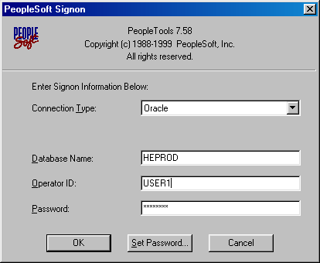
- To sign on to the PeopleSoft Campus Budget Module (CBM), double-click on the PeopleSoft icon on your desktop. You will then see the signon screen below.

- The database that you need to signon to is HEPROD.
- Type in your operator ID and password in the indicated boxes.
- Before you click OK, it is recommended that you change your password from the default one you were given.

Changing Your Password

- If you are still using your default password, please change it to a personalized one by clicking on the Set Password button at the bottom of the PeopleSoft signon screen.
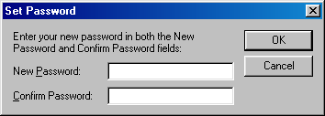
- In the Set Password window, type in your new password in the spaces provided and click Okay.
3.0 Getting Started

Menu Overview

- After signing on to the system, you will see a blank PeopleSoft screen. [If you also have HR access, this is the same screen you use to access the Human Resources modules.]
- To access the Campus Budget Module, click on the Go menu and select Budget.

- Once you select Budget from the Go menu, you will notice that the title bar of the window changed to Budget.
- If you only have CBM access, you will automatically be defaulted to the Budget module when you sign in.
- In the Budget module, you will see the menus displayed below.
- The Budget menus that you need are Use, Inquire, Report and sometimes Setup. The remaining menu items contain other functions that relate to the PeopleSoft environment.
- 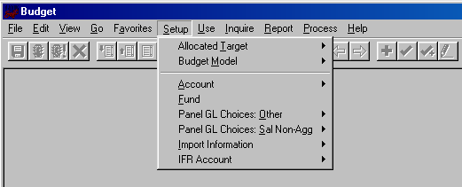The Setup menu is available in display-only mode for informational purposes. It contains setup information (such as IFR rate and account fund & function) that you can safely ignore for the duration of the budget process.
Title bar

The USE Menu
- 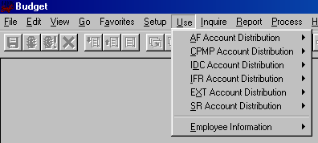The Use menu is the one you will use most often. You will input and modify all of your data on the panel groups in this menu.

- There are seven panel groups in this menu:
- AF Account Distribution panel group
- This panel group is used to budget expenditures on accounts that are in appropriated funds (AF).
- AF accounts include State Purpose (fund 10), Dormitory (fund 30), Hospital (fund 40) and Veterans Home (fund 60).
- CPMP Account Distribution panel group
- This panel group is used to budget revenue and expenditures on accounts that are in the Clinical Practice fund (fund 90).
- IDC Account Distribution panel group
- This panel group is used to budget expenditures on accounts that are in the Research Foundation Indirect Cost of Practice fund (fund 73).
- IFR Account Distribution panel group
- This panel group is used to budget revenue and expenditures on accounts that are in Income Fund Reimbursable (IFR) funds.
- Although IFR accounts are appropriated fund accounts, they are budgeted in a separate panel group because they have revenue component that is budgeted by account.
- IFR accounts include General IFR (fund 20), SUTRA (fund 35), Dormitory IFR (fund 35) and Hospital IFR (fund 45).
- EXT Account Distribution panel group
- This panel group is used to budget revenue to offset the salary supplements from external sources. External sources include the Northport VA (fund 93), Brookhaven National Labs (fund 95) and other external sources (fund 97).
- SR Account Distribution panel group
- This panel group is used to budget revenue and expenditures on accounts that are in the Research Foundation Sponsored Research and Service & Agreements funds.
- Employee Information panel group
- The six Account Distribution panel groups are for budgeting information by account. The Employee Information panel group is for budgeting information by employee. You add and modify employee records from this panel group.
- For detailed information on each Account Distribution panel group, see Unit 5, Budgeting by Account. For detailed information on budgeting by employee see Unit 7.
- Please refer to the Appendix for a summary of the fund type, account code and fund code conventions used in CBM. The chart also directs you to which panel group to go to for certain funds. The information contained in this summary is also included in Unit 4, Budgeting by Account.

The INQUIRE Menu
- 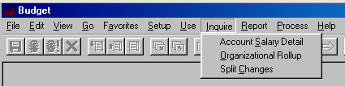The Inquire menu contains display-only information.

- There are three panels in this menu:
- Account Salary Detail panel
- This panel lists all of the employee records that is charged to the selected account.
- Organizational Rollup panel
- This panel is a summary of the allocation targets/revenue and budgeted expenditures within an organizational area.
- Split Changes panel
- This panel lists all employee records that are split outside your area and that have been modified.

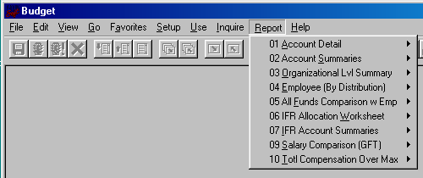The REPORT Menu

- The Report menu contains panels for each of the reports in the system.
- You will run the reports from their corresponding panel.
- For detailed instructions on running reports and descriptions of each report see Unit 8, Reports.

Concepts Formerly Known As…

- The table below lists the “new” names of some familiar concepts.

Old | New PeopleSoft Field | Description
Object Code | GL Class (General Ledger Class) | GL class is the name of the budget categories. Each fund has it’s own set of valid revenue and expense GL classes.
Pay Basis | Comp Frequency | Compensation frequency describes an employee’s rate of pay.
Organizational area | Department ID | Despite its name, Department ID does not necessarily mean department. Department ID is really analogous to organizational level. This can be anything from the VP level to a parent account.
- | Model ID | The data in the system is grouped by model. This is roughly analogous to fiscal year. See Unit 1 for more details.
Annual Salary | AF Comp Rate | The AF Comp Rate is the full time value of an employee’s salary.

Command Buttons
Save
Next in List
List
Delete Row
Forward
Update/Display
Previous panel in group
Run with Defaults
Insert Row
Back
Add
Next panel in group

Previous in List
Cancel
Run

4.0 Organizational Overview

The Search Dialog Box
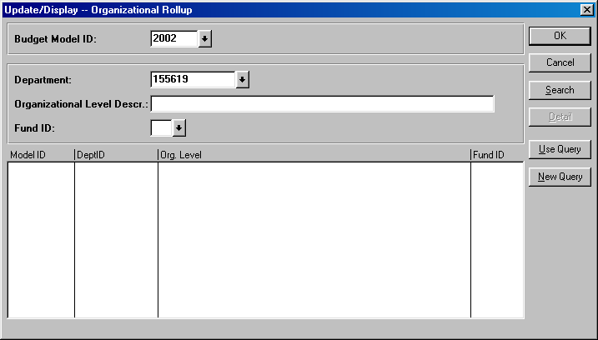

- In PeopleSoft, you will spend a great deal of time looking at windows like the one shown above. They are search dialog boxes. They are PeopleSoft’s way of asking you for the information that you would like to select.
- Each panel group has its own search dialog box. Depending on where you are in the system, the search dialog box will default certain information for you.
- From the Inquire menu, select Organizational Rollup. You will see the search dialog box above.
- The fields at the top of the box (Budget Model ID, Department, Organizational Level Descr, and Fund ID) are search keys.

Budget Model ID
- The system will automatically default the model ID of the Proposed year. For more information on the model, see Unit 1.
- To change the model, you can enter the desired value in the edit box or you can click on the down arrow to the right of the edit box to view a list of options to choose from.

Department
- For this panel, the system is also defaulting to the highest level organizational area to which you have access. In this example the default is 155619, which is Central Services in VP for Administration.
Organizational Level Descr
- The Organizational Level Descr field is the literal description of the Department field.
- When narrowing a search based using a description field, you can use the % symbol as a placeholder for one or more characters. For example, if you are looking for an organizational level that contains the word “Central” in the description, you may type %Central% in the Organizational Level Descr field and click the Search button.
- Please remember that PeopleSoft character fields are case sensitive. %Central% is different from %central%.

Fund
- To select the fund, you can enter the desired value in the edit box or you can click on the down arrow to the right of the edit box to view a list of options to choose from.
- For this panel, if you do not select a fund you will get all of the funds.

- Once you have inputted the desired search criteria, click Search. You will then see a list at the bottom half of all of the data that PeopleSoft found as a match to your criteria. You can then select the desired data and click OK.
- To summarize, in a search dialog box, you may directly enter the information you need, or you can view the list of valid values for a field by clicking on the down arrow to the right of the field.

The Organizational Rollup Panel

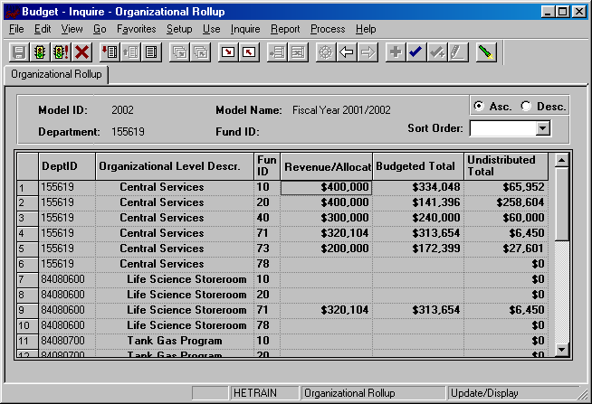
Command buttons
Panel name
Title Bar
Panel name
Database name
Panel name
Selected Action

- If you click OK from the previous search dialog box, you will see the Organizational Rollup panel above.
- Please note that all of the PeopleSoft panels have the following panel layout in common:
  - Title bar – the title bar is located at the top of the screen and contains the name of the module that you are in, the panel group you have selected and the menu it is located in. In the example above, you are in the Budget module, and you have selected the Organizational Rollup panel group, which is located in the Inquire menu.
  - Panel name – the panel name can be found in two places, under the command buttons at the top of the panel and at the bottom of the panel.
  - Selected action – there are two actions that are used in the Budget module, Update/Display and Add.
  - Database name – the database name that you are logged into will always be at the bottom of the PeopleSoft window.

- The Organizational Rollup panel is a summary of the allocation targets/revenue and budgeted expenditures within an organizational area
- Since you did not specify a fund, all of the valid funds for your organizational level were included in the grid.
- Under the panel name at the top of the screen, is the model and department you selected.
- The grid on the panel is a summary of your budgeted information by organizational level and fund. The grid contains the following columns:
  - Dept ID – This is all of the organizational nodes under the “Department” you selected in the search dialog box.
  - Organizational Level Descr – This column contains the corresponding literal descriptions of the Dept ID column. The descriptions of the organizational levels are indented to visually represent a lower level.
  - Fund ID – This column displays the fund code of each grouping of accounts in your area.
  - Revenue/Allocation
    - For appropriated funds (including IFR), this column displays the allocation that you have been authorized to budget against.
    - For the IDC fund, this column displays the amount of spending authority you have to budget against.
    - For Sponsored Research (SR) and Clinical Practice (CPMP), this column is a rollup of the revenue that is budgeted on each account within those funds.
  - Proposed Total – This is the total of all expenditures that were budgeted in the model you have selected.
    - For appropriated funds (including IFR), this total does not include fringe benefits or overhead.
    - For IDC, SR and CPMP, this total does include fringe benefits and overhead.
  - Undistributed Total – This column is the difference between the Revenue/Allocation column and the Proposed Total column.
- 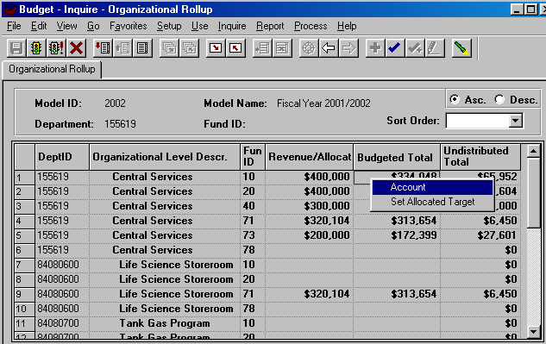The grid is initially displayed in the tree node order of the organizational levels. You can change the sort order by using the sort order drop down box at the upper right hand corner of the panel.

- Since 71 is the fund code for SR, row 4 tells you that you have budgeted $313,654 in revenue in all of your SR accounts in Central Services.
- Since 10 is the fund code for State Purpose, row 1 tells you that you have $400,000 available to budget in all of the State Purpose accounts in Central Services. You have budgeted $334,048 leaving $65,952.
- The grid is display only (gray fields). To change the numbers, you have to change the values that are budgeted by account.
- To go to the panel group where you budget by account, right-click on the first row of the grid and select Account. You will then see the search dialog box on the next page.

5.0 Budgeting by Account

The Search Dialog Box
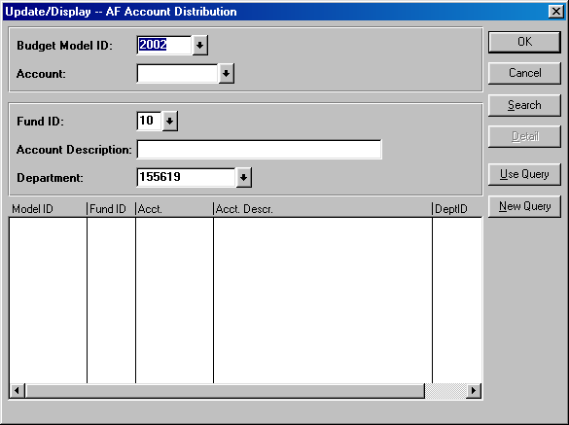

- In the Search dialog box, the Proposed model is defaulted. If you would like to work in a different model, you can type in the desired model number, or you can click on the down arrow and select from the valid values in the secondary screen.
- If you know the account that you would like to budget for, you can type in the 8 to 10-digit account number.
- If you don’t know the account number, type the fund code of the account and click the Search button.
- The system will then list all of the accounts in your organizational area within the selected fund.
- You should not use the Account down arrow to look for the account number you need because the valid value list on the secondary panel is not just for the accounts in your area, it is for all 2000 of the accounts.
- You will notice that the department ID defaulted to the one in the previous Organizational Rollup panel. That is the advantage of starting your PeopleSoft budgeting session from the Organizational Rollup panel.
- Also, since you right-clicked on a State Purpose row the system knows to bring you to the AF Account Distribution search dialog box.
- The AF Account Distribution panel group is used to budget accounts in the following funds:
- Fund 10 – State Purpose
- Fund 30 – Dormitory
- Fund 40 – Hospital
- Fund 60 – Veterans Home
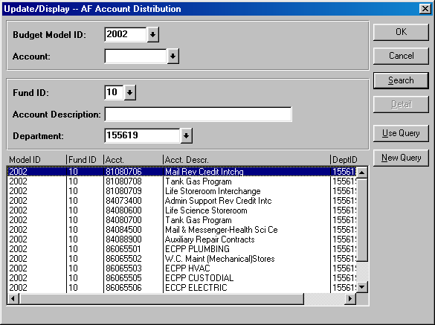
- After you select the fund and click the Search button, you will see a listing similar to the one below. This is all of the fund 10 accounts in 155619 (Central Services).

- Select the account that you would like to budget and click OK.

AF Account Distribution Panel Group

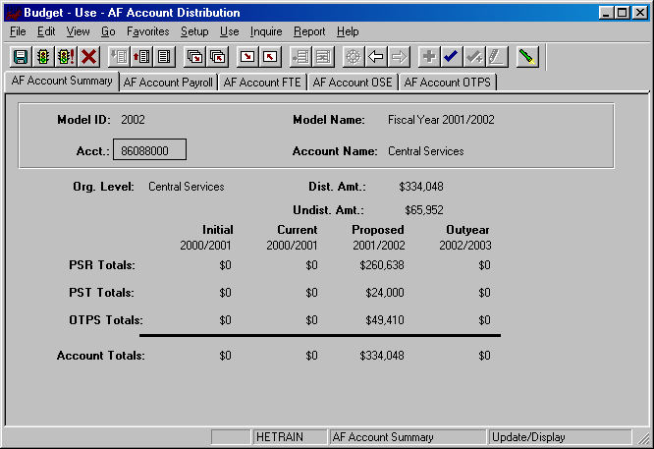
- You are now in the AF Account Distribution panel group.
- There are five panels in this panel group. The panel tabs are displayed under the command buttons.
- AF Account Summary panel
- AF Account Payroll panel
- AF Account FTE panel
- AF Account OSE (in Aggregate) panel
- AF Account OTPS panel
- You can click on the panel name to activate the panel or you can navigate using the Next Panel In Group button or the Previous Panel In Group button.
- You will see the model ID and the account number that you selected at the top of each of the panels in this group.
- You will notice that although you are in the Proposed model, you will see the corresponding budget information for the associated models.

AF Account Summary Panel
  - This first panel is a display only summary of the GL classes that have been budgeted on the account.
  - Under the account number and the account name, there is a distributed amount for the organizational level (department) that you selected in the Organizational Rollup panel.
    - The distributed amount is the same number that you saw in the Organizational Rollup panel.
    - The system is telling you that from your targeted allocation, you have distributed (or budgeted) $334,048 and that you have $65,952 left to distribute.
      - The distributed amount is for ALL of the accounts within the organizational level and fund that you selected. The reason the distributed amount of $334,048 matches the account total is because account 86088000 is the only one with budgeted information. If you had other State Purpose accounts that were budgeted, the distributed amount would be larger.
    - You will only see the distributed and undistributed information if you start off in the Organizational Rollup panel.
  - As you can see from the title bar, this AF Account Distribution Panel group is under the Use menu. We accessed it from the Organizational Rollup panel on the Inquire menu, but you can also access it from Use. The advantage of going through the Organizational Rollup is the following:
    - The system will “remember” your department ID on the search dialog box.
    - The system will “remember” your distributed and undistributed amounts on the AF, IDC & IFR Account Distribution Summary panels. The distributed and undistributed amounts are not applicable for the SR and CPMP Account Distribution Summary panels.
  - Under the distributed and undistributed figures, you see PSR (Personal Services Regular), PST (Personal Services Temporary), OTPS (Other Than Personal Services) and account totals for all four associated models.
    - Initial – The numbers in this column are your final figures from last year’s Proposed model.
    - Current – Use the information in this column to project your budgetary needs for the current fiscal year. This model was pre-loaded with a current payroll snapshot and the OTPS data from last year’s Proposed model.
    - Proposed – Use the information in this column to project your budgetary needs for the upcoming fiscal year. The final version of this model will be used to load various financial systems. For example, the Proposed data in appropriated funds (including IFRs) will be used to load the initial allocation from SUNY.
    - Outyear – This column contains your anticipated budget for the budget period two years from now. Please note that the data in the Outyear model will not be carried forward to next year’s associated models.
  - During next year’s budget cycle, the information that you budget for this year’s Proposed will become next year’s Initial.

AF Account Payroll Panel
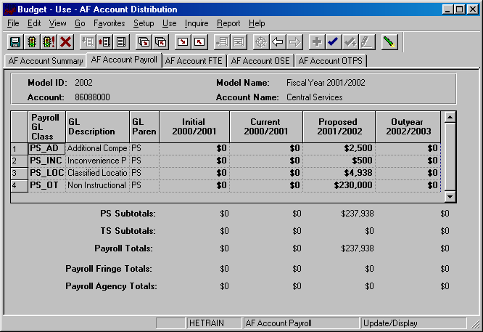

- This panel is a display only sub-total of the employee records by GL class. To modify the numbers on this panel, you will need to modify the employee records associated with this account. (Unit 5 provides instructions on viewing the employees that are charged to a particular account.)
- Since you are in the Proposed model, you are viewing all of the payroll GL class sub-totals in that model. You are also viewing the corresponding budget numbers for the associated models.
- This means that you will only see budget values for the three associated models if there is budgeted information for that expense in the Proposed model.
- To view all of the budgeted GL classes in an associated model, you must select that model in the Search dialog box.
- The first two columns in the grid contain the GL classes and their descriptions.
- The third column contains the GL Parent field. This column indicates whether the GL class is under the PS (personal services regular) node or the TS (personal services temporary) node. There are also PS and TS sub-totals by model under the grid.
- The Payroll Fringe Totals are only calculated for applicable funds (i.e., IFRs, SR, IDC and CPMP).
- The Payroll Agency Totals are only calculated for CPMP staff.

AF Account FTE Panel
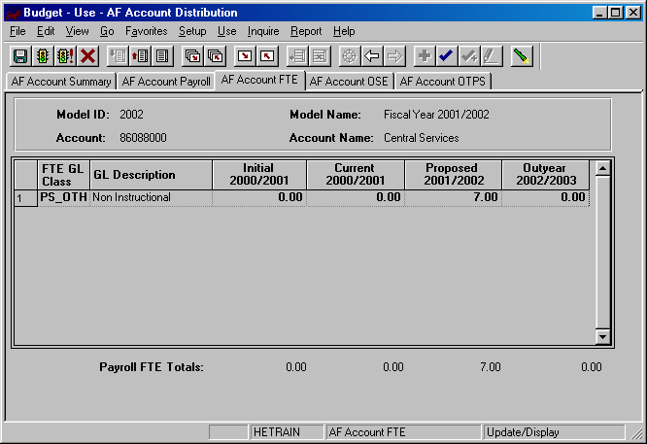
- This panel is similar to the AF Account Payroll panel except that instead of summarizing salaries, the system is summarizing FTE numbers.
- FTEs are summarized for base salary regular GL classes only.
AF Account OSE (in Aggregate) Panel
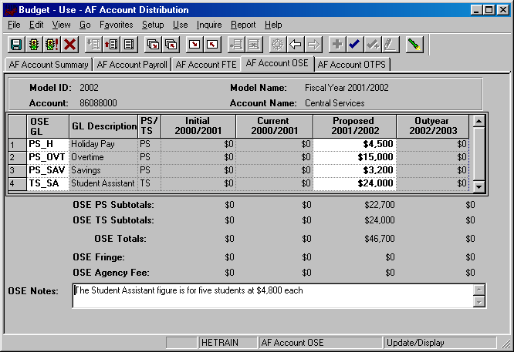
- This is the panel you will use to budget other salary expenses (OSE) in aggregate by account. The OSE in aggregate expenditures are salary expenses that you want to budget in a lump sum for the account, rather than by employee. For example, you may not know which employee will be working holidays, but you do know that you need to budget for that expense. So, rather than budgeting it for each employee, you can budget it here in total for the account.
- Student assistant expenditures should be budgeted in aggregate on this panel. Their employee records were not loaded on the system.
- The white fields are directly modifiable.
- Since you are in the Proposed model, only the Proposed column is modifiable. If you would like to enter data in another model, you have to first change the model you are in.
- To change the model:
- Click on the Update/Display button.
- You will be prompted with a search dialog box.
- Enter the desired model and account and click OK.
- To budget for a OSC GL class that is not on the grid:
- Click anywhere on the grid and click on the Insert Row command button.
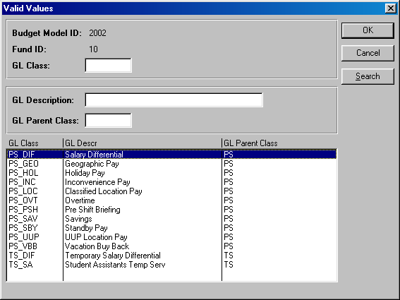
- On the new row, click the arrow in the OSE GL Class column. You will then see the list of valid values shown below.

- The list of values contains a column for GL Parent Class. This determines whether a category is personal services regular (PS) or personal services temporary (TS). Since GL Parent Class is also a search key, you can use Search for OSE GL classes in specific GL Parent Classes.
- Please note that the set of GL classes you can use depends on the fund or fund type that your account belongs to.
- The list above is valid for OSE in aggregate expenditures in all appropriated funds (including IFRs).
- Select the OSE GL class that you would like to budget and click OK.
- Once you tab off of the GL class field on the grid, you will see the description of the GL class will be displayed.
- Tab to the writable white field and enter the amount that you would like to budget for the selected GL class. When you tab off of the field, you will notice the sub-totals at the bottom of the panel are updated.
- As with the AF Account Payroll panel, there is a sub-total for PS, TS, fringe and agency fee.
- A note field has been provided so that you can enter clarifying notes.
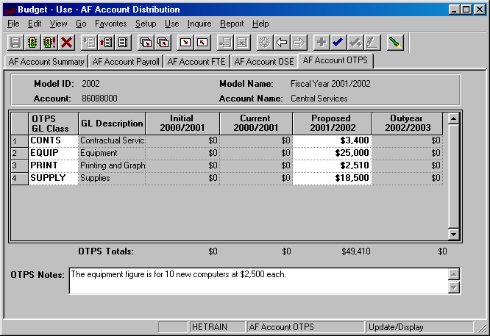
AF Account OTPS Panel

- This is the panel you will use to budget Other Than Personal Services (OTPS) expenditures.
- The white fields are directly modifiable.
- Since you are in the Proposed model, only the Proposed column is modifiable. If you would like to enter data in another model, you have to first change the model you are in.
- To change the model:
- Click on the Update/Display button.
- You will be prompted with a search dialog box.
- Enter the desired model and account and click OK.
- To budget for a OTPS GL class that is not on the grid:
- Click anywhere on the grid and click on the Insert Row command button.
- On the new row, click the arrow in the OTPS GL Class column. You will then see the list of valid values for OTPS GL classes below.
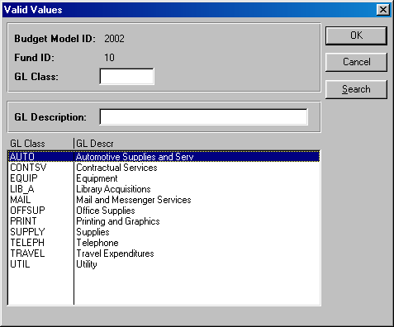
- This list is valid for OTPS GL classes in all appropriated funds (including IFRs) except fund 40. For fund 40 (Hospital), the expenditure categories from the Lawson financial system will be displayed.
- The following is a list of the OTPS expenditures for the Hospital fund:
500400 Advertising
800725 Anesthetic Materials
823251 Books, Subcrip, Memberships
802701 Cleaning
814671 Collection Agency Fees
803701 Consulting
804335 Data Processing Fees
817135 Empl Benefits Non Payroll
817150 Employee Wearing Apparel
805401 Equip Repair/Maint
805601 Equip<$ 500
806301 Expenses Other
806725 Food - Meat, Fish, Poultry
806701 Food Other
809401 Insurance
809851 IV Solutions
810305 Lease / Rental Other
810255 Lease/Rental Bldg Fixed Equip
810260 Lease/Rental Moving Equipment
810725 Licenses and Taxes
810790 Linen & Bedding
805125 Major Movable Equipment >500
812601 Office Supplies
806535 Other Fees
823340 Other Med Care Supplies
823345 Other Non Med & Non Surg Suppl
813001 Other Purch Serv (incl rental)
822410 Outside Training Registr Fees
813255 Oxygen & Other Med Gases
813425 Pharmaceuticals
813801 Postage & Shipping
813901 Printing & Reproduction
814501 Professional Services Audit
814601 Professional Services Legal
813430 Prosthesis
813061 Purch Serv - Manpower
813051 Purch Serv Laundry & Linen
806502 Radioactive Materials
823350 Radiology Film
814405 Services - Medical
822301 Spec Contractual Serv.
823355 Surgical Supplies - General
823690 Tableware & Kitchen Utensils
823801 Telephone
824551 Transcription Fees
826802 Travel & Lodging
827401 Utilities - Electricity
827721 Utilities - Fuel Oil
827725 Utilities - Other
827601 Utilities - Sewage
010158 Utilities - Steam
827701 Utilities - Water

- Select the OTPS GL class that you would like to budget and click OK.
- Once you tab off of the GL class field on the grid, you will see the description of the GL class will be displayed.
- Tab to the writable white field and enter the amount that you would like to budget for the selected GL class. When you tab off of the field, you will notice the sub-totals at the bottom of the panel are updated.
- A note field has been provided so that you can enter clarifying notes.

CPMP Account Distribution Panel Group

- Since the budgets for the CPMP accounts are not driven by allocation, it is not necessary to access these accounts through the Organizational Rollup panel.
- From the Use menu, select CPMP Account Distribution. You will then see the following search dialog box.
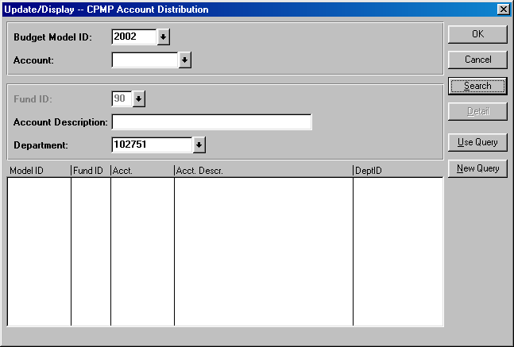
- Since the CPMP Account Distribution panel group is valid only for fund 90, the fund code is automatically entered for you. Enter your department ID and click the Search button.
- From the list of accounts, select the account that you wish to budget and click OK.

CPMP Account Summary Panel
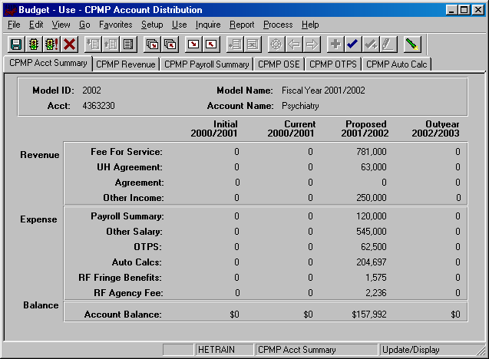
- You are now in the CPMP Account Distribution panel group.
- There are six panels in this panel group. The panel tabs are displayed under the command buttons.
- CPMP Account Summary panel
- CPMP Payroll panel
- CPMP Revenue panel
- CPMP OSE (in Aggregate) panel
- CPMP Auto Calc panel
- CPMP OTPS panel
- You can click on the panel name to activate the panel or you can navigate using the Next Panel In Group button or the Previous Panel In Group button.
- You will see the model ID and the account number that you selected at the top of each of the panels in this group.
- You will notice that although you are in one model, you will see the corresponding budget information for the related models.
- The CPMP Account Summary panel is a display only summary of the GL classes that have been budgeted on the account.
  - The panel is separated into three sections: Revenue, Expense and Balance. These sections are sub-totaled for all four associated models.
    - Initial – The numbers in this column are your final figures from last year’s Proposed model.
    - Current – Use the information in this column to project your budgetary needs for the current fiscal year. This model was pre-loaded with a current payroll snapshot and the OTPS data from last year’s Proposed model.
    - Proposed – Use the information in this column to project your budgetary needs for the upcoming fiscal year. The final version of this model will be used to load various financial systems.
    - Outyear – This column contains your anticipated budget for the budget period two years from now. Please note that the data in the Outyear model will not be carried forward to next year’s associated models.
  - During next year’s budget cycle, the information that you budget for this year’s Proposed will become next year’s Initial.

CPMP Revenue Panel
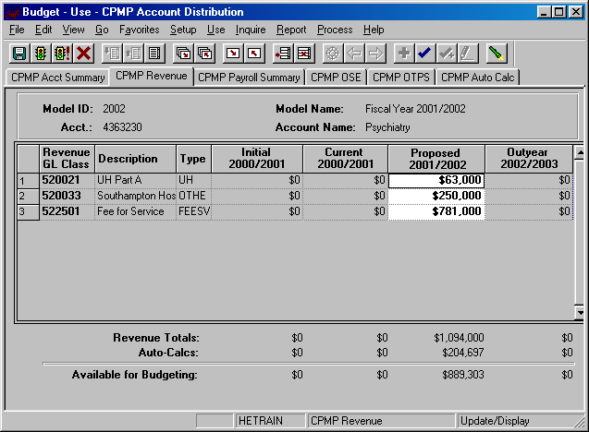
- This panel contains the revenue details that are sub-totaled on the CPMP Account Summary panel.
- The white fields are directly modifiable.
- Since you are in the Proposed model, only the Proposed column is modifiable. If you would like to enter data in another model, you have to first change the model you are in.
- To change the model:
- Click on the Update/Display button.
- You will be prompted with a search dialog box.
- Enter the desired model and account and click OK.
- To budget for a revenue category that is not on the grid:
- Click anywhere on the grid and click on the Insert Row command button.
- On the new row, click the arrow in the Revenue GL Class column. You will then see the list of valid values for CPMP revenue shown below.
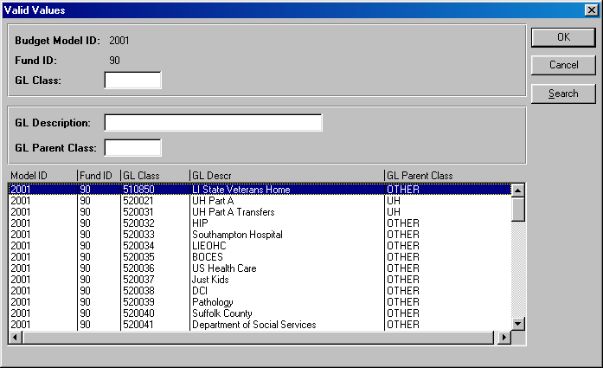
- The list of values contains a column for GL Parent Class. This determines the grouping of the revenue on the CPMP Account Summary panel. Since GL Parent Class is also a search key, you can use Search for revenue GL classes in specific GL Parent Classes.
- Select the revenue GL class that you would like to budget and click OK.
- Once you tab off of the GL class field on the grid, you will see the description of the GL class will be displayed.
- Tab to the write-able white field and enter the amount that you would like to budget for the selected GL class. When you tab off of the field, you will notice the sub-totals at the bottom of the panel are updated.

- The list below contains a current list of valid values for CPMP revenue grouped by the GL parent class.
FEESVC - Fee for Service
522501 Fee for Service
UH - UH Agreements
521002 Coram Health Center Agreement
522001 UH Medicaid
520021 UH Part A
520031 UH Part A Transfers
522041 UH Part B
522011 UH Back Program
AGREE - Agreements
521001 Brookhaven National Lab Agreement
521003 Developmental Disability Agree
521004 Eastern Hospital Agreement
521005 Epilepsy Foundation Agreement
521006 Family Service League Agreement
521007 St Johnland Nursing Ctr
521008 Lab Animal Resources Agreement
521009 Maryhaven Center Hope Agreement
521010 Planned Parenthood Agreement
521011 School of Dental Med Agreement
521012 St Charles Neo-Natal Agreement
521013 St John's Hospital Agreement
521014 UCP PSY Agreement
521015 UCP PSY Greater NY Agreement
521016 Winthrop UH Agreement
521017 National Inst Peo/Disbl Agreement
OTHER - Other Income
510850 LI State Veterans Home
520032 HIP
520033 Southampton Hospital
520034 LIEOHC
522551 VA Salary Revenue
520035 BOCES
520036 US Health Care
520037 Just Kids
520415 Contractual
520416 Board Fund
520417 Deans Fund
520418 Billing Cost
520419 Administrative Costs

CPMP Payroll Summary Panel
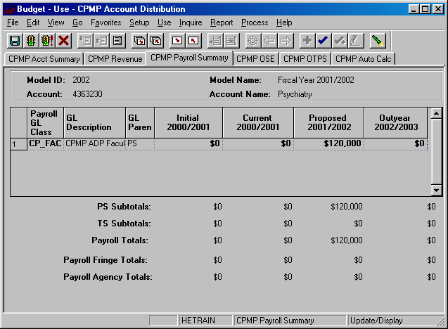
- This panel is a display only sub-total of the employee records by GL class. To modify the numbers on this panel, you will need to modify the employee records associated with this account. (Unit 5 provides instructions on viewing employees by account.)
- Since you are in the Proposed model, you are viewing all of the payroll GL class sub-totals in that model. You are also viewing the corresponding budget numbers for the associated models.
- This means that you will only see budget values for the three associated models if there is budgeted information for that expense in the Proposed model.
- To view all of the budgeted GL classes in an associated model, you must select that model in the Search dialog box.
- The first two columns in the grid contain the GL classes and their descriptions.
- The third column contains the GL Parent field. This column indicates whether the GL class is under the PS (personal services regular) node or the TS (personal services temporary) node. There are also PS and TS sub-totals by model under the grid.
- The Payroll Fringe Totals are only calculated for applicable funds (i.e., IFRs, SR, IDC and CPMP).
- The Payroll Agency Totals are only calculated for CPMP staff.

CPMP OSE (in Aggregate) Panel
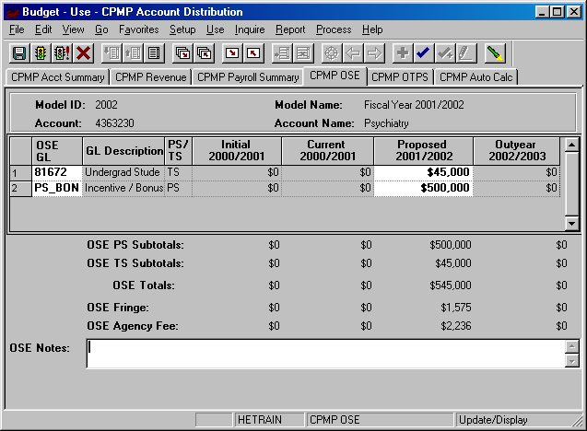
- This is the panel you will use to budget other salary expenses (OSE) in aggregate by account. The OSE in aggregate expenditures are salary expenses that you want to budget in a lump sum for the account, rather than by employee. For example, you may not know which employee will be receiving incentive payments, but you do know that you need to budget for that expense. So, rather than budgeting it for each employee, you can budget it here in total for the account.
- Student assistant expenditures should be budgeted in aggregate on this panel. Their employee records were not loaded on the system.
- The white fields are directly modifiable.
- Since you are in the Proposed model, only the Proposed column is modifiable. If you would like to enter data in another model, you have to first change the model you are in.
- To change the model:
- Click on the Update/Display button.
- You will be prompted with a search dialog box.
- Enter the desired model and account and click OK.
- To budget for a OSC GL class that is not on the grid:
- Click anywhere on the grid and click on the Insert Row command button.
- On the new row, click the arrow in the OSE GL Class column. You will then see the list of valid values shown below.
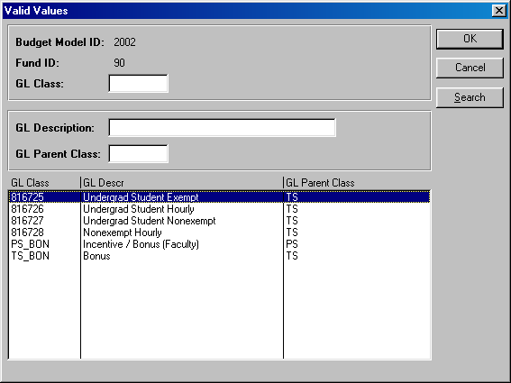
- The list of values contains a column for GL Parent Class. This determines whether a category is personal services regular (PS) or personal services temporary (TS). Since GL Parent Class is also a search key, you can use Search for OSE GL classes in specific GL Parent Classes.
- Please note that the set of GL classes you can use depends on the fund or fund type that your account belongs to.
- Select the OSE GL class that you would like to budget and click OK.
- Once you tab off of the GL class field on the grid, you will see the description of the GL class will be displayed.
- Tab to the write-able white field and enter the amount that you would like to budget for the selected GL class. When you tab off of the field, you will notice the sub-totals at the bottom of the panel are updated.
- As with the CPMP Payroll Summary panel, there is a sub-total for PS, TS, fringe and agency fee.
- A note field has been provided so that you can enter clarifying notes.

CPMP OTPS Panel
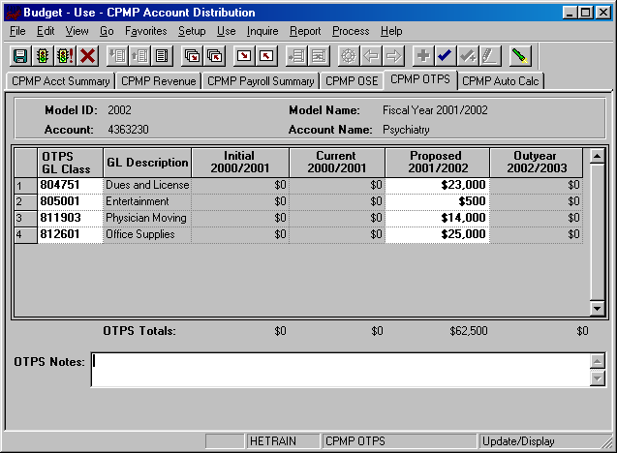
- This is the panel you will use to budget Other Than Personal Services (OTPS) expenditures.
- The white fields are directly modifiable.
- Since you are in the Proposed model, only the Proposed column is modifiable. If you would like to enter data in another model, you have to first change the model you are in.
- To change the model:
- Click on the Update/Display button.
- You will be prompted with a search dialog box.
- Enter the desired model and account and click OK.
- To budget for a OTPS GL class that is not on the grid:
- Click anywhere on the grid and click on the Insert Row command button.
- On the new row, click the arrow in the OTPS GL Class column. You will then see the list of valid values for OTPS GL classes shown below.
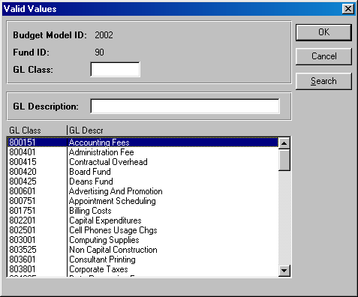
- Select the OTPS GL class that you would like to budget and click OK.

- Once you tab off of the GL class field on the grid, you will see the description of the GL class will be displayed.
- Tab to the write-able white field and enter the amount that you would like to budget for the selected GL class. When you tab off of the field, you will notice the sub-totals at the bottom of the panel are updated.
- A note field has been provided so that you can enter clarifying notes.

CPMP Auto Calc Panel
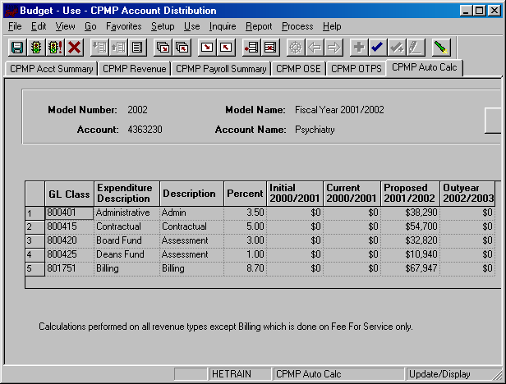
- This panel contains a grid with display-only information for revenue assessments.
- These assessments are automatically calculated on the revenue in the CPMP Revenue panel.
- The first three columns on the grid contain the GL class and the description of these automatic calculations.
- The fourth column contains the rate of each auto calc.
- The next four columns contain the calculated amounts by model ID.
- All of the auto calcs are assessed on all the revenue types except for Billing which is assessed on Fee-For-Service only.

IDC Account Distribution Panel Group

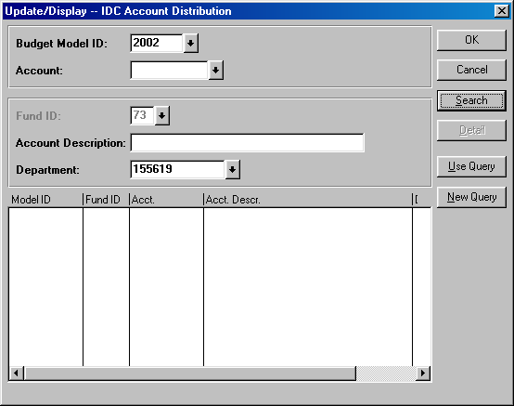
- Similar to the AF Account Distribution panel group, it is recommended the you access your IDC accounts through the Organizational Rollup panel. When you right click on the IDC row (fund 73) on the Organizational Rollup panel, you will get the search dialog box below.

- Since the IDC Account Distribution panel group is valid only for fund 73, the fund code is automatically entered for you.
- Since you started with the Organizational Rollup panel, the system “remembers” your Department ID.
- For the search dialog box, click the Search button and select the IDC account you wish to budget.
- You are now in the IDC Account Distribution panel group
- There are four panels in this panel group. The panel tabs are displayed under the command buttons.
- IDC Account Summary panel
- IDC Account Payroll panel
- IDC Account OSE (in Aggregate) panel
- IDC Account OTPS panel
- You can click on the panel name to activate the panel or you can navigate using the Next Panel In Group button or the Previous Panel In Group button.
- You will see the model ID and the account number that you selected at the top of each of the panels in this group.
- You will notice that although you are in one model, you will see the corresponding budget information for the related models.
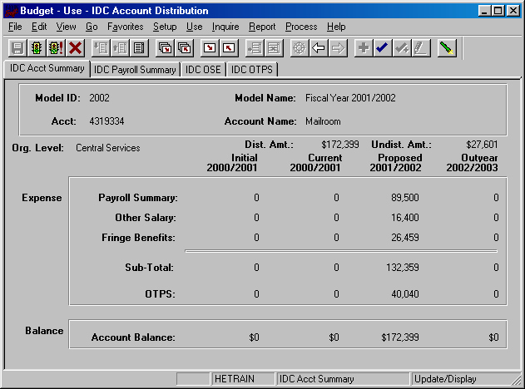
IDC Account Summary Panel

- This first panel is a display only summary of the GL classes that have been budgeted on the account.
- Under the account number and the account name, there is a distributed amount for the organizational level (department) that you selected in the Organizational Rollup panel.
- The distributed amount is the same number that you saw in the Organizational Rollup panel.
- The system is telling you that from your targeted allocation, you have distributed (or budgeted) $172,399 and that you have $27,601 left to distribute.
- The distributed amount is for ALL of the accounts within the organizational level and fund that you selected. The reason the distributed amount of $172,399 matches the account total is because account 4319334 is the only one with budgeted information. If there were other IDC accounts that were budgeted, the distributed amount would be larger.
- You will only see the distributed and undistributed information if you start off in the Organizational Rollup panel.
- As you can see from the title bar, this IDC Account Distribution Panel group is under the Use menu. We accessed it from the Organizational Rollup panel on the Inquire menu, but you can also access it from Use. The advantage of going through the Organizational Rollup is the following:
- The system will “remember” your department ID on the search dialog box.
- The system will “remember” your distributed and undistributed amounts on the AF, IDC & IFR Account Distribution Summary panels. The distributed and undistributed amounts are not applicable for the SR and CPMP Account Distribution Summary panels.
- Under the distributed and undistributed figures, you see Payroll Summary, Other Salary, Fringe Benefits, OTPS and the Account Balance for all four associated models.
    - Initial – The numbers in this column are your final figures from last year’s Proposed model.
    - Current – Use the information in this column to project your budgetary needs for the current fiscal year. This model was pre-loaded with a current payroll snapshot and the OTPS data from last year’s Proposed model.
    - Proposed – Use the information in this column to project your budgetary needs for the upcoming fiscal year. The final version of this model will be used to load various financial systems.
    - Outyear – This column contains your anticipated budget for the budget period two years from now. Please note that the data in the Outyear model will not be carried forward to next year’s associated models.
  - During next year’s budget cycle, the information that you budget for this year’s Proposed will become next year’s Initial.
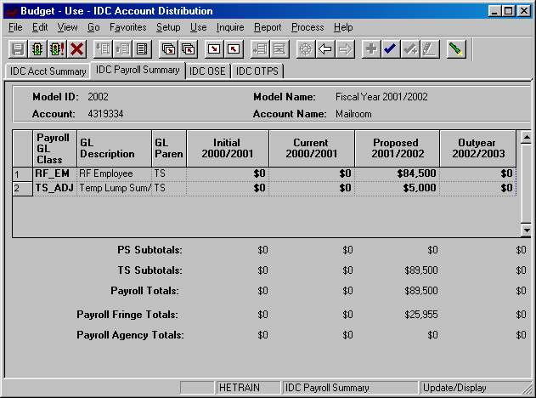
IDC Payroll Summary Panel

- This panel is a display only sub-total of the employee records by GL class. To modify the numbers on this panel, you will need to modify the employee records associated with this account. (Unit 5 provides instructions on viewing employees by account.)
- Since you are in the Proposed model, you are viewing all of the payroll GL class sub-totals in that model. You are also viewing the corresponding budget numbers for the associated models.
- This means that you will only see budget values for the three associated models if there is budgeted information for that expense in the Proposed model.
- To view all of the budgeted GL classes in an associated model, you must select that model in the Search dialog box.
- The first two columns in the grid contain the GL classes and their descriptions.
- The third column contains the GL Parent field. This column indicates whether the GL class is under the PS (personal services regular) node or the TS (personal services temporary) node. There are also PS and TS sub-totals by model under the grid.
- The Payroll Fringe Totals are only calculated for applicable funds (i.e., IFRs, SR, IDC and CPMP).
- The Payroll Agency Totals are only calculated for CPMP staff.

IDC OSE (in Aggregate) Panel
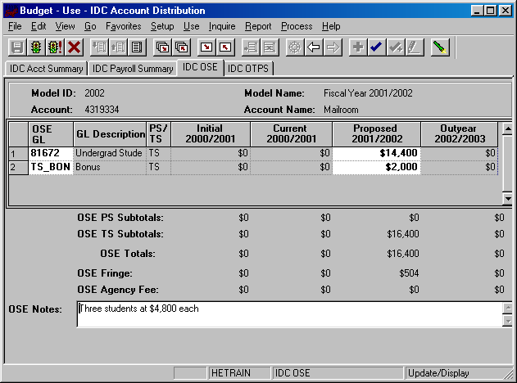
- This is the panel you will use to budget other salary expenses (OSE) in aggregate by account. The OSE in aggregate expenditures are salary expenses that you want to budget in a lump sum for the account, rather than by employee. For example, you may not know which employee will be getting a bonus, but you do know that you need to budget for that expense. So, rather than budgeting it for each employee, you can budget it here in total for the account.
- Student assistant expenditures should be budgeted in aggregate on this panel. Their employee records were not loaded on the system.
- The white fields are directly modifiable.
- Since you are in the Proposed model, only the Proposed column is modifiable. If you would like to enter data in another model, you have to first change the model you are in.
- To change the model:
- Click on the Update/Display button.
- You will be prompted with a search dialog box.
- Enter the desired model and account and click OK.
- To budget for a OSC GL class that is not on the grid:
- Click anywhere on the grid and click on the Insert Row command button.
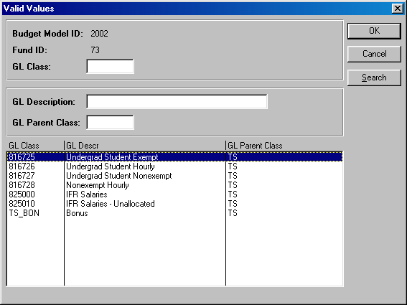
- On the new row, click the arrow in the OSE GL Class column. You will then see the list of valid values shown below.

- The list of values contains a column for GL Parent Class. Since GL Parent Class is also a search key, you can use Search for OSE GL classes in specific GL Parent Classes.
- Select the OSE GL class that you would like to budget and click OK.
- Once you tab off of the GL class field on the grid, you will see the description of the GL class will be displayed.
- Tab to the write-able white field and enter the amount that you would like to budget for the selected GL class. When you tab off of the field, you will notice the sub-totals at the bottom of the panel are updated.
- As with the Account Payroll panel, there is a sub-total for PS, TS, fringe and agency fee.
- A note field has been provided so that you can enter clarifying notes.
- Please note that the set of GL classes you can use depends on the fund or fund type that your account belongs to.
- The list above is valid for the OSE panel in the IDC Account Distribution panel group and the SR Account Distribution panel group.

IDC OTPS Panel
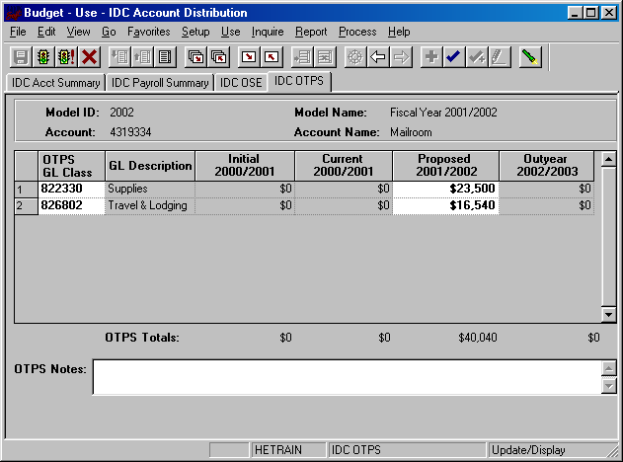
- This is the panel you will use to budget Other Than Personal Services (OTPS) expenditures.
- The white fields are directly modifiable.
- Since you are in the Proposed model, only the Proposed column is modifiable. If you would like to enter data in another model, you have to first change the model you are in.
- To change the model:
- Click on the Update/Display button.
- You will be prompted with a search dialog box.
- Enter the desired model and account and click OK.
- To budget for a OTPS GL class that is not on the grid:
  - Click anywhere on the grid and click on the Insert Row command button.
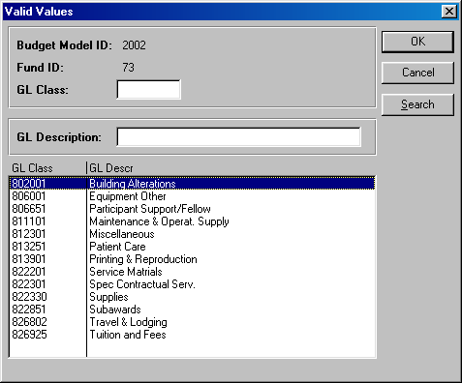
  - On the new row, click the arrow in the OTPS GL Class column. You will then see the list of valid values for OTPS GL classes shown below.

  - Select the OTPS GL class that you would like to budget and click OK.

- Once you tab off of the GL class field on the grid, you will see the description of the GL class will be displayed.
- Tab to the write-able white field and enter the amount that you would like to budget for the selected GL class. When you tab off of the field, you will notice the sub-totals at the bottom of the panel are updated.
- A note field has been provided so that you can enter clarifying notes.
- The list above is valid for the OTPS panel in the IDC Account Distribution panel group and the SR Account Distribution panel group.

IFR Account Distribution Panel Group

- IFR accounts are accounts in the following funds:

Fund 20 – General IFR
Fund 25 – SUTRA
Fund 35 – Dormitory IFR
Fund 45 – Hospital IFR
- Since targets are not set for IFR accounts by VP area, you need not start in the Organizational Rollup panel. From the Use menu, select IFR Account Distribution. You will then see the following search dialog box
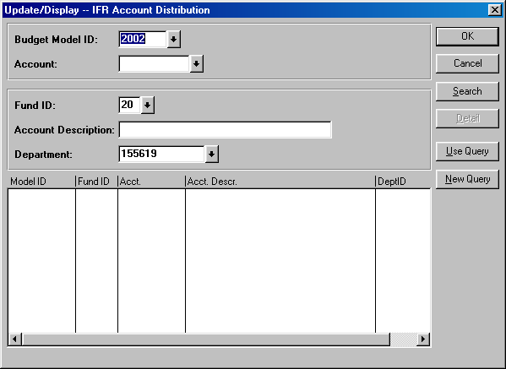
- Enter the IFR fund that you wish to select an account from and enter your department ID. Then click the Search button.

- You will then see a list of all of the accounts that match your search criteria.
- In the screen print below, the system displays all of the General IFR accounts within Central Services.
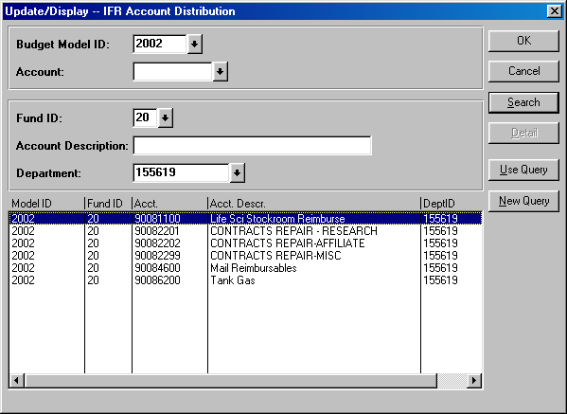
- From the list of accounts, select the account that you wish to budget and click OK.

IFR Summary Panel
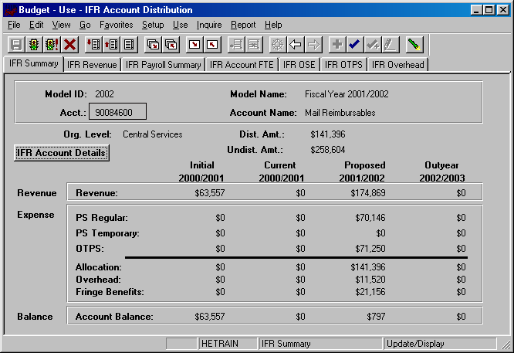
- You are now in the IFR Account Distribution panel group.
- There are six panels in this panel group. The panel tabs are displayed under the command buttons.
- IFR Summary panel
- IFR Revenue panel
- IFR Payroll Summary panel
- IFR OSE (in Aggregate) panel
- IFR OTPS panel
- IFR Overhead panel
- You can click on the panel name to activate the panel or you can navigate using the Next Panel In Group button or the Previous Panel In Group button.
- You will see the model ID and the account number that you selected at the top of each of the panels in this group.
- You will notice that although you are in one model, you will see the corresponding budget information for the related models.

The IFR Summary panel is a display only summary of the GL classes that have been budgeted on the account.
- If you selected this panel group from the Organizational Rollup panel you will see a distributed amount for the organizational level (department) that you selected. This is located under the account number and the account name.
- The distributed amount is the same number that you saw in the Organizational Rollup panel.
- The system is telling you that from your targeted allocation, you have distributed (or budgeted) $141,396 and that you have $258,604 left to distribute.
- The distributed amount is for ALL of the accounts within the organizational level and fund that you selected. You have $141,285 budgeted in allocation, which equals the distributed amount. This is because you have only budgeted on this account.
- As you can see from the title bar, this AF Account Distribution Panel group is under the Use menu. We accessed it from the Organizational Rollup panel on the Inquire menu, but you can also access it from Use. The advantage of going through the Organizational Rollup is the following:
- The system will “remember” your department ID on the search dialog box.
- The system will “remember” your distributed and undistributed amounts on the AF, IDC & IFR Account Distribution Summary panels.
- Under the distributed and undistributed figures, you see a Revenue section and an Expense section.
- The Revenue section is a sub-total of the information in the IFR Revenue panel.
- The expense section contains sub-totals for PS Regular, PS Temporary, OTPS as well as an Allocation sub-total for all three.
- The expense section also contains the Overhead total and the Fringe Benefit total.
- The Balance section is the difference between the Revenue section and the Expense section.
- This information is displayed for all four associated models.
    - Initial – The numbers in this column are your final figures from last year’s Proposed model.
    - Current – Use the information in this column to project your budgetary needs for the current fiscal year. This model was pre-loaded with a current payroll snapshot and the OTPS data from last year’s Proposed model.
    - Proposed – Use the information in this column to project your budgetary needs for the upcoming fiscal year. The final version of this model will be used to load various financial systems. For example, the Proposed data in appropriated funds (including IFRs) will be used to load the initial allocation from SUNY.
    - Outyear – This column contains your anticipated budget for the budget period two years from now. Please note that the data in the Outyear model will not be carried forward to next year’s associated models.
  - During next year’s budget cycle, the information that you budget for this year’s Proposed will become next year’s Initial.

IFR Account Details Panel
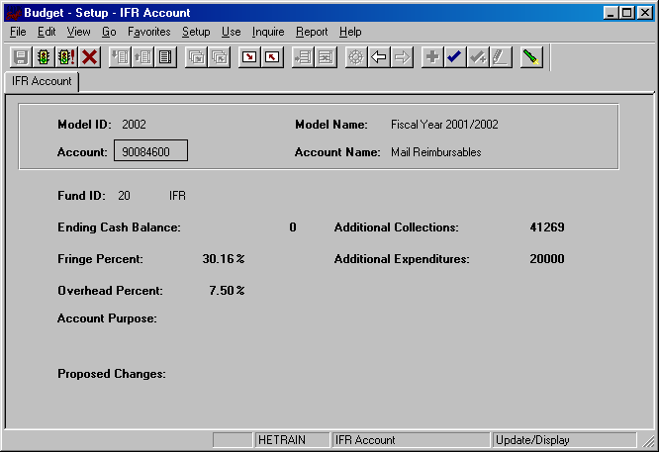
- When you click on the IFR Account Details button on the IFR Summary panel, you will see the panel below. This panel contains information about the fringe benefit rate and overhead rate assessed on the account.
Back button

- To get back to the IFR Account Distribution panel group, click on the Back button.
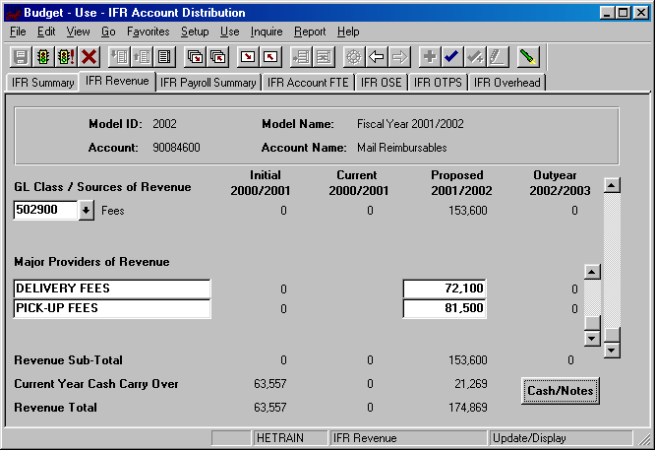

IFR Revenue Panel

- This panel contains the revenue details that are sub-totaled on the IFR Summary panel.
- As in prior years, you must detail the Sources of Revenue and Major Providers of Revenue. However, now there is a parent-child relationship between Sources of Revenue and Major Providers of Revenue. That is, for each Source of Revenue, you must list the corresponding Major Providers of Revenue.
- Use the outer scroll bar to scroll between Sources of Revenue. Use the inner scroll bar to scroll between the Major Providers of Revenue of a particular Source of Revenue.
- To insert a Source of Revenue, click on the arrow in field under the Sources of Revenue label. You will then see the list of valid values for Source of Revenue shown below.

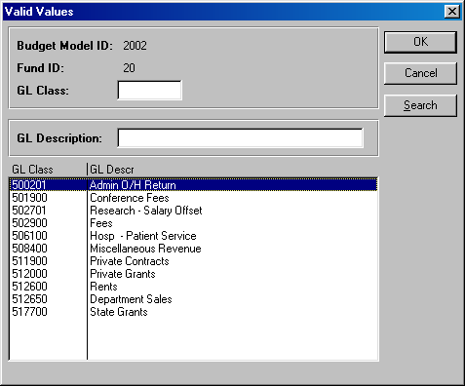
- Select the desired Source of Revenue and click OK. Once you tab off the field, you will see the description of the Source of Revenue you selected.
- The numeric field to the right of the Source of Revenue field is display only. It is a sub-total of Major Providers of Revenue entries.
- Click on the editable box under Major Providers of Revenue. Enter the description of the Major Provider of Revenue and tab to the right to enter the corresponding amount.
- Typically each IFR account has one Source of Revenue. To enter additional Sources of Revenue, click the Insert Row button while in the Sources of Revenue section.
- To enter additional Major Providers of Revenue, click the Insert Row button while in the Major Providers of Revenue section.
- Once you have entered the Sources of Revenue and Major Providers of Revenue that you are anticipating for the Proposed fiscal year, click on the Cash/Notes button located at the bottom right-hand corner of the IFR Revenue panel.
- You will then see the secondary panel displayed on the next page.
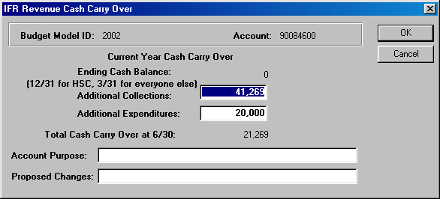
- Use this panel to project your cash balance at the end of this Current year.
- The Ending Cash Balance is as of 12/31 for HSC users, and 3/31 for West Campus and Hospital users.
- In the Additional Collections field, enter collections you expect for the remainder of the current year. The collection figure should be net of applicable overhead charges.
- In the Additional Expenditures field, enter the expenses you anticipate for the current year.
- The Total Cash Carry Over at 6/30 is the amount you anticipate carrying over from the Current year to the Proposed year. It is the sum of the Ending Cash Balance at 12/31 or 3/31 plus Additional Collections, less Additional Expenditures.
- In the example above, you anticipate carrying over $21,269 to the Proposed year.
- Once you have completed the IFR Revenue Cash Carry Over secondary panel, click OK to go back to the IFR Revenue panel.
- You are now done budgeting your revenue. From the Revenue panel previously display, you are projecting $153,600 in revenue for the Proposed year, and you are anticipating to carry over $21,269 from the Current year. The total revenue you can budget against is $174,869.
IFR Payroll Summary Panel
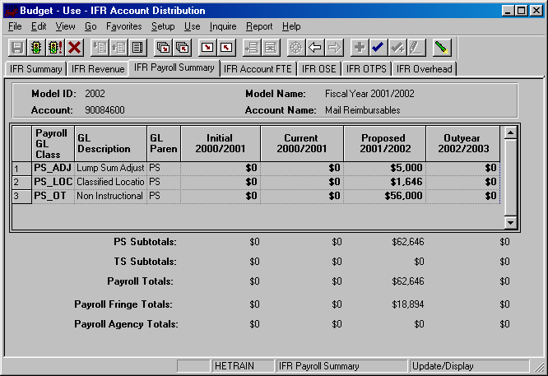
- This panel is a display only sub-total of the employee records by GL class. To modify the numbers on this panel, you will need to modify the employee records associated with this account. (Unit 6 provides instructions on viewing employees by account.)
- Since you are in the Proposed model, you are viewing all of the payroll GL class sub-totals in that model. You are also viewing the corresponding budget numbers for the associated models.
- This means that you will only see budget values for the three associated models if there is budgeted information for that expense in the Proposed model.
- To view all of the budgeted GL classes in an associated model, you must select that model in the Search dialog box.
- The first two columns in the grid contain the GL classes and their descriptions.
- The third column contains the GL Parent field. This column indicates whether the GL class is under the PS (personal services regular) node or the TS (personal services temporary) node. There are also PS and TS sub-totals by model under the grid.
- The Payroll Fringe Totals are only calculated for applicable funds (i.e., IFRs, SR, IDC and CPMP).
- The Payroll Agency Totals are only calculated for CPMP staff.

IFR OSE (in Aggregate) Panel
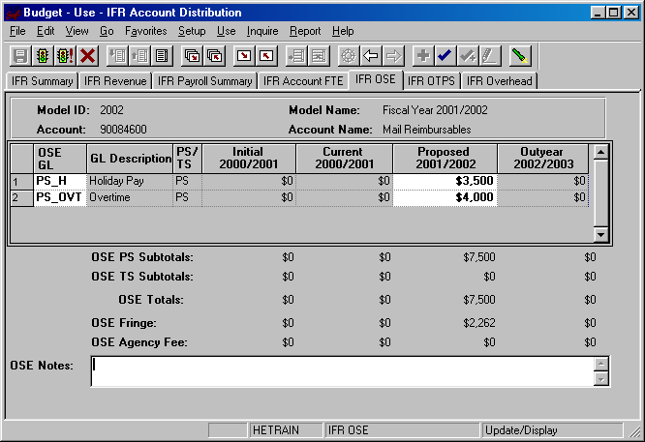
- This is the panel you will use to budget other salary expenses (OSE) in aggregate by account. The OSE in aggregate expenditures are salary expenses that you want to budget in a lump sum for the account, rather than by employee. For example, you may not know which employee will be working holidays, but you do know that you need to budget for that expense. So, rather than budgeting it for each employee, you can budget it here in total for the account.
- Student assistant expenditures should be budgeted in aggregate on this panel. Their employee records were not loaded on the system.
- The white fields are directly modifiable.
- Since you are in the Proposed model, only the Proposed column is modifiable. If you would like to enter data in another model, you have to first change the model you are in.
- To change the model:
- Click on the Update/Display button.
- You will be prompted with a search dialog box.
- Enter the desired model and account and click OK.
- To budget for an OSE GL class that is not on the grid:
- Click anywhere on the grid and click on the Insert Row command button.
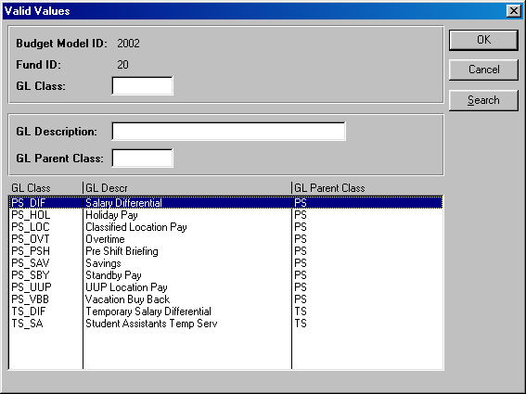
- On the new row, click the arrow in the OSE GL Class column. You will then see the list of valid values shown below.

- The list of values contains a column for GL Parent Class. This determines whether a category is personal services regular (PS) or personal services temporary (TS). Since GL Parent Class is also a search key, you can use Search for OSE GL classes in specific GL Parent Classes.
- Please note that the set of GL classes you can use depends on the fund or fund type that your account belongs to.
- The list above is valid for OSE in aggregate expenditures in all appropriated funds (including IFRs).
- Select the OSE GL class that you would like to budget and click OK.
- Once you tab off of the GL class field on the grid, you will see the description of the GL class will be displayed.
- Tab to the write-able white field and enter the amount that you would like to budget for the selected GL class. When you tab off of the field, you will notice the sub-totals at the bottom of the panel are updated.
- As with the Account Payroll panel, there is a sub-total for PS, TS, fringe and agency fee.
- A note field has been provided so that you can enter clarifying notes.
- The list of valid GL class values for this panel is the same as the list for the AF Account OSE panel in the AF Account Distribution panel group.

IFR OTPS Panel
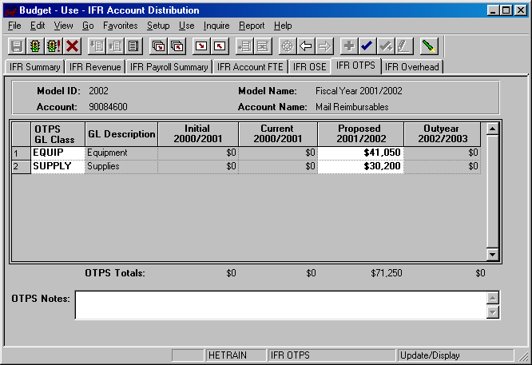
- This is the panel you will use to budget Other Than Personal Services (OTPS) expenditures.
- The white fields are directly modifiable.
- Since you are in the Proposed model, only the Proposed column is modifiable. If you would like to enter data in another model, you have to first change the model you are in.
- To change the model:
- Click on the Update/Display button.
- You will be prompted with a search dialog box.
- Enter the desired model and account and click OK.
- To budget for a OTPS GL class that is not on the grid:
- Click anywhere on the grid and click on the Insert Row command button.
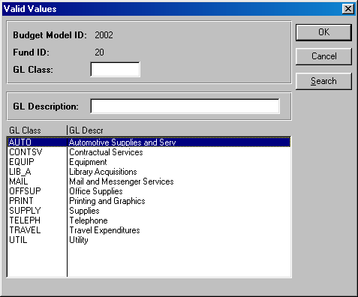
- On the new row, click the arrow in the OTPS GL Class column. You will then see the list of valid values for OTPS GL classes shown below.

- This list is valid for OTPS GL classes in all appropriated funds (including IFRs)
- Select the OTPS GL class that you would like to budget and click OK.
- Once you tab off of the GL class field on the grid, you will see the description of the GL class will be displayed.
- Tab to the write-able white field and enter the amount that you would like to budget for the selected GL class. When you tab off of the field, you will notice the sub-totals at the bottom of the panel are updated.
- A note field has been provided so that you can enter clarifying notes.

IFR Overhead Panel
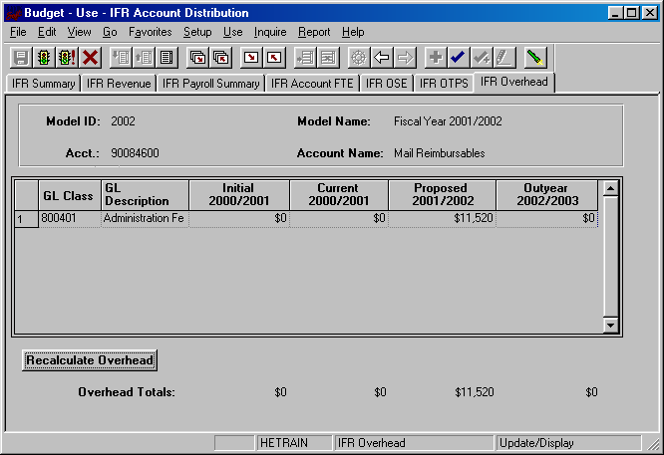
- This panel contains a display-only grid, which automatically calculates the Overhead on the account based on the rate that the account is assessed.
- The overhead calculation is performed on Revenue Sub-Total on the IFR Revenue panel, not on the Current Year Carry Over figure.

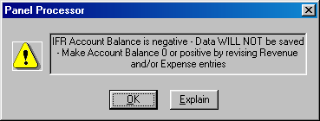
Please note that in order to save the IFR Account Distribution panel group, the account balance on the summary page must be zero or greater. If you attempt to save the panel with a deficit, you will get the following error message:

EXT Account Distribution Panel Group

- This panel group is only used to budget revenue. It is used to budget the revenue used to offset the salary supplements from external sources that are budgeted on employee records in the Employee Information panel group.
- There are three types of External funds:

Fund 93 – Northport VA
Fund 95 – Brookhaven National Labs
Fund 97 – Other
- Since the budget for the External accounts are not driven by allocation, it is not necessary to access these accounts through the Organizational Rollup panel.
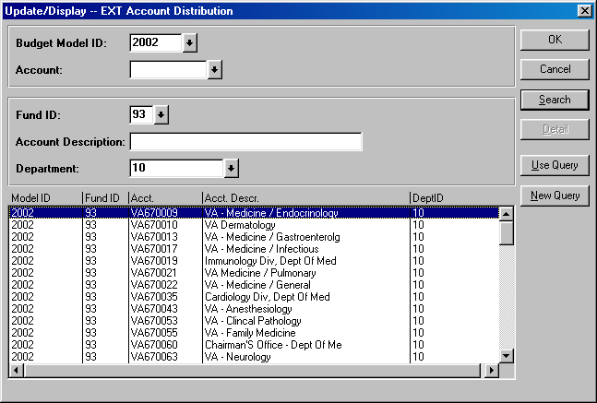
- From the Use menu, select EXT Account Distribution. You will then see the following search dialog box.

- Enter the desired fund in the Fund ID field. Then enter your department ID and click the Search button
- From the list of accounts, select the account that you wish to budget and click OK.

EXT Account Summary Panel
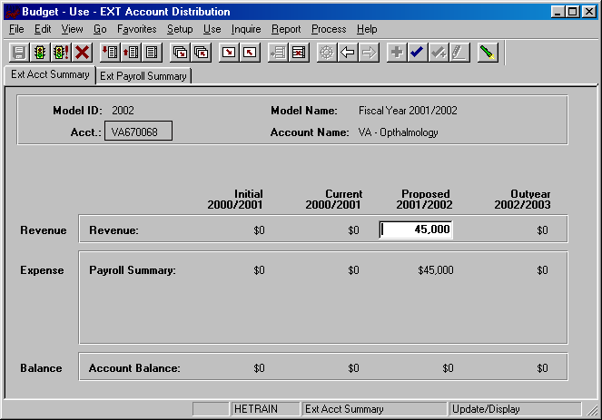
- You are now in the EXT Account Distribution panel group.
- OTPS and account OSE cannot be budgeted on these accounts. There are only two panels in this panel group.
- EXT Account Summary panel
- EXT Payroll Summary panel
- You can click on the panel name to activate the panel or you can navigate using the Next Panel In Group button or the Previous Panel In Group button.
- You will see the model ID and the account number that you selected at the top of each of the panels in this group.
- You will notice that although you are in one model, you will see the corresponding budget information for the related models.
- The EXT Account Summary panel is a display only summary of the GL classes that have been budgeted on the account.
  - The GL classes are separated into three sections, Revenue, Expenses (Payroll Summary) and the Balance.
  - These sections are sub-totaled for all four associated models.
    - Initial – The numbers in this column are your final figures from last year’s Proposed model.
    - Current – Use the information in this column to project your budgetary needs for the current fiscal year. This model was pre-loaded with a current payroll snapshot and the OTPS data from last year’s Proposed model.
    - Proposed – Use the information in this column to project your budgetary needs for the upcoming fiscal year. The final version of this model will be used to load various financial systems.
    - Outyear – This column contains your anticipated budget for the budget period two years from now. Please note that the data in the Outyear model will not be carried forward to next year’s associated models.
  - During next year’s budget cycle, the information that you budget for this year’s Proposed will become next year’s Initial.
  - In the Revenue edit box enter a revenue figure equal to the payroll expenditures on the account.

EXT Payroll Summary Panel
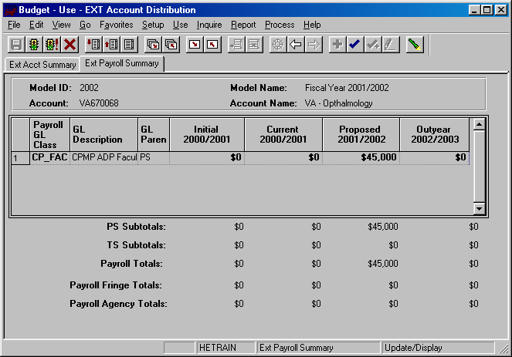
- This panel is a display only sub-total of the employee records by GL class. To modify the numbers on this panel, you will need to modify the employee records associated with this account. (Unit 5 provides instructions on viewing employees by account.)
- Since you are in the Proposed model, you are viewing all of the payroll GL class sub-totals in that model. You are also viewing the corresponding budget numbers for the associated models.
- This means that you will only see budget values for the three associated models if there is budgeted information for that expense in the Proposed model.
- To view all of the budgeted GL classes in an associated model, you must select that model in the Search dialog box.
- The first two columns in the grid contain the GL classes and their descriptions.
- The third column contains the GL Parent field. This column indicates whether the GL class is under the PS (personal services regular) node or the TS (personal services temporary) node. There are also PS and TS sub-totals by model under the grid.
- The Payroll Fringe Totals are only calculated for applicable funds (i.e., IFRs, SR, IDC and CPMP).
- The Payroll Agency Totals are only calculated for CPMP staff.

SR Account Distribution Panel Group

- In the Sponsored Research Account Distribution panel group, the revenue and expenditures are grouped by parent accounts rather than grants. That is, instead of seeing your individual grant numbers, they are rolled up into their parent account number. The parent account will have a SR prefix followed by the six digit parent account number.
- Since the budgets for the Sponsored Research accounts are not driven by allocation, it is not necessary to access these accounts through the Organizational Rollup panel.
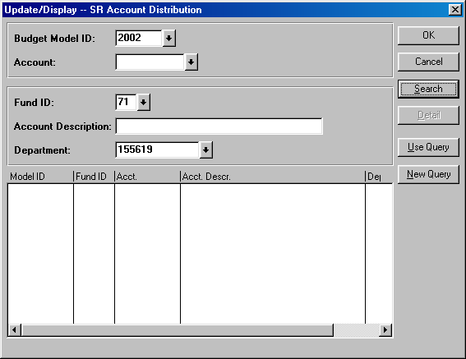
- From the Use menu, select SR Account Distribution. You will then see the following search dialog box.

- The SR Account Distribution panel group is valid for fund 71 (Sponsored Research) and fund 78 (Service & Facilities). You will need to specify one of theses fund codes. Then, enter your department ID and click the Search button.
- From the list of accounts, select the account that you wish to budget and click OK.

SR Account Summary Panel
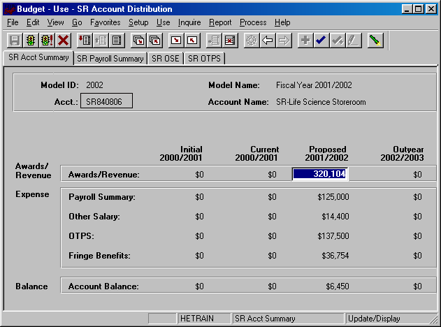
- You are now in the SR Account Distribution panel group.
- On this account you will budget for all the Sponsored Research grants that rollup to parent account 840806. The payroll for all the grants under 840806 will rollup to this account.
- There are four panels in this panel group. The panel tabs are displayed under the command buttons.
- SR Account Summary panel
- SR Account Payroll panel
- SR Account OSE (in Aggregate) panel
- SR Account OTPS panel
- You can click on the panel name to activate the panel or you can navigate using the Next Panel In Group button or the Previous Panel In Group button.
- You will see the model ID and the account number that you selected at the top of each of the panels in this group.
- You will notice that although you are in one model, you will see the corresponding budget information for the related models.
- The SR Account Summary panel is a display only summary of the GL classes that have been budgeted on the account.
  - The GL classes are separated into three sections, Awards/Revenue, Expenses (Payroll Summary, Other Salary, OTPS and Fringe Benefits) and the Balance.
  - These sections are sub-totaled for all four associated models.
    - Initial – The numbers in this column are your final figures from last year’s Proposed model.
    - Current – Use the information in this column to project your budgetary needs for the current fiscal year. This model was pre-loaded with a current payroll snapshot and the OTPS data from last year’s Proposed model.
    - Proposed – Use the information in this column to project your budgetary needs for the upcoming fiscal year. The final version of this model will be used to load various financial systems.
    - Outyear – This column contains your anticipated budget for the budget period two years from now. Please note that the data in the Outyear model will not be carried forward to next year’s associated models.
  - During next year’s budget cycle, the information that you budget for this year’s Proposed will become next year’s Initial.
  - In the Awards/Revenue edit box enter the net direct revenue for the account. The expenditure figures are sub-totals from the remaining panels.

SR Payroll Summary Panel
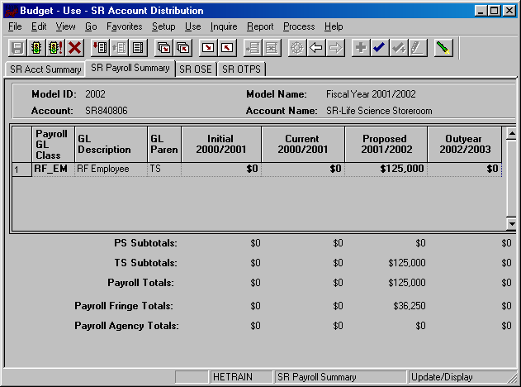
- This panel is a display only sub-total of the employee records by GL class. To modify the numbers on this panel, you will need to modify the employee records associated with this account. (Unit 5 provides instructions on viewing employees by account.)
- Since you are in the Proposed model, you are viewing all of the payroll GL class sub-totals in that model. You are also viewing the corresponding budget numbers for the associated models.
- This means that you will only see budget values for the three associated models if there is budgeted information for that expense in the Proposed model.
- To view all of the budgeted GL classes in an associated model, you must select that model in the Search dialog box.
- The first two columns in the grid contain the GL classes and their descriptions.
- The third column contains the GL Parent field. This column indicates whether the GL class is under the PS (personal services regular) node or the TS (personal services temporary) node. There are also PS and TS sub-totals by model under the grid.
- The Payroll Fringe Totals are only calculated for applicable funds (i.e., IFRs, SR, IDC and CPMP).
- The Payroll Agency Totals are only calculated for CPMP staff.
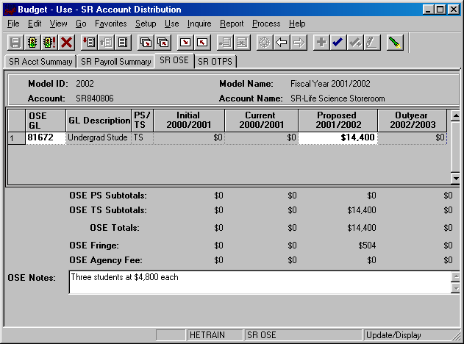

SR OSE (in Aggregate) Panel

- This is the panel you will use to budget other salary expenses (OSE) in aggregate by account. The OSE in aggregate expenditures are salary expenses that you want to budget in a lump sum for the account, rather than by employee. For example, you may not know which employee will be getting a bonus, but you do know that you need to budget for that expense. So, rather than budgeting it for each employee, you can budget it here in total for the account.
- Student assistant expenditures should be budgeted in aggregate on this panel. Their employee records were not loaded on the system.
- The white fields are directly modifiable.
- Since you are in the Proposed model, only the Proposed column is modifiable. If you would like to enter data in another model, you have to first change the model you are in.
- To change the model:
- Click on the Update/Display button.
- You will be prompted with a search dialog box.
- Enter the desired model and account and click OK.
- To budget for an OSE GL class that is not on the grid:
- Click anywhere on the grid and click on the Insert Row command button.
- On the new row, click the arrow in the OSE GL Class column. You will then see the list of valid values shown below.
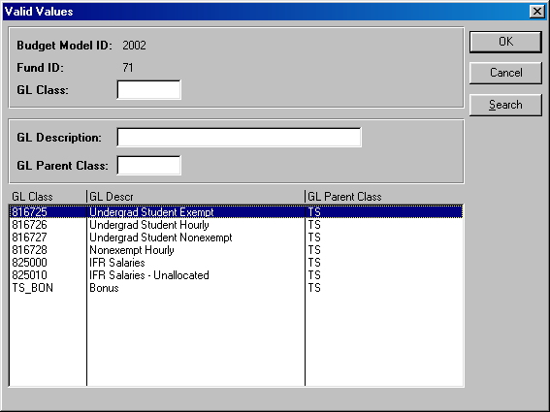
- The list of values contains a column for GL Parent Class. Since GL Parent Class is also a search key, you can use Search for OSE GL classes in specific GL Parent Classes.
- Select the OSE GL class that you would like to budget and click OK.
- Once you tab off of the GL class field on the grid, you will see the description of the GL class will be displayed.
- Tab to the write-able white field and enter the amount that you would like to budget for the selected GL class. When you tab off of the field, you will notice the sub-totals at the bottom of the panel are updated.
- As with the Account Payroll panel, there is a sub-total for PS, TS, fringe and agency fee.
- A note field has been provided so that you can enter clarifying notes.
- The list of valid GL class values for Sponsored Research is the same as the ones for Service & Facility accounts.

SR OTPS Panel
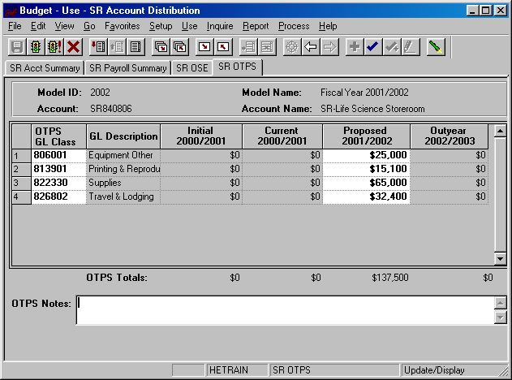
- This is the panel you will use to budget Other Than Personal Services (OTPS) expenditures.
- The white fields are directly modifiable.
- Since you are in the Proposed model, only the Proposed column is modifiable. If you would like to enter data in another model, you have to first change the model you are in.
- To change the model:
- Click on the Update/Display button.
- You will be prompted with a search dialog box.
- Enter the desired model and account and click OK.
- To budget for a OTPS GL class that is not on the grid:
  - Click anywhere on the grid and click on the Insert Row command button.
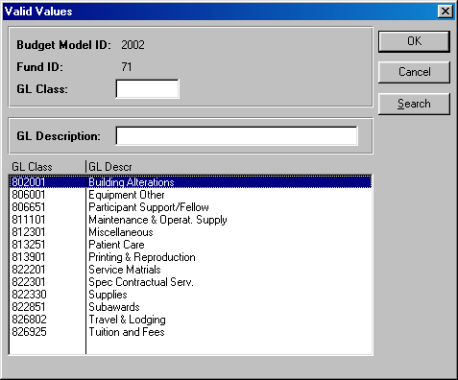
- On the new row, click the arrow in the OTPS GL Class column. You will then see the list of valid values for OTPS GL classes shown below.

  - Select the OTPS GL class that you would like to budget and click OK.
- Once you tab off of the GL class field on the grid, you will see the description of the GL class will be displayed.
- Tab to the write-able white field and enter the amount that you would like to budget for the selected GL class. When you tab off of the field, you will notice the sub-totals at the bottom of the panel are updated.
- A note field has been provided so that you can enter clarifying notes.
- The list of valid GL class values for Sponsored Research is the same as the ones for Service & Facility accounts.
6.0 Targets by Account

- The Target by Account panel is used to set targets on the account level for Appropriated funds (fund codes 10 through 70) and IDC fund code 73.

- This feature does not replace the functionality of setting targets by org level and does not change what is displayed in the organizational overview. If an account has a target, the Target by Account amount will be displayed on the Account Distribution panel for AF, IDC, and IFR accounts, not on the Organizational Rollup Panel.

- A total target amount for each account within an organizational level can be set by users with VP level access.

- Users below the VP level can view but not update their account targets.

Setting Targets By Account

- To access the Target by Account panel, select Target by Account from the Setup menu. You will see the search dialog box below.

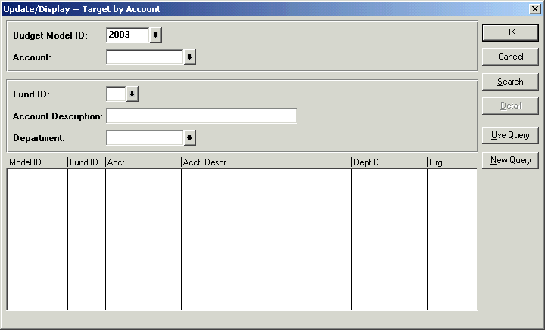

- In the Search dialog box, the Proposed model is defaulted. In order to display accounts that you have access to, type the desired fund code and click the Search button. Valid fund codes for the Target by Account panel are 10 through 70 and 73.

- If you type an invalid fund for Target by Account, you will get the following error message:

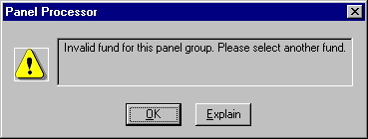
- To make the search more specific, type an organizational area into the Department field in the Search dialog box and click the Search button.

- You will see all of the accounts in the selected organizational area for the selected fund as displayed below.

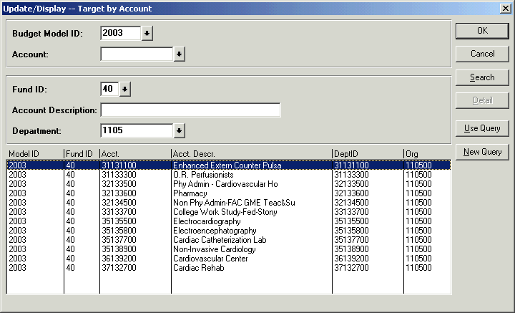

- Highlight an account from the list in the Search dialog box and click OK.
- The Target by Account panel will be displayed.

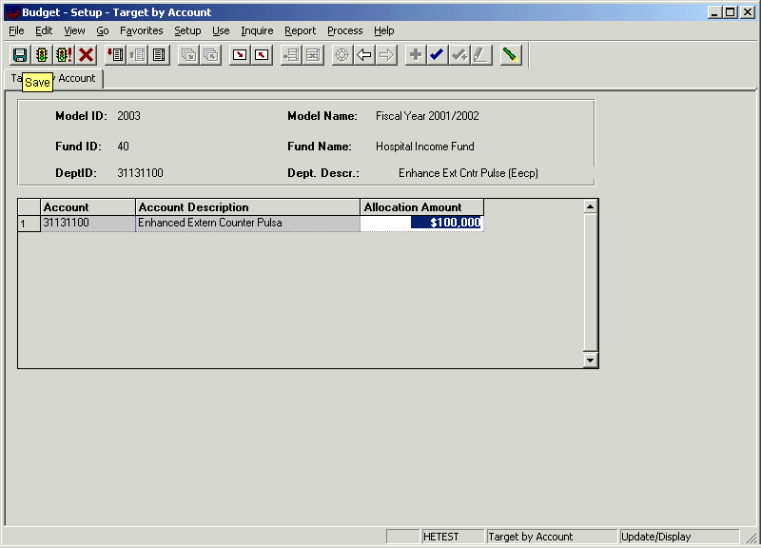

- If your security is below the VP level, the Allocation Amount field will be grayed out. Only users with VP level access may enter the targets for their accounts.

- To input an amount in the Allocation Amount field, tab into the field and enter the desired amount. Then click the Save command button.

- Whether you are viewing or updating, click the Next in List or the List command button to select another account.

- If an account has a Target, it will be displayed on the summary panels of the following panel groups as shown in the next panel:
- AF Account
- IFR Account
- IDC Account

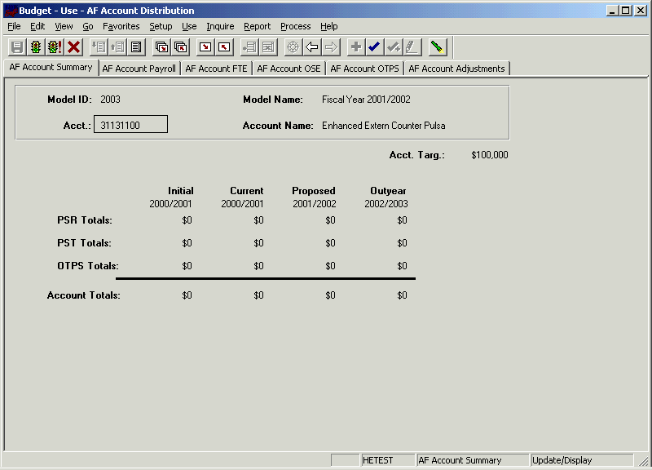

7.0 Viewing Employees by Account

The Search Dialog Box
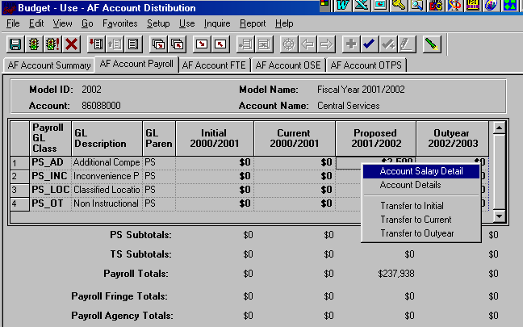

There are two methods to view the employees that are charged to an account.

First Method:
  - The first method is shown above. From the Account Payroll panel right-click anywhere in the grid and select Account Salary Detail. This will bring you to the Account Salary Detail panel.

Second Method:
  - The second method is to click on the Inquire menu and select the Account Salary Detail panel.
    - You will then see the search dialog box shown below.
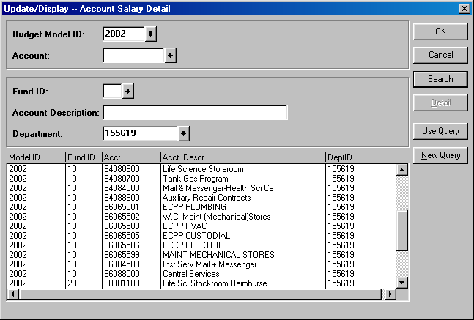
    - Enter your Department ID and click the Search button. The system will list all of the accounts within your organizational level.
    - Select the desired account and click OK.

Account Salary Detail Panel

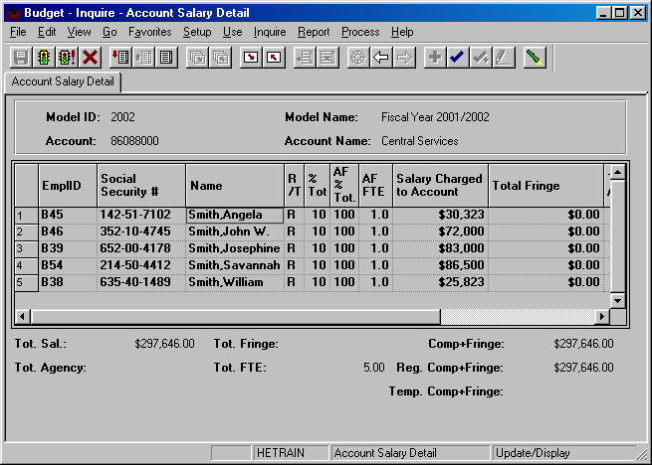
- The Account Salary Details panel is a grid containing all of the distributions charged to the account you’ve selected. That is, the grid contains the pieces of each employee’s salary that is charged to the selected account.
- The grid contains the following columns:
  - EmplID – This key field is used to identify all of the employee records. For employees pre-loaded into the system from the HR modules, the employee ID is the same as the HR employee ID. For employee records from other systems or for employees that were manually created on the system, the employee ID is automatically generated by CBM.
  - Social Security # - Social Security numbers are provided for employees that were pre-loaded into the system.
  - Name – The name field must be in the PeopleSoft default format: Lastname,Firstname
  - R/T – This is the regular/temporary indicator. For employees on appropriated funds, everyone is “regular” except for those whose compensation frequency is bi-weekly or hourly. Employees on RF are “temporary.”
  - % Total – The value in this column represents the percent of the employee’s total salary that is charged to the account.
  - AF % Total – The value in this column represents the percent of the employee’s total appropriated funds salary that is charged to the account. The value in the % Total column will only differ from the AF % Total column if the employee is split between appropriated funds and non-appropriated funds.
  - AF FTE – This column is the appropriated funds FTE. This value is also only displayed if the employee is “regular.”
  - Salary Charged to Account – This column is the amount of an employee’s salary that is charged to the selected account.
  - Total Fringe – This column is the fringe on the salary charged to the account.
  - Agency Costs – This is the 4.8% of salaries and fringe that is charged to RF CPMP payroll. This is automatically calculated based on the fund of the account and the GL class of each distribution.
- The numeric fields are totaled under the grid.
- The values on the Account Salary Detail grid are not modifiable.
- 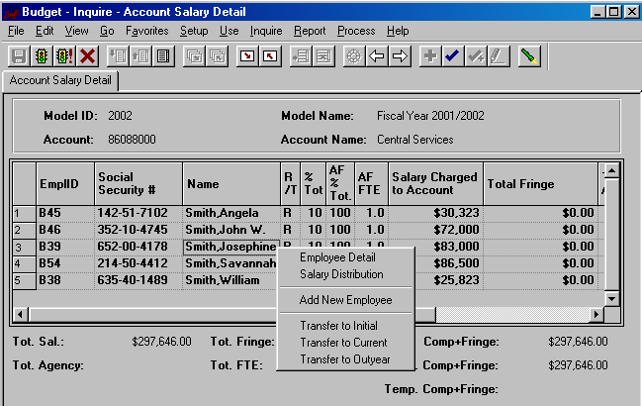To make changes to an individual employee record, right-click on the employee’s row on the grid.

- You will then see the pop-up menu shown in the screen print above.
- Select Employee Detail or Salary Distribution to open the Employee Information panel group.
8.0 Budgeting By Employee

- There are two ways to access existing employee data in the Employee Information panel group.

First Method:
    - If you are already in the Account Salary Detail panel, right-click on the employee record that you would like to view/modify. Then, select Employee Detail from the pop-up menu on the previous page. [See the screen print on the previous page.]
      - When you select Employee Detail from the pop-up menu, the system will bring up the Employee Information panel group for the employee you selected on the grid.

Second Method:
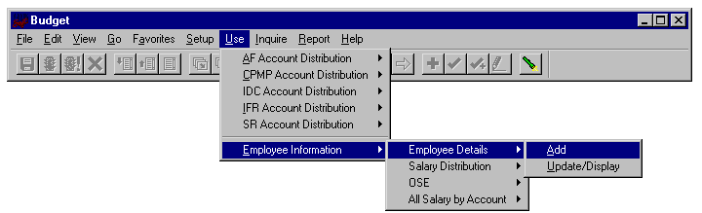
    - Alternately, you can select the Employee Information panel group from the Use menu.
      - Select the Add action to add a new employee or select Update/Display to view/modify a pre-loaded employee.
      - If you access the Employee Information from the Use menu, you will have the extra step of having to select an employee from the Employee Information search dialog box.

The Search Dialog Box

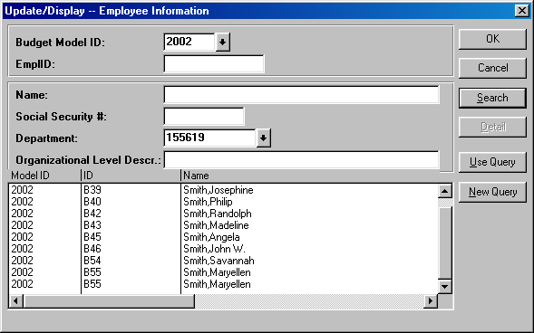
- If you enter the Model ID and the Department ID and click the Search button, the system will list all of the employees within the organizational area you selected.
- You can search using any of the search keys in this dialog box. For example, if you enter “Smith” in the Name field, the system will list all of the employees within your organizational level whose name starts with “Smith”
- In the example above, the system listed all of the employees who have a salary distribution in Central Services.
- Please note that if an employee is split, each of their distributions will roll up under its respective organizational area. In the example above, Maryellen Smith is listed twice. This is because she is split and two of her distributions are rolling up to 155619.
- To view employee records that are split outside your area and that have been modified, see the Employee Split section at the end of this unit.

Employee Information Panel Group

- There are four panels in the Employee information panel group:
- Employee Details – This panel contains demographics information for the employee.
- Salary Distribution – This panel contains the base salary amounts and the accounts to which the base salaries are charged.
- OSE – This panel contains non-base other salary amounts (OSE) and the accounts to which they are charged.
- All Salary by Account – This panel contains a summary grid of all of the pieces of an employee’s compensation.
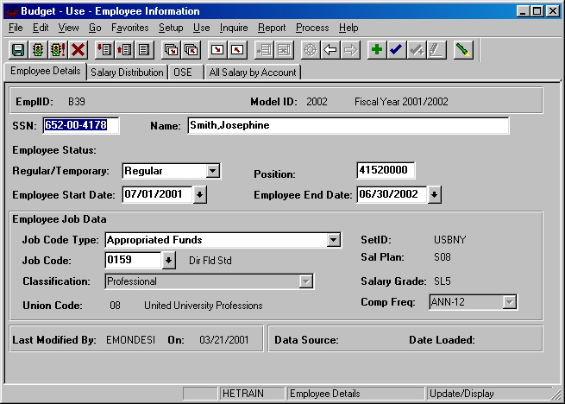

Employee Details Panel

The Employee Details panel contains the following fields:

EmplID
- This key field is used to identify all of the employee records.
- For employees pre-loaded into the system from the HR modules, the employee ID is the same as the HR employee ID.
- For employee records from other systems or for employees that were manually created on the system, the employee ID is automatically generated by CBM.
- Employee IDs that have been generated by the CBM will start with the letter B.

SSN
- Social Security numbers are provided for employees that were pre-loaded into the system.
- If you are adding a new employee to CBM, leave the Social Security number field empty unless you know it. If not blank, the system performs an edit check for uniqueness. Therefore, you cannot enter dummy placeholders for this field.
- This field is display only for employee records that were pre-loaded into the system.

Name
- The name field must be in the PeopleSoft default format: Lastname,Firstname.
- This field is display only for employee records that were pre-loaded into the system.
- When you add an employee to the system, you need not format the name field in proper case. When you tab off of the field the system will automatically change the case of the name field to proper case, this is, initial capitalization. This feature is for this field only. The other character fields in the system are case sensitive.

Employee Status
- This display only field is the employee’s status at the time of the data load.
- If the employee status is “Leave” or “Leave With Pay” the system will also display the reason for the leave.

Regular/Temporary
- This field indicates whether or not an employee is “Regular” or “Temporary.”
- Employees that meet the following criterion should be coded as “Regular”
- Employees in appropriated funds (including IFRs) whose pay basis is not biweekly, hourly or fee.
- Employees that meet the following criterion should be coded as “Temporary”
- Employees in appropriated funds (including IFRs) whose pay basis is biweekly, hourly or fee.
- All Research Foundation employees should be coded as temporary, unless the employee is a GFT faculty member split with appropriated funds.
- It is important to select the correct Regular/Temporary indicator because it will determine the GL classes that are available to you on the Salary Distribution panel.

Position
- This field is for employees who have at least one distribution charged to an appropriated fund account.
- Position is an eight-character field, which is the five-digit SUNY line number followed by three zeros.
- This field is display only for employee records that were pre-loaded into the system.
- You may leave this field empty for TBA (to be announced) employees that you have added to the system.
- Please note that currently if you only enter the five-digit line number and tab off of the field, three zeros will be added to the beginning of the number instead of at the end. In order to avoid this, you will need to manually add the three zeros at the end of the line number before tabbing off of the field.

Employee Start Date & Employee End Date
- These date fields do not represent the actual start and end date for the employee. It is the start and end date of the employee during the selected fiscal year.
- For each model, the default is 7/1 and 6/30 of that model’s fiscal year.
- If the employee will be on the payroll for the entire fiscal year, you should leave the default values. Otherwise, if the employee will be terminating mid-year, you should change the Employee End Date field to reflect the end date of the employee. Alternately, if a new employee is starting mid-year, you should change the Employee Start Date field to reflect the start date of the employee.
- These two fields are informational purposes only. They do not at this time alter the salary figures.

Job Code Type
- This field indicates whether the employee is on appropriated funds or on the Research Foundation. Once you have the selected the correct one, the system will use the information to determine which set of job codes will be available in the Job Code field.
- For employee who has all or part of his/her salary on an appropriated fund account, select the Appropriated Funds job code type. (If an employee is split between appropriated funds and non-appropriated funds, select the Appropriated Funds job code type.)
- For employees who have all of their salary on non-appropriated fund accounts, select the Research Foundation job code type.

Set ID
- This is a PeopleSoft required field that is automatically entered based on the Job Code Type of the employee.

Job Code
- The job code field is a listing of all of the titles for the selected job code type.
- It is very important that the correct job code is selected because the values for several fields are defaulted based on the job code.
- To select a job code, click on the arrow to the right of the field.
- You will then get a list of valid values.
- Since there are more valid values than can be displayed, you will need to narrow the search by typing in values in the search keys above the list.
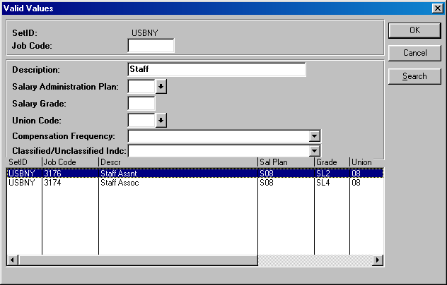
- For example, if you need job code descriptions that start with “Staff” you will type “Staff” in the Description field and click on the Search button on the right of the screen.
- The system will then display the job codes shown above.
- You can search by any of the search keys shown.
- Remember that the Description field is case sensitive. If you type “staff” instead of “Staff” the system would not have found any matching items.
- Once you select the desired job code, click OK. You will then see the job code number in the job code field, but the description and other related displays will not be shown until you tab off of the job code field.

Sal Plan, Classification, Salary Grade, Union Code & Comp Frequency
- The values of these fields are automatically entered based on the job code selected.
- The value in the Classification field is used to group employees in one of the reports in development.
- The Union Code field is used to automatically calculate the classified location payment and the UUP location stipend in the OSE panel on the Employee Information panel group.
- This is a one-to-many relationship between the job code and the Comp Frequency field. It is possible to have more than one valid Comp Frequency for a given job code. Therefore, if the default compensation frequency is not the one you wish to assign to the employee, you can override the compensation frequency on the Salary Distribution panel.

- At the bottom of the Employee Details panel, there is a Last Modified By field. This field stores the operator ID of the last user to save changes to the employee record. The date of the change is also displayed.
- Also at the bottom of the Employee Details panel is a field indicating the data source of the employee record as well as the date the record was loaded.
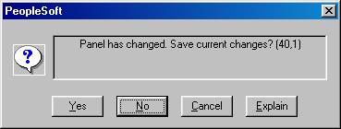
- Please note that when you bring up an employee record in the Employee Information panel group, the system will prompt you to save your changes to the panel even when you have not made changes. There is some complexity in the programming that is causing this. Therefore, if you are certain that you have not made any changes, click the Cancel button at the top of the panel group, or click on No when the system prompts you to save your changes.

Salary Distribution Panel
For AF funds only.
Appropriated fund Salary Rate field
Non-appropriated fund Salary Rate field
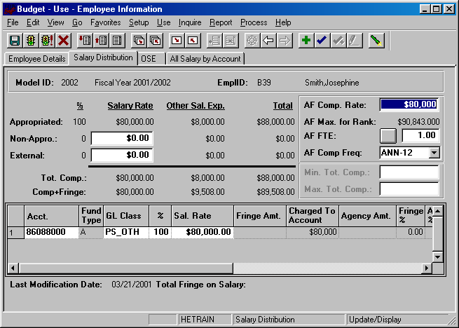
To create and modify account splits
External fund Salary Rate field
There are two ways to add and modify salary distribution information on this panel. There is one for the appropriated funds salaries, and one for the non-appropriated/external fund salaries.

To budget appropriated fund salaries:
- You must begin in the upper right-hand corner of the panel where the AF fields are displayed.
    - AF Comp Rate – This field is the compensation rate for appropriated funds. This field was formerly known as the annual salary.
    - AF Max for Rank – This field is the maximum for the rank of the employees appropriated funds job code.
    - AF FTE – This field is the appropriated funds full-time equivalent.
      - To the right of the AF FTE label there is a button for the FTE Calculation Worksheet.
      - This worksheet will calculate the AF FTE based on the AF Comp Rate you enter.
      - After you enter the AF Comp Rate, click on the AF FTE button. Then, in the white field labeled Appropriated Base Salary (salary rate) enter the amount that you want the person to receive.
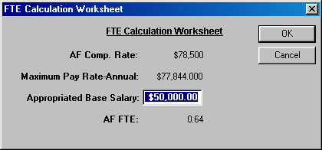
      - When you click OK, the system will calculate the closest FTE that will generate the salary rate that you entered.
    - AF Comp Freq – This is the rate of pay for the employee.
      - Comp frequency ending in “SEM,” signify semester employees. The salary rate for employees with compensation frequencies ending in “SEM” is the product of the AF Comp Rate, the AF FTE and 0.5.
      - For pre-loaded employees, the AF Comp Freq corresponds with the AF Comp Rate.
  - As you modify the AF fields you will notice that the Appropriated Fund Salary Rate field on the left side of the panel changes. For appropriated Funds, the Salary Rate field is a product of the AF Comp Rate field and the AF FTE field.
  - The Appropriated Fund Salary Rate field is the amount that you want the employee to receive. This is the amount that you will distribute by account.
  - Once you have the desired amount in the Appropriated Funds Salary Rate field, you are ready to distribute this amount in the grid at the bottom of the panel.
- The salary distribution grid contains the following fields:
- Acct – This column contains the account(s) the employee’s salary is charged to.
    - Fund Type – This display only column is the fund type of the account field in the first column. It is automatically entered when you tab off of the Account field.
    - GL Class – This the expenditure code that the salary will be charged to on the account. The valid values for this field differs depending on the fund of the account and the “Regular/Temporary” indicator on the Employee Details panel.
      - The valid values for Regular employees on appropriated fund accounts are shown below.
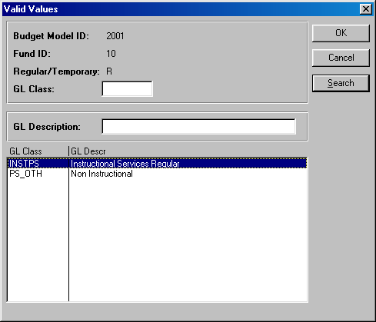
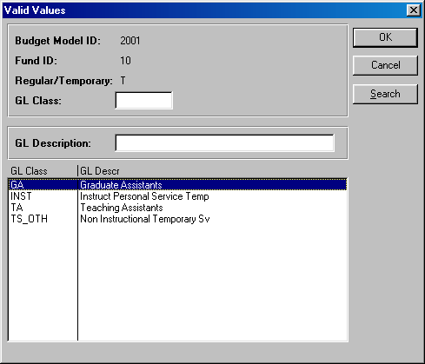
      - The valid values for Temporary employees on appropriated fund accounts are shown below:
    - % - This column contains the percent field. This is where you will indicate the percent of the Appropriated Fund Salary Rate that you want charged to each account. For appropriated funds only, the salaries distributed to each account must be a whole number percent of the AF Salary Rate.
    - Sal Rate – This column contains the portion of the Salary Rate (Appropriated Funds, Non-Appropriated Funds or External) that is budgeted on the selected account.
    - Fringe Amount – This display only column contains the fringe benefit assessments associated with the account selected. The fringe benefit calculation is based on the fund of the account and the GL class of the distribution.
    - Charged to Account – This display only column is the sum of the Salary Rate column on the grid and the Fringe Amount column.
    - Agency Amt – This display only column is automatically calculated based on the fund of the account and the GL class of the distribution. Agency charges are assessed only for CPMP staff.
    - Fringe % - This column displays the fringe benefit percentage that is being assessed on the distribution.
    - Agency % - This column displays the agency percentage that is being assessed on the distribution.
    - AF FTE – This column displays the AF FTE for the distribution.
    - GL Parent Class – This column displays the parent of the GL class, that is, whether the GL class is PS (Personal Services Regular) or TS (Personal Services Temporary).
    - Import ID – This display only column indicates the import ID of the data load. [This is for use by the technical team. You can safely ignore it.]
    - Emp Srce – This indicates the source of the distribution. An employee may have distributions from several sources if their distributions are split across fund types.
  - If you are distributing the Appropriated Fund Salary Rate to only one account, type 100 in the % column after entering the account and GL class in the Salary Distribution grid. Once you tab off of the % field, you will notice that the next column will contain the full value of the Appropriated Fund Salary Rate field.
  - If you are distributing the Appropriated Fund Salary Rate to more than one account, you can do one of the following:
- Enter the percent of the Appropriated Fund Salary Rate that you want in each distribution.
- Alternately, tab past the % column and type in the amount that you want to charge to the account in the Salary Rate column in the grid.
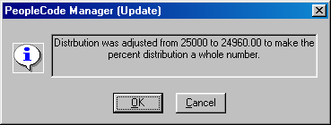
- Once you tab off of the Salary Rate field on the grid, you will notice that the system changed the amount you entered to the nearest whole percent of the Appropriated Fund Salary Rate field. This is done only for account distributions in appropriated funds. You will get a message similar to the one below.
- You will also notice that the value in the % column is adjusted.
  - For appropriated funds, the value in the % column is always the Salary Rate amount on the grid divided by the Appropriated Fund Salary Rate field.
  - In order to save the Employee Information panel, the total appropriated fund percent in the upper left-hand corner of the panel must equal 100. You will need to modify the percentages of each distribution until you have a total of 100%.
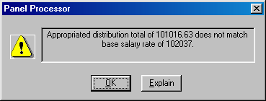
  - If you attempt saving the panel while the Appropriated Fund Salary Rate is not equal to the sum of the distribution Salary Rates, you will get an error message similar to the one below.
  - If you change the Appropriated Fund Salary Rate (by changing the AF Comp Rate or AF FTE), the system will hold the % values constant and automatically prorate the Salary Rate amounts in the grid.

To budget salaries on accounts that are in non-appropriated funds and external funds:
  - For employees with no appropriated fund salary component, you may budget the salaries directly in the grid at the bottom of the panel.
  - As you insert rows on non-appropriated and external accounts, you can skip the % column and enter the amount you want budgeted in the Sal Rate column on the grid. For non-appropriated funds there is no whole number percent restriction on the distribution salary rate. The amount you enter in the grid is the amount you want. It will not be rounded to the nearest percent of the Non-Appropriated Fund Salary Rate.
  - As you enter an amount in the Salary Rate column on the grid, the system will add that amount to the Non-Appropriated Fund Salary Rate field in the upper left-hand corner of the panel.
  - Additionally, the percentages will automatically adjust when you tab off of the Sal Rate column on the grid.
  - For non-appropriated funds (and external funds), the amounts in the % column are not important. It is the values on the distributions that are key. You can save the panel if the Non-Appropriated Fund Salary Rate or the External Fund Salary Rate is not equal to 100%. After you save the panel, the percentage will reset to 100%.
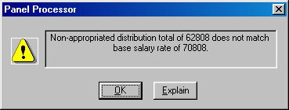
  - If you change the Non-Appropriated Fund Salary Rate (or the External Fund Salary Rate), the system will hold the Salary Rate values in the grid constant and automatically prorate the figures in the % column. Consequently, you will not be able to save the panel until the amount in the Non-Appropriated Fund Salary Rate (or the External Fund Salary Rate) is equal to the distribution Salary Rates in the grid. You will get an error message similar to the one below.

  - The valid values for Regular employees on non-appropriated fund or external fund accounts are shown below:

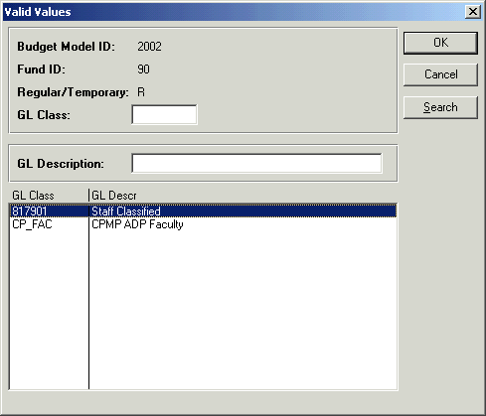

- The valid values for Temporary employees on non-appropriated fund or external fund accounts are shown below:

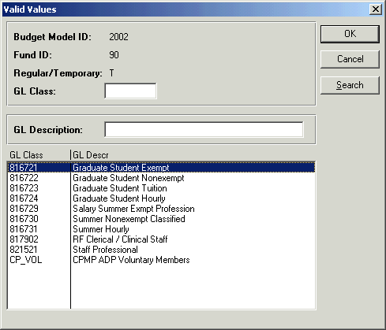

Minimum Total Compensation & Maximum Total Compensation
  - These fields are located on the right side of the panel, above the grid.
  - These fields are editable only for employees whose AF Comp Freq is ANN-GFT.
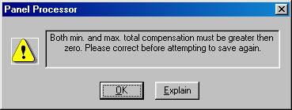
  - For ANN-GFT employees you will not be able to save the panel group unless you enter a non-zero value for both the Minimum Total Compensation field and the Maximum Total Compensation field. You will get the error message below if you attempting saving the panel without values for both fields.

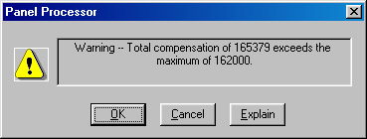
  - If the Total Compensation amount (located above the grid to the left of the panel) is greater than the Maximum Total Compensation you will get the warning message similar to the one below, but you will be able to save the panel.

At the top of the panel, to the right of the Salary Rate fields, there are Other Sal Exp fields. The grid at the bottom of the panel is only for distributing the Salary Rate fields. To modify and distribute the Other Sal Exp fields, click on the next panel in the group: OSE.

OSE (by Employee) Panel
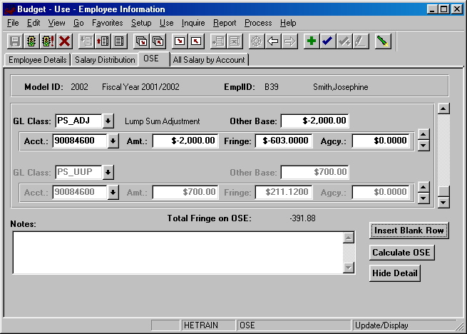
- The OSE panel is used to add and modify Other Salary Expense categories and their distributions.
- There are two components of the OSE GL classes that need to be budgeted: their amounts and their distributions. Different GL classes are calculated and distributed to accounts differently.
- In the panel shown above, you see that each OSE GL class has its own scroll bar for the account distribution.
- There are three types of OSE GL classes.

Types of OSE by Employee GL Classes: Auto Calc/Auto Distribute
- The first type of OSE GL classes is automatically calculated and automatically distributed.
- Examples of this type are the UUP location stipends and the classified location payments.
- These types are valid for appropriated fund distributions only.
- In the screen print on the previous page, the second GL class is PS_UUP. It is grayed out because it is automatically calculated based on the employee’s union code, FTE and compensation frequency.
- Additionally, the $700 amount for UUP is automatically distributed among the accounts of the employee’s base salary from the Salary Distribution panel. Since this employee’s base salary is charged 100% on 90084600, the UUP location stipend is charged 100% to account 90084600.

Please note that since the costs of the UUP location stipends are fiscally reimbursed for State Purpose and Hospital accounts, distributions on State Purpose and Hospital accounts are empty for the PS_UUP GL class.

Types of OSE by Employee GL Classes: Manual Calc/Auto Distribute
- The second type of OSE GL classes is manually calculated and automatically distributed.
- Examples of this type are Additional Compensation, Geographic Pay, Inconvenience Pay and Shift Pay.
- These types are valid for appropriated fund distributions only.
- To budget for one of these GL classes on an employee, click the Insert Blank Row button at the bottom of the screen. You will then get an empty row.
- Click the arrow to the right of the GL class field and select Additional Compensation, Geographic Pay, Inconvenience Pay or Shift Pay.
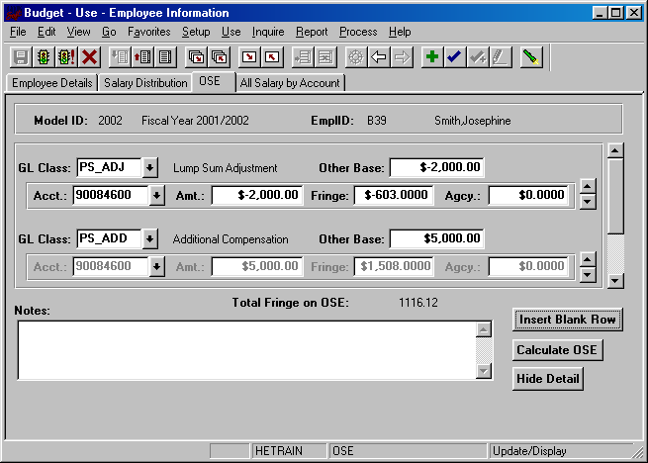
- Once you tab off of the GL class field, type an amount in the Other Base field.
- When you tab off of the Other Base field, you will then notice that the account distribution scroll bar underneath is grayed out. The system is automatically distributing the amount that you have manually entered using the salary distribution of the base salary in the Salary Distribution panel.
- In the screen print above, the employee’s base salary is charged 100% to account 90084600, to the system is distributing 100% of the $5,000 in additional compensation to account 90084600.

Types of OSE by Employee GL Classes: Manual Calc/Manual Distribute
- The third type of OSE GL classes is manually calculated and manually distributed.
- The only GL class is that is manually calculated and manually distributed is Lump Sum Adjustment.
- This GL class is valid for appropriated and non-appropriated fund types.
- The Lump Sum Adjustment GL class allows you the flexibility of designating the account where the amount will be budgeted.
- Once you select PS_ADJ GL class (or TS_ADJ for Temporary employees) and you enter the Other Base amount, you will need to manually enter the account number for each distribution, as well as the portion of the amount that you wish to budget for each distribution.
- In the screen print below, you see that a PS_ADJ amount of -$2,000 is budgeted and all of it is distributed to account 90084600.

- Please note that for the Lump Sum Adjustment GL class, you need to manually enter the fringe amounts for any accounts that are assessed fringe as well as any application agency costs.
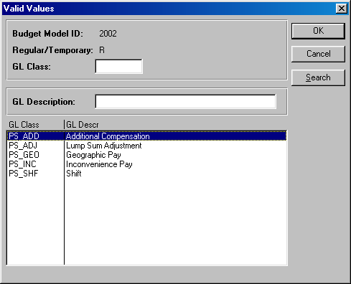
- The screen print below displays the valid OSE GL class values for Regular employees.

- The screen print below displays the valid OSE GL class values for Temporary employees.

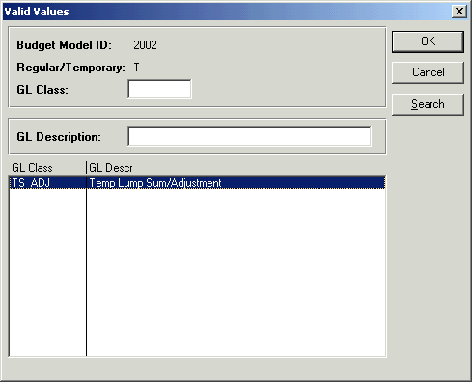

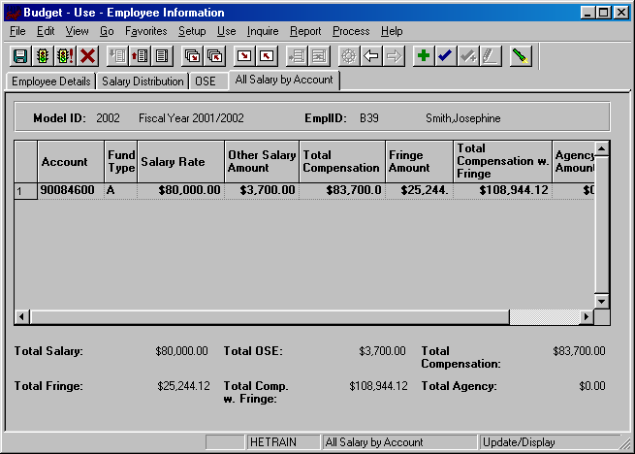
All Salary by Account Panel

- The last panel in the Employee Information panel group is the All Salary by Account panel. This panel is a display only grid, which summarizes all of the accounts an employee is charged to.
- The Salary Rate column on the grid corresponds with the base distribution amounts in the Salary Distribution panel.
- The Other Salary Amount column corresponds with the amounts in the OSE panel.
- The Total Compensation column is the sum of the Salary Rate column and the Other Salary Amount column.
- The Fringe Amount column is the total fringe charged to the account.
- The Total Compensation with Fringe column is the sum of the Total Compensation column and the Fringe Amount column.
- The Agency Fee Amount column is the total agency assessment charged to the account.
- Totals for the columns in the grid are displayed under the grid.

Adding an Employee

There are two types of employee “Add”s on the CBM system. You can create an employee record from scratch, or you can copy an employee record from another CBM model or from an HR module.

Adding an Employee Record From Scratch:
- From the Use menu, select Employee Information, Employee Details and Add.
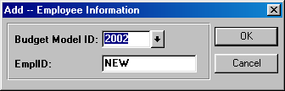
- You will then see the screen below. Enter the model where you would like to create the employee record and click OK. The system will automatically generate temporary “B” employee ID numbers. The “B” employee ID number indicates that the employee record did not originate from the PeopleSoft HR modules.

- You will then see an empty Employee Information panel group. You should enter data for the white fields.
- SSN is not a required field. You can leave it empty. If you fill-in the SSN field and it is already in use on another employee record, you will get an error message when you try to save the panel.
- Name is also not required, but we recommend that you enter data for that field since it is used on the Search dialog box.
- Please refer to the Employee Details field descriptions on the preceding pages in this unit for information on using each field in this panel group.

Copying an Employee Record from the HR Modules or a CBM Model:

- From the Use menu, select Employee Information, Employee Details and Add.
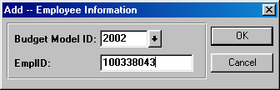
- You will then see the screen below. Enter the model where you would like to create the employee record, and enter the employee ID of the employee record that you want the system to copy into the indicated model.

- You will then see the Employee Information panel group for the employee ID you requested. Please note that the system fills in the information on the Employee Details panel only. You will need to enter salary distribution information on the Salary Distribution panel and the OSE panel.

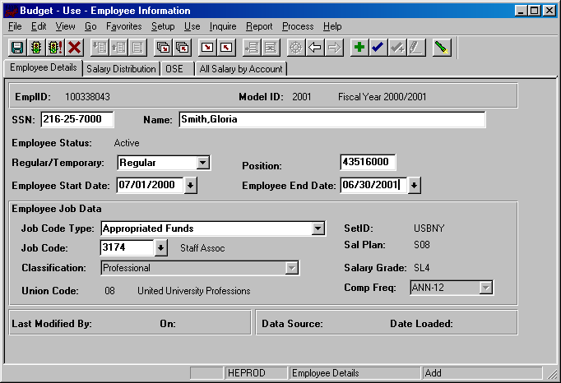
- When you enter the employee ID on the previous screen, the system searches the HR modules first to find the most current information on the employee. If the system does not find the requested employee record in the HR modules, it will then search the CBM module for that employee record.

- Please refer to the Employee Details field descriptions on the preceding pages in this unit for information on using each field in this panel group.

Deleting an Employee

- For each budget preparation cycle, a current snapshot of active employees will be pre-loaded into the write-able models (Current, Proposed & Outyear). Consequently, you will not need to delete an employee record unless he/she terminated after the snapshot was taken.
- Since a new employee snapshot is taken every year, the vice presidential areas did not want records to be delete-able.
- Therefore, you may not delete employee records once they have been added to the CBM system.
- If an employee terminates after the payroll snapshot was loaded, you will want to adjust their salary.
- If no portion of an employee’s salary will be charged during the fiscal year of the model that you are budgeting, then zero the salary fields and the FTE field.

Employees Split Outside Your Organizational Level

- If an employee is split between organizational levels, each area that the employee is split to has access to the employee record.
- You cannot view or modify an employee record unless some portion of the employee’s salary is charged to one of your accounts.
- In order to keep track of whether or not a split employee record has been modified you will use the Split Changes Panel in the Inquire menu.
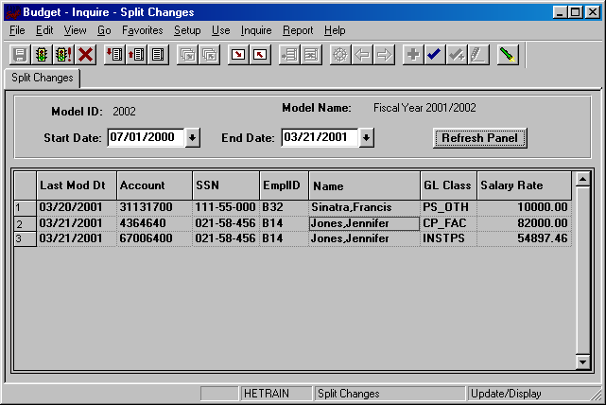
- Use the Start Date field and the End Date field on this panel to specify the date range of the modifications. In the example above, we are searching for all changes to employees split outside our area since July 1st. Three employee distributions were modified during that timeframe.
9.0 Reports

The CBM reports run from an NT server. The data is collected by the server and the print job is saved as a file to your personal PeopleSoft Reports Directory. From this directory you will be able to open the report file and do the following:
- Preview the report on screen
- Print the report file to any printer connected to your PC (including local printers)
- Export the data in the report file to an Excel spreadsheet.

In order to run reports this way, you will need to create a Run Control ID. You need only create the run control ID once. After you set it up, you will use it to run all of your reports. The Run Control ID will store your setup information.

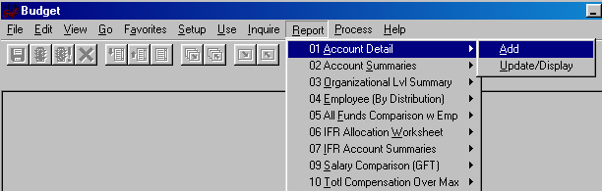Creating a Run Control ID

- Select any report from the Report menu and click on the Add action.
- You will be prompted to name your Run Control ID.
- Enter a name for your Run Control ID. Use a string that is no longer than 13 characters with no spaces, and click OK.
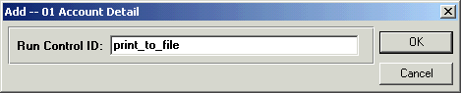
- You will then be brought to the report panel you selected. The fields on the report panels are the parameters of the report.
- In the screen print below, the Account Detail report is selected. The system needs to know the model ID you want to print as well as the department ID or account number you would like to print. Enter the desired values and then click the Run button.
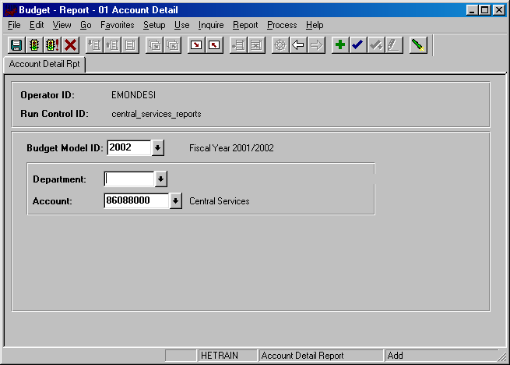
Run
Run with Defaults

- After you click on the Run button, you will see the Process Scheduler screen on the next page.
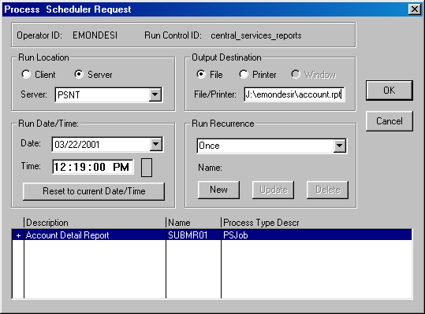
- You will need to change the Run Location and the Output destination.

  - Change the Run Location to Server and select the PSNT server from the dropdown list.
  - Change the Output Destination to File and enter the path of your PeopleSoft Report directory.
  - For West Campus the path is G:\PSReports\username\nameofreport.rpt
  - For HSC and University Hospital the path is J:\username\nameofreport.rpt
- "Username" is your "regular" logon username (It must match the folder name on the reports server.) and "nameofreport" is the name you chose for the file (no spaces). When you run a new report and you do not change the name of the report, the system will write over the previous file with the same name. The "rpt" extension will allow you to open the file from the Crystal Report application.
- Once you have changed the Run Location and the Output Destination, click OK. You have setup your Run Control ID. PeopleSoft is now processing your request.

Printing & Exporting From Report Files

- 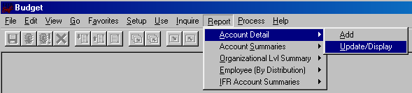Now, when you would like to run a report, select the report from the Report menu and choose the Update/Display action. You will see your Run Control ID listed. Select it and click OK.
- After you have inputted the requested report parameters, click the Run command button and change the name of the report. If you do not change the name of the report the system will write over the file with the same name.
- Your report file will be saved in your PeopleSoft Reports directory.
- In order to access your report file Minimize the PeopleSoft window. There should be two new icons on your desktop: one shortcut to Crystal Reports and one shortcut to your PeopleSoft Report directory.
- Double click the shortcut to the PeopleSoft Report directory to open it. Look for the report file you just created and double click on it. If you are not able to open the report file in Crystal Reports by double-clicking on it, double-click on the shortcut to Crystal Reports first and then open the file in Crystal Reports.
- You should then see a preview screen similar to the one on the next page.
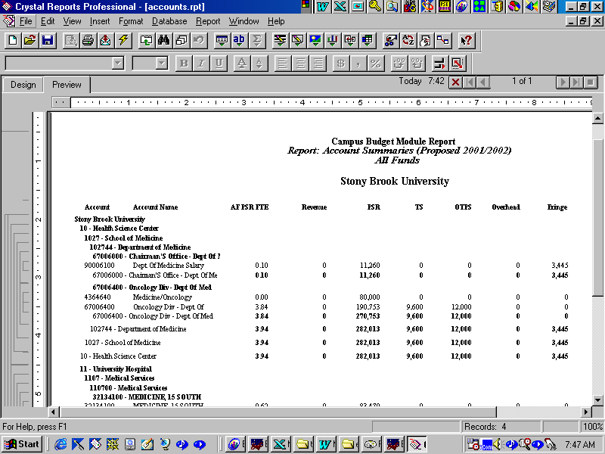

To print the report file:
- You can print the file from the File menu by selecting Print, then Printer, then clicking Okay.
- You can change the destination printer from the File menu by selecting Printer Setup.

To export the file to Excel:
- You can export the file into Excel from the File menu by selecting Print, then Export.

- From the Export box, select the following then click Okay.

Format: Excel 5.0
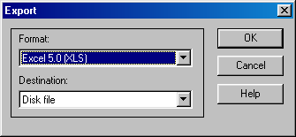
Destination: File

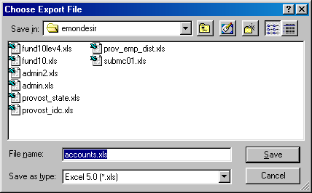
- Type the name that you would like to assign to your file, select the desired directory and click Save.

- You can now open your export file through the Excel application.

Report Types

There are currently nine reports in production:
- Account Detail (#01)– This report details the revenue, allocation, and expenditures budgeted within an account by GL class. The base salary GL classes include employee names and amounts. Also, the Notes fields are appended at the end of the report. This report can be printed for individual accounts or departments.
- Account Summaries (#02) – This report displays the budgeted targets, revenue, allocation, and expenditures by major categories for each account within an organizational area. The accounts are grouped by organizational level. Since account balances are included on this report, the targeted allocation was included (for appropriated funds and IDC) in order to generate an accurate representation of an area’s resources. This report can be printed for specific funds within a department or for combinations of funds (i.e., State & IDC). When you run the report from the report panel, you will now see two choices at the bottom of the Process Scheduler Request box: "Account Summaries MF by Dept" and "Account Summaries MF by Fund." If you select "Account Summaries MF by Dept" you will see your accounts grouped by organizational level (dept). If you select "Account Summaries MF by Fund" you will see the accounts grouped first by fund and then by organizational level.
- Organizational Level Summary (#03) – This report displays revenue and expenditure GL class sub-totals for the organizational level selected. This report can be printed for a specified fund or for all funds.
- Employee by Distribution (#04) – This report is a listing of all employee distributions within the selected organizational level. The employee records are grouped by organizational level and account. There are now three choices at the bottom of the Process Scheduler Request box. If you select “Employee (By Distribution)” the report will be printed in alphabetical order by employee name. If you select “Empl By Distrib (Title Shown)” you will see the grade and title of the employee displayed. If you select “Empl By Distrib (Title Sub Tot)” the report will be printed grouped by employee title with subtotals for each title group. The employee GL classes are displayed in columns. This report may be printed for any combination of fund and department or for a specific account. This report includes a column named "Flg". This column contains a flag that denotes whether or not an employee record has been modified or manually added into the system. "L" indicates that the employee record was pre-loaded into CBM from PeopleSoft HR or ADP. "M" indicates that the employee record was pre-loaded and then subsequently modified by a user. "N" indicates that the employee record was manually added to CBM.
- All Funds Comparison With Employees (#05) – This report has multi-fund parameters. Each selected fund appears on the report as a column. You can select any combination of up to seven funds. Please note that for this particular report you should use a "txt" extension when you name this report on the Process Scheduler Request box. You can open the report from Microsoft Word or any word processing application. Within Word, please change the setup to landscape for legal size paper. You may also need to make the font smaller in order to fit all seven fund columns across the page. Most reports take a minute or two to run, but this report may take three to eight minutes to run to a file because of its complexity.
- IFR Allocation Worksheet (#06) – This two-page report displays the budgeted revenue and expenditures by GL class for a selected IFR account. This report will be reviewed by the Accounting Office for all Income Fund Reimbursable accounts. You can print this report for a department or for a specific account.
- IFR Account Summaries (#07) – This report is similar to the second report except it contains fields that are specific to IFR funds. This report displays the budgeted revenue and expenditures by major categories for each account within an organizational area. The accounts are grouped by organizational level.
- Salary Comparison (#09) – This report lists the salaries of the GFT faculty in your department for the associated models.

Total Compensation Over Max (#10) – This report lists all of the GFT faculty in your area whose total compensation is 250% or 275% over the salary maximum for their rank.

For samples of these reports, please refer to the Appendix.
10.0 Helpful Hints

Cutting & Pasting Grids into Worksheets

You can copy and paste this grid and all of the PeopleSoft grids into Excel by doing the following:
  - Click on upper left hand corner of the grid to select it.
  - Press Ctrl and C on your keyboard to copy the grid.
  - Open an Excel spreadsheet and select an empty cell.
  - Press Ctrl and V on your keyboard to paste the grid onto the spreadsheet.

Changing the Model

The CBM system groups data by model. This is analogous to a fiscal year. In all of the search dialog boxes the model ID field has the default value of the proposed year. There are two ways to change the model on CBM:

Method 1:
- If you are already in a panel group, change the model by clicking on the Update/Display command button.
- You will then get the search dialog box of the panel group you are in.
- Alternately, if you do not have an open panel, select the desired panel from the menu and choose the update display action.

Method 2:
- If you are on a panel with a grid (except the Auto Calc panel & Employee Information All Salary by Account), right click on the grid.
- The pop up menu contains the following options:
- Transfer to Initial - This option will open your active panel for the Initial model.
- Transfer to Current - This option will open your active panel for the Current model.
- Transfer to Outyear - This option will open your active panel for the Outyear model.
- Please be aware that when you are in an associated model, the position where you are entering data is still the third column. To view all of the associated models you have to be in the Proposed year.
- Once you have transferred to a related model, you must use the Back button to get back to the Proposed model.

Error Messages & Warnings

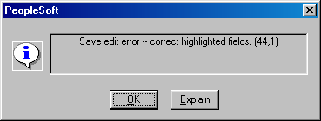
- Keep in mind the Save button saves everything in the panel group, not just the active panel. When you get an error message, it may have to do with a field on a panel that you are not currently on. The error message below states to correct the highlighted fields. The highlighted field may be on another panel in the panel group that you are viewing. Click through all of the panels in the group in order to find the one causing the problem.

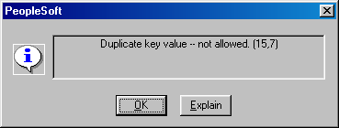
- If you get the error message below, this means that you are attempting to insert a GL class that you already have on the grid that you are working on. Click OK and then hit F8 to delete the duplicate row or click the drop down list to change the selected GL class.

- If you are budgeting an account in one of the six Account Distribution panel groups, and you select another Account Distribution panel group without changing the account number, you will get the error message below. To avoid this message click the Cancel button after saving your current panel. Then you can select the next Account Distribution panel group you wish to work in.
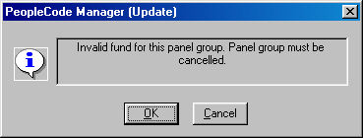
- If you enter a positive amount for Savings (GL Class PS_SAV) on the Account OSE panel, you will get the error message below when you try to save. Click on the OK button and enter a negative amount or zero.

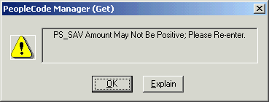

11.0 Need Help?

West Campus CBM Users

- For technical questions regarding PeopleSoft installations, forgotten passwords, etc., call Client Support at 2-9800.
- For general questions regarding the CBM module, call the Budget Office at 2-6090.

Health Sciences Center CBM Users

- For technical questions regarding PeopleSoft installations, access to PS Reports Directory, forgotten passwords, etc., call the UHMC Help Desk at 4-4357.
- For general questions regarding the CBM module, call the HSC Budget Office at 4-7500.

University Hospital CBM Users

- For technical questions regarding PeopleSoft installations, access to PS Reports Directory, forgotten passwords, etc., call the UHMC Help Desk at 4-4357.
- For general questions regarding the CBM module, call your Budget Liaison at the Hospital Cost & Budget Office. The name and responsibility area for each liaison are listed below.
- Timothy Riley 4-4119

COO, Nursing, Medical & Regulatory, Information Technology
- Bob Torrey 4-4115

Cardiovascular Services, Hospital Services
- Violet Payne 4-4117

Women/Child Services, Finance, Interns & Residents
- Rosann Meberg 4-4116

Ambulatory Care & Cancer Center, Community Affairs
- Susan Kass 4-4118
CEO, Finance-Core Campus CFS, Support Services, Laboratory
Appendix

