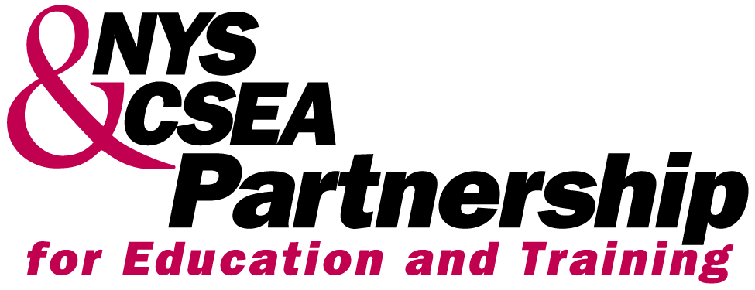 | TUITION BENEFITS PROGRAM APPLICATION FORM  FOR PROGRAM YEAR 2005-2006 (APRIL 1, 2005 TO MARCH 31, 2006)

Fill out this form completely and mail it to the Partnership, Corporate Plaza East, Suite 502, 240 Washington Avenue Ext., Albany, NY 12203 or fax to (518) 473-9457 or (518) 473-0056. Call 1-800-253-4332 if you have questions about any of the information requested. You may apply for TWO tuition benefits between April 1, 2005 and March 31, 2006. Please complete a separate application form for each tuition benefit requested.
Social Security #: □□□-□□-□□□□
Name:_________________________________________________________________________________________

Home Address:__________________________________________________________________________________

City:___________________________ State:______________________ Zip code:____________________

Work Phone: ( )___________________Ext.___________ Home Phone: ( )___________________________

Work Hours:_______________________ State Agency Name: SUNY-Stony Brook
School Code: 681 School Name: SUNY-Stony Brook University
(Fill in the three-digit code for the school you have selected from the catalog and include the school’s name on the line provided. Use “TRP” in the 3 boxes and include the school’s name, address, and phone number if you are applying for reimbursement at a school or location that does not accept Partnership vouchers or if you have already paid for your course and prefer to be reimbursed directly, after course completion. DO NOT send payment/completion documentation at this time.)

Subject Area:___________________________________________________________________________________
(DO NOT LEAVE BLANK! You must indicate the subject area you intend to study using your tuition benefit—a specific course title or number is not needed.)

Check all that apply:
□ I am currently laid off from NYS service, was separated in the past year, and am on a Civil Service Preferred List. Provide your date of separation from NYS service. Date of Separation:_________________
□ I have a disability that requires support services in order to participate in the course. I would like to be contacted by the Partnership’s Accessibility Coordinator Colleen Thompson, by phone at the numbers I provided above OR by e-mail @ ____________________________________________.
□ I want information on getting a high school diploma or GED, learning English, or entry-level classes to prepare for college courses. (All inquiries will be kept confidential.)
□ I am currently on a non-disciplinary leave of absence or receiving Workers’ Compensation benefits. Attached is verification from my human resources office including the type of leave, the start date and anticipated end date.

All the information contained in this application is true and accurate to the best of my knowledge and belief. I hereby authorize the school named above to release to the Partnership final grades and other data regarding my participation.

Signature:_______________________________________________________ Date:_______________________

