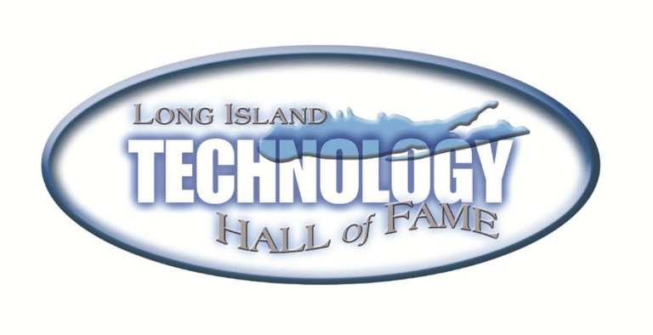

Intel Science Talent Search 2013 Finalists

**Mayuri Sridhar**

Kings Park High School

“Computational Analysis of the DNA-Binding Mechanism of the p53 Tumor Suppressor and its Inactivation through the R249S Mutation”

**Michael Zhang**

Smithtown High School East

“Role-Inducted Perspective Visual Behavior During Scene Free-Viewing”